

12th march, 2024 Project Guide: John Devassy,

Suraj Waghmare

***S2V Gym Bot using Azure Services***

Project Documentation

Created By: Vedant Babade , Sree Lakshmi Nair & Sanjana Maurya

**ABSTRACT**

This project report presents the design and implementation of **S2VGYM-BOT**, made by using Azure Services. This bot helps the user to enquire about admission process and details of the gym without the hustle of being physically present. The user access the bot and can get answers to all the question without visiting the gym just by chatting with bot.**S2VGYM-BOT** consist of azure AI service, language studio, webapp and container. **S2VGYM-BOT** uses AI to answer the questions asked by the client. A list of default question and answers is saved on database made in excel. When the client ask any questions the bot gives answer to it. It also uses the key words from the default questions the AI-bot ,shows the list of questions which contains the key word. It also recommends specific questions to the user. If the client asks questions outside from the default question the bot will suggest the default answer to the client. The bot stored the data base in the container. This container is stored in storage account.

Table of Contents

1. Chapter 1: Introduction​………………………………………………………………………………………………………………………………………..1

1.1. [Fundamentals………………………………………………………………………………………………..………………………………………………​1](x-apple-ql-id://9DAE09D5-D601-4FCD-9EB4-A7607295B552/x-apple-ql-magic/#_TOC_250013)

1.2. [Objectives​……………………………………………………………………………………………………………………………………………………..1](x-apple-ql-id://9DAE09D5-D601-4FCD-9EB4-A7607295B552/x-apple-ql-magic/#_TOC_250012)

1.3. [Scope​…………………………………………………………………………………………………………………………………………………………….1](x-apple-ql-id://9DAE09D5-D601-4FCD-9EB4-A7607295B552/x-apple-ql-magic/#_TOC_250011)

2. Chapter 2: System requirements and specifications​…………………………………………………………………………………………..3

2.1. [What is SRS? ……………………………………………………………………………………………………………………………………………….​3](x-apple-ql-id://9DAE09D5-D601-4FCD-9EB4-A7607295B552/x-apple-ql-magic/#_TOC_250010)

2.2. [Role of SRS​…………………………………………………………………………………………………………………………………………………..3](x-apple-ql-id://9DAE09D5-D601-4FCD-9EB4-A7607295B552/x-apple-ql-magic/#_TOC_250009)

2.3. [Requirements Specification Document​……………………………………………………………………………………………………….3](x-apple-ql-id://9DAE09D5-D601-4FCD-9EB4-A7607295B552/x-apple-ql-magic/#_TOC_250008)

2.4. [Functional requirements………………………………………………………………………………………………………………………………​3](x-apple-ql-id://9DAE09D5-D601-4FCD-9EB4-A7607295B552/x-apple-ql-magic/#_TOC_250007)

2.5. [Non-Functional Requirements​…………………………………………………………………………………………………………………….4](x-apple-ql-id://9DAE09D5-D601-4FCD-9EB4-A7607295B552/x-apple-ql-magic/#_TOC_250006)

2.6. [Performance​…………………………………………………………………………………………………………………………………………………4](x-apple-ql-id://9DAE09D5-D601-4FCD-9EB4-A7607295B552/x-apple-ql-magic/#_TOC_250005)

2.7. [Software Requirements…………………………………………………………………………………………………………………………….…​4](x-apple-ql-id://9DAE09D5-D601-4FCD-9EB4-A7607295B552/x-apple-ql-magic/#_TOC_250004)

2.8. [Hardware Requirements​…………………………………………………………………………………….………………………………………..4](x-apple-ql-id://9DAE09D5-D601-4FCD-9EB4-A7607295B552/x-apple-ql-magic/#_TOC_250003)

3. Chapter 3: Literature Survey​……………………………………………………………………………………………………………………………...5

3.1. [Paperwork​…………………………………………………………………………………………………………………………….………………………5](x-apple-ql-id://9DAE09D5-D601-4FCD-9EB4-A7607295B552/x-apple-ql-magic/#_TOC_250002)

3.2. [Proposed model…………………………………………………………………………………………………………………………………….…..….​6](x-apple-ql-id://9DAE09D5-D601-4FCD-9EB4-A7607295B552/x-apple-ql-magic/#_TOC_250001)

3.3. [Related work​……………………………………………………………………………………………………………………………….………………..7](x-apple-ql-id://9DAE09D5-D601-4FCD-9EB4-A7607295B552/x-apple-ql-magic/#_TOC_250000)

4. Chapter 4: Azure Services Used…………………………………………………………………………………………….……………………………​8

5. Chapter 5: Implementation​………………………………………………………………………………………………………………………………..16

6. Chapter 6: Website Overview​…………………………………………………………………………………………………………………………...22

7. Chapter 7: Benefits​…………………………………………………………………………………………………………………………………………….29

8. Chapter 8: Conclusion​……………………………………………………………………………………………………………………………………….30

**1: INTRODUCTION:-**

**CHAPTER1**

S2VGYM-BOT have become a popular and convenient way of access of whereabout of the gym and other details related to gym. Our s2v chatbot uses AI to reply the question asked by user/client. If users ask question which contain the keywords from the default questions then the AI will automatically show all the questions with the same question. This project report presents the design and implementation of **S2VGYM-BOT**, made by using Azure Services. This bot helps the user to enquire about admission process and details of the gym without the hustle of being physically present. The user access the bot and can get answers to all the question without visiting the gym just by chatting with bot.**S2VGYM-BOT** consist of azure AI service, language studio, webapp and container. **S2VGYM-BOT** uses AI to answer the questions asked by the client. A list of default question and answers is saved on database made in excel. When the client ask any questions the bot gives answer to it. It also uses the key words from the default questions the AI-bot ,shows the list of questions which contains the key word. It also recommends specific questions to the user. If the client asks questions outside from the default question the bot will suggest the default answer to the client. The bot stored the data base in the container. This container is stored in storage account.

**1.1 Fundamentals**

Fundamental steps in building the s2vgym-bot are:

• Planning the purpose, scope, and functions of the s2vgym-bot, as well as the budget, timeline, and stakeholders involved.

• Designing the s2vgym-bot architecture, interface, and features, as well as the digital collection, metadata, and access policies.

• Implementing the s2vgym-bot system using appropriate software, hardware, and network technologies, as well as testing and debugging the system.

• Evaluating the s2vgym-bot performance, usability, and user satisfaction, as well as collecting feedback and data for improvement.

• Maintaining and updating the s2vgym-bot system, content, and services, as well as ensuring security and backup measures.

**1.2****Objectives:**

The objectives that we took into consideration while creating a this gym-bot.

• To design and develop an gym-bot that help user to enquire about the gym online.

• To implement AI-bot to the web-services.

• To create a bot which answer’s all the basic questions about registration and admission.

• To connect the date with the storage, which will fetch the answer for the user.

**1.3****Scope:**

• To develop an gym-chatbot system that provides easy enquiry and details regarding the gym.

• The user can type a single keyword and the AI-bot will automatically recommend all the following questions which contains the particular keyword in them.

• If the user ask a question aside from the default list of question then the ai-chatbot will automatically give them the default response.

• The container is used to store/edit or delete the data, which can be modify according to the need of the server-side .

**CHAPTER 2**

**2. System requirements and specifications**

2.1 What is SRS?

Software requirements Specifications (SRS) is the starting point of the software developing activity.

As the system grew more complex it became evident that the goal of the entire system cannot be

easily comprehended hence the need for the requirement phase arose. The software project is initiated by the client needs. The SRS is the means of translating the idea of the mind of client (the input) in to a formal document (the output of the required phase.)

The SRS phase consists of two basic activities:

Problem/ requirement analysis: The process is order and more nebulous of the two deals with understanding the problem the goals and constraints.

Requirement specifications: Here the focus is on specifying what has been found giving analysis such as representation specification language and tools and checking the specification and addresses during this activity requirement phase terminates with the production of the validate SRS document producing the SRS document is the basic goal of this phase.

2.2 Role of SRS:

The purpose of the software requirement specification is to reduce the communication gap between the clients and the developers. The software requirement specification is the medium through which the client and user needs are accurately specified. It forms the basis of software development. A good SRS should satisfy all the parties involved in the system.

2.3 Requirements Specification Document:

A software requirement specification is a document that describes the nature of a project software or application. In simple words SRS document is a manual of a project provided It is preferred before you kick -start a project application This document is also known by the name SRS report software document A software document is primarily prepared for a project software of any kind of application ,There are set of guidelines to be followed while preparing the software requirement specificationdocument. This includes the purpose, scope, functional and non-functional requirements, software,

and hardware requirements of the project. In addition to this, it also contains the information about environmental condition required Safety and security requirements software quality attributes of the project etc.

2.4 Functional requirements:

For documenting the functional requirements, the set of functionalities supported by the system are to be specified. A function can be specified by identifying the state at which data is to be input to the system Its input data domain, the output domain, and the type of processing to be carried on the input data to obtain the output data Functional require Define specific behaviour of function of the

application.

Following other functional requirements:

FR.1 The users should be able to type in the chat-bot, and register as well.

FR.2 All the questions should be when the user enter the keywords.

FR.3 When a user types the question in the chat-bot the answer must returned to the user .

FR.4 The default answer will be returned when an external question is asked.

FR.5 The answers should be fetched from the database.

2.5 Non-Functional Requirements:

A non-functional requirement is a requirement that specifies criteria that can be used to judge the operation of the system, rather than specific behaviour. Especially these are the constraints the system must work within.

Following are the non-functional requirements:

NFR.1 the chat-bot must be able to work properly without bugs.

NFR.2 The chat-bot should not have any lag while showing the answers.

NFR.3 The database should access proper user data.

NFR.4 In the scenario where the bot is not able to answer, the default answer should appear .

2.6 Performance:

The performance of the deployed chat-bot can be calculated by using following method: Measuring How the performance of your application stands in relation to the defined performance goals and helps you to identify the bottleneck that affected your application performance. It helps you identify whether your application is moving towards or away from performance goals. Defining what you will measure that is your matrix and defining the objective for each metric is critical part of your testing plan. Performance objective includes the following: response time latency throughput or resource utilization.

2.7 Software Requirements:

• Operating system: Windows 10/11 or MAC OS.

• Platform: Microsoft Azure

• Microsoft azure subscription(Free Trial or Azure for student or Pay-as-you-go)

• AI language studio

• Azure bot service

•Azure web app

• Azure language services

• Azure storage account

• Microsoft Excel

2.8 Hardware Requirements:

• Processor: Intel core i3 and above

• Hard disk: 256 GB or above

• RAM: 4GB or above

• Internet: 1 Mbps or above

**CHAPTER 3**

**3.**Literature Survey

3.1 Paperwork

This project uses azure services and storage to build a AI-chat-bot, for gym enquiry. The features of this chat-bot are as follows,

* The bot can guess the list of questions by simply using the keyword.
* Even if the question asked by the user does exist in the database a default answer will be generated.
* The storage helps to save/edit/delete the data according to the server-side requirement.

The project helps people to make a decision about joining the gym before actually going in person to enquire .

The challenges that AI-GYM chatbot faces,

* Since a set of default questions and answers are already set up in the database, if the user ask something which doesn’t contains any keyword of default question they will only be replied back with the default answer.

3.2 Related work

**Whizard**-its an fitness chat-bot.

**CHAPTER 4**

**Azure Services Used:**

1. Azure AI Language studio:

Language Studio is a set of UI-based tools that lets you explore, build, and integrate features from Azure Cognitive Service for Language into your applications. Language Studio provides you with a platform to try several service features, and see what they return in a visual manner. Question answering provides cloud-based Natural Language Processing (NLP) that allows you to create a natural conversational layer over your data. It is used to find appropriate answers from customer input or from a project. Question answering is commonly used to build conversational client applications, which include social media applications, chat bots, and speech-enabled desktop applications.

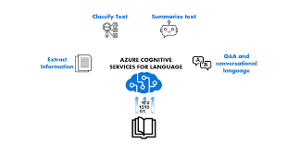

2. Azure AI Bot Service:

Azure AI Bot Service provides an integrated development environment for bot building. Its integration with [Power Virtual Agents](https://go.microsoft.com/fwlink/?linkid=2214993), a fully hosted low-code platform, enables developers of all technical abilities build conversational AI bots—no code needed. A chatbot is an application that has written or spoken natural language as its user interface. In other words, a conversation is the means through which questions are answered, requests are serviced, and so on.

This article provides an overview of some of the chatbot solutions Microsoft provides. If you're new to making chatbots, we recommend starting with Power Virtual Agents.

The following table lists Microsoft products and services for building bots, who they support, and a brief description. Following sections describe each product in more detail.

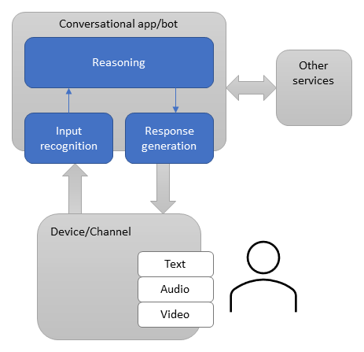

3.Azure Web App:

Web Apps are one of the most widely used Azure services that enable us to host our web applications in Azure. It can host a user-interactive application or even a backend service like a WCF Service or Web APIs. With Web Apps, we can leverage the power of Microsoft Azure and build multi-functional, immensely scalable, highly secured, and seamlessly accessible internet or intranet-based applications. Check out our free courses by getting Azure Certification to get an edge over the competition What we need to do is to push our application package into the web app and Azure App Service will take care of anything and everything required to keep it running. The most important advantage of using a web application is that we need not worry about the infrastructure plumbing that may be required to host the application. In traditional web hosting, we need to make sure that the Server is up, the OS is updated and the IIS is running. But in the case of web apps, Azure Service Fabric makes sure that the web app is allocated with all required computing power and resources.

Azure Web Apps provides an extensive platform to build an app in Azure without having to deploy, configure, and maintain your own Azure virtual machines. We can build any web app using different languages such as ASP.NET, PHP, Node.js, and Python.

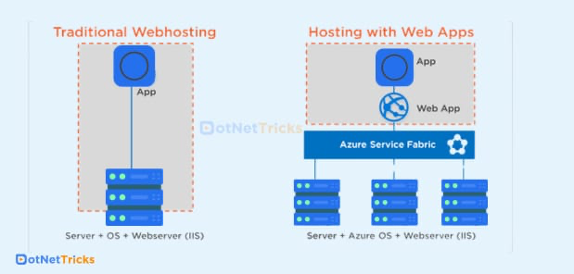

4.Azure language service:

Azure AI Language is a managed service for developing natural language processing applications. Identify key terms and phrases, analyse sentiment, summarize text, and build conversational interfaces. Use Language to annotate, train, evaluate, and deploy customizable AI models with minimal machine-learning experts. Azure AI Language is a cloud-based service that provides Natural Language Processing (NLP) features for understanding and analysing text. Use this service to help build intelligent applications using the web-based Language Studio, REST APIs, and client libraries.

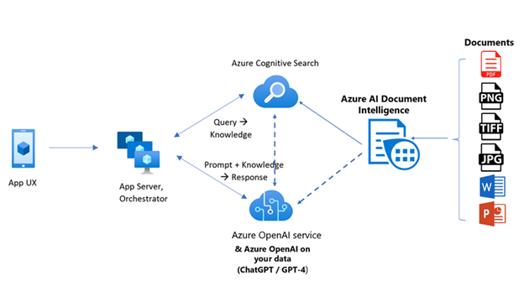

5.Azure Storage Account:

An Azure storage account contains all of your Azure Storage data objects: blobs, files, queues, and tables. The storage account provides a unique namespace for your Azure Storage data that's accessible from anywhere in the world over HTTP or HTTPS. Data in your storage account is durable and highly available, secure, and massively scalable.

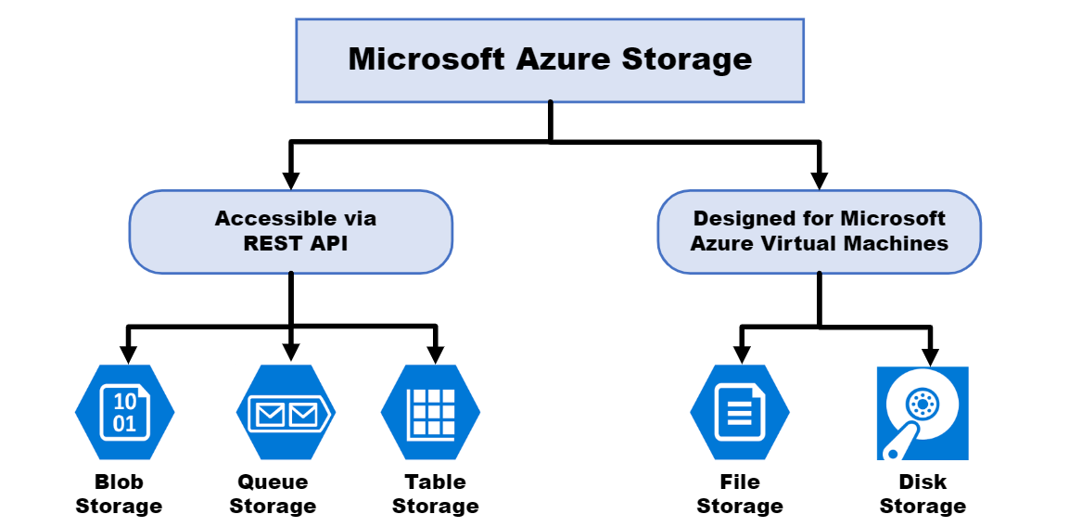

**CHAPTER 5: IMPLEMENTATION**

Topology:

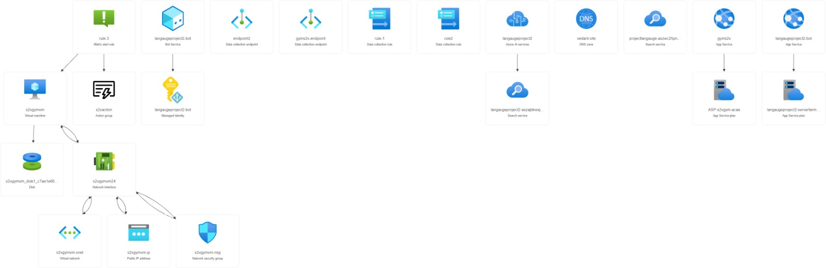

1. First we created an excel file for backend data base

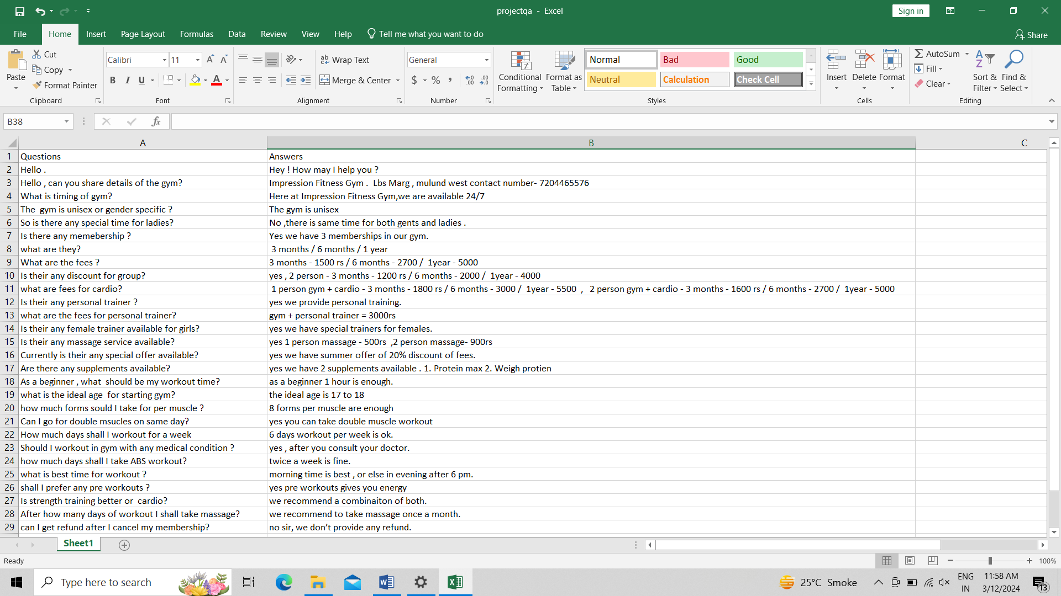

1. Then we created a resource group in azure portal.

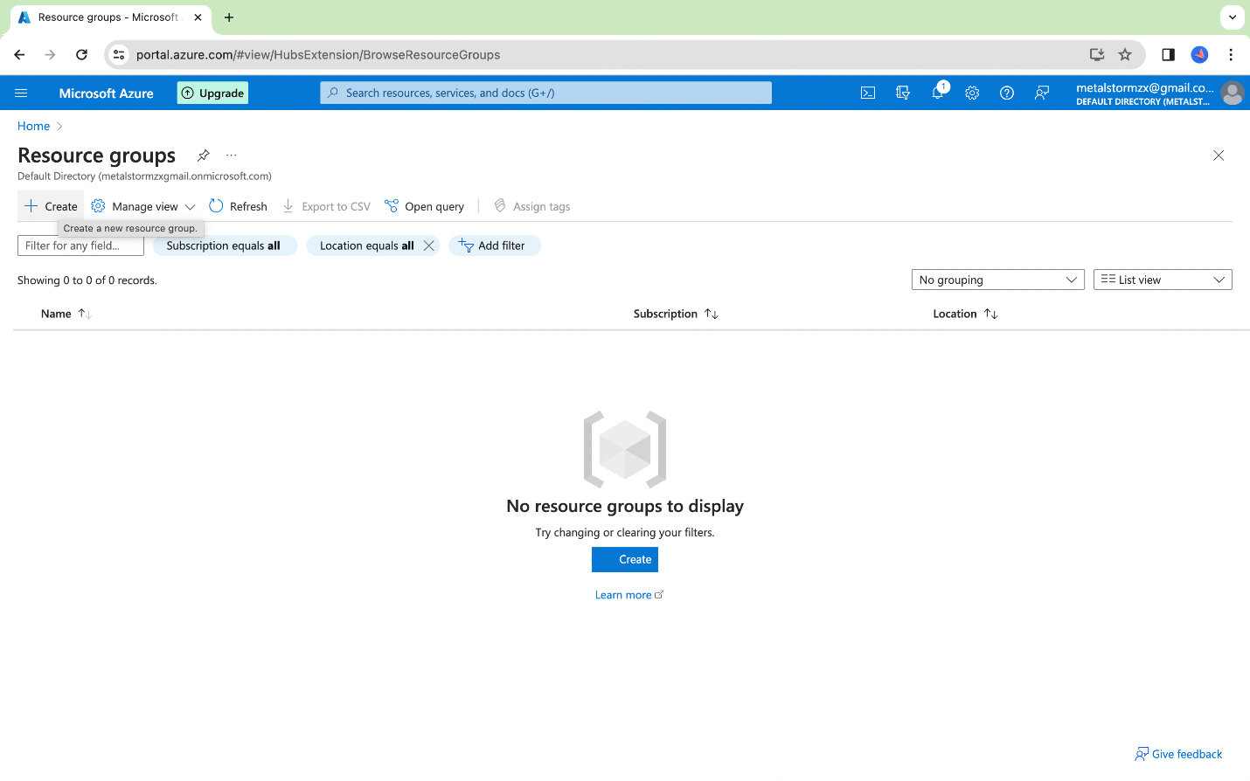

1. We named the resource group as S2Vgym

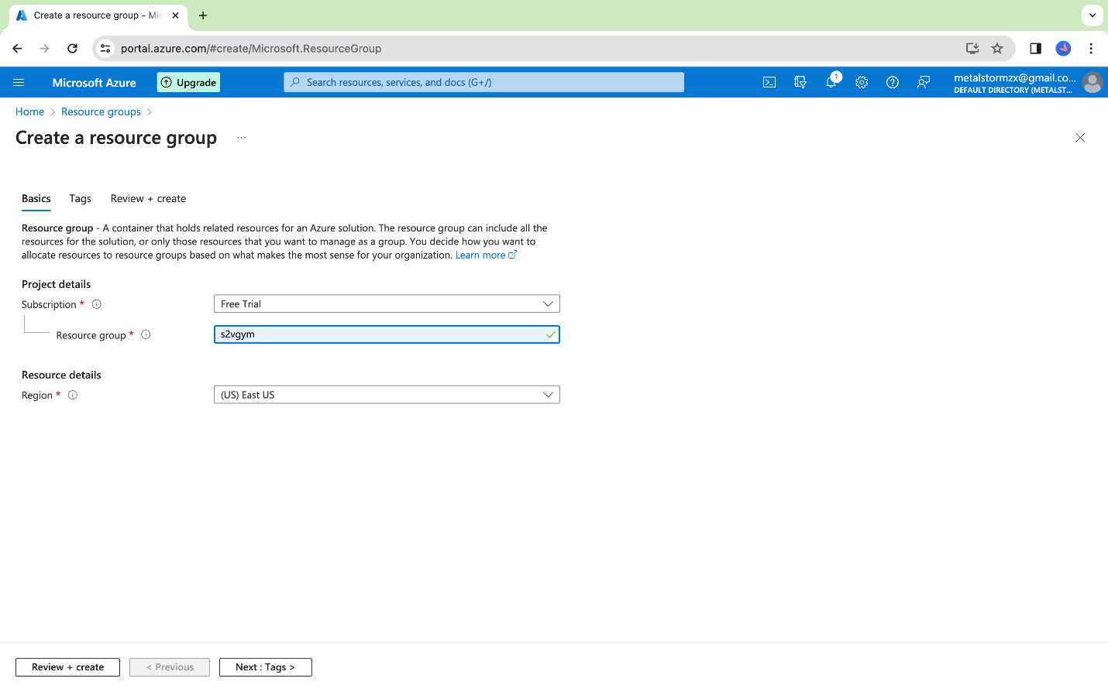

4.Resource group is created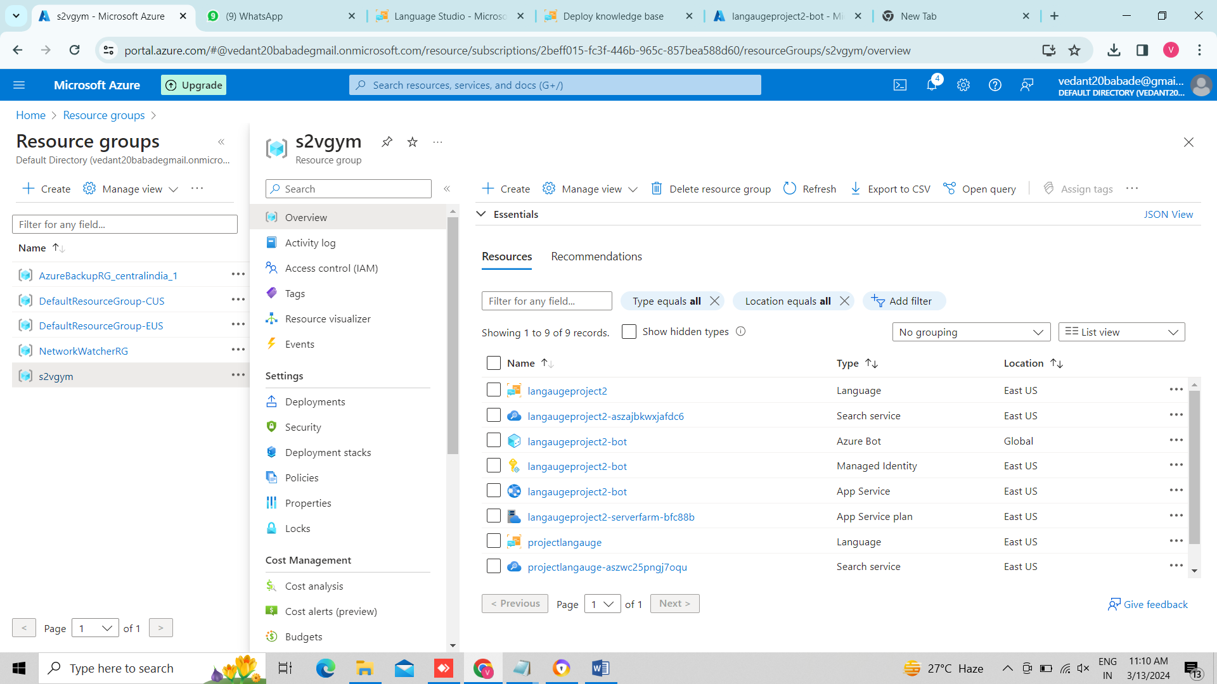

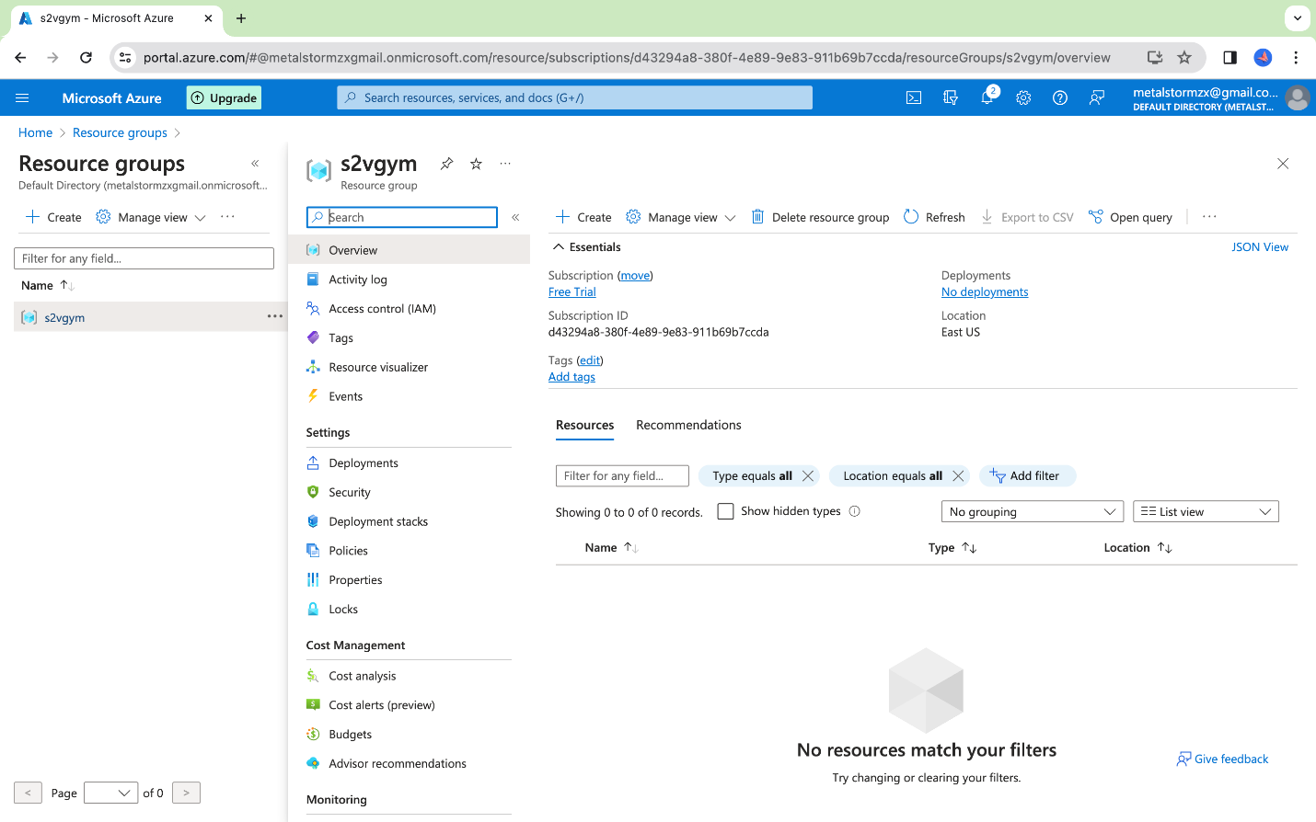

5.We created a storage account

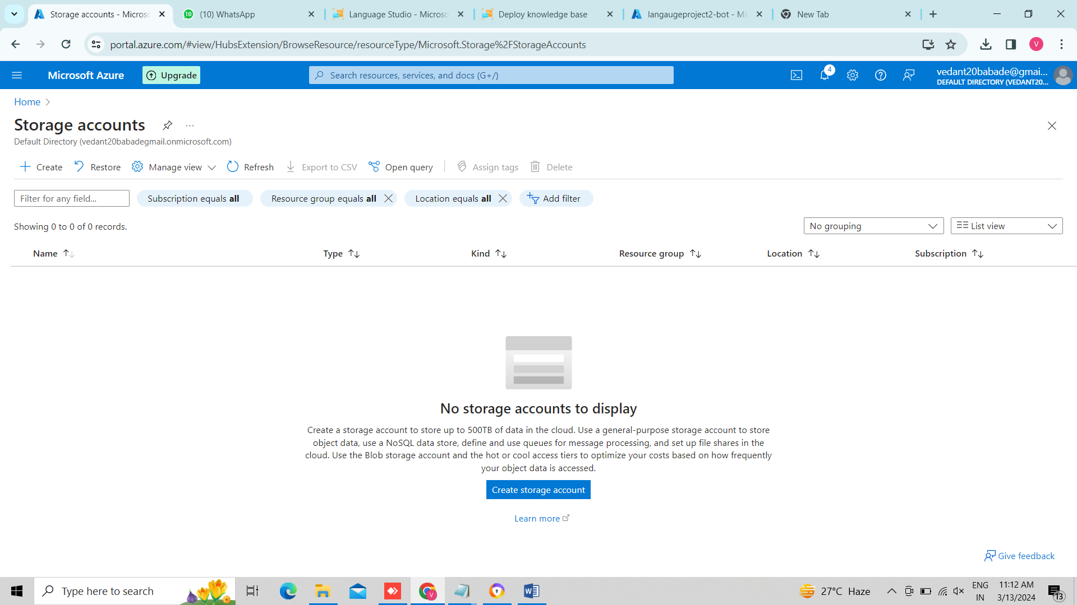

6.we selected performance as standard.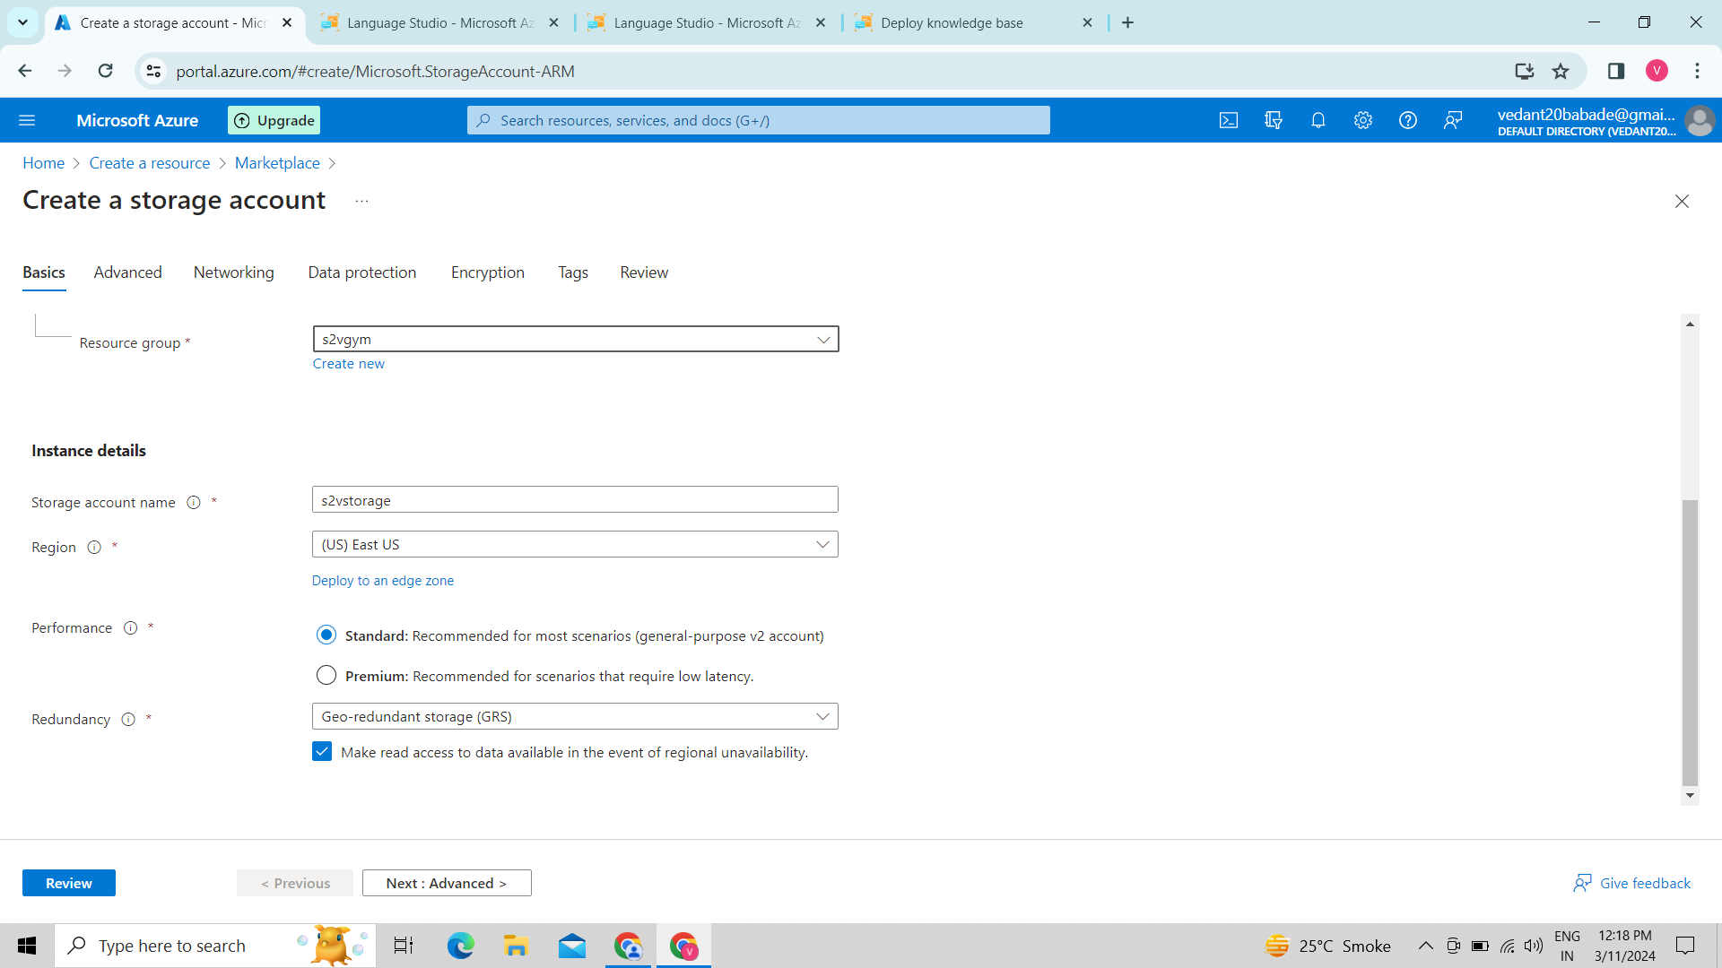

7.we allowed enabling anonymous access

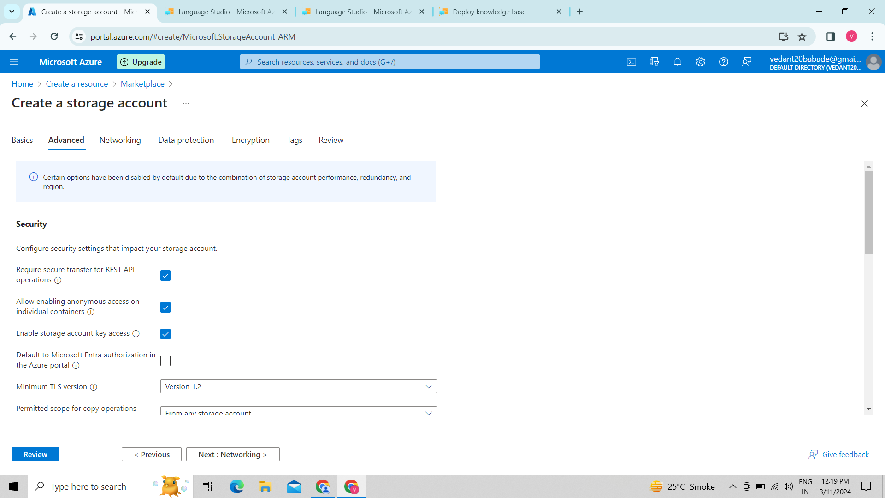

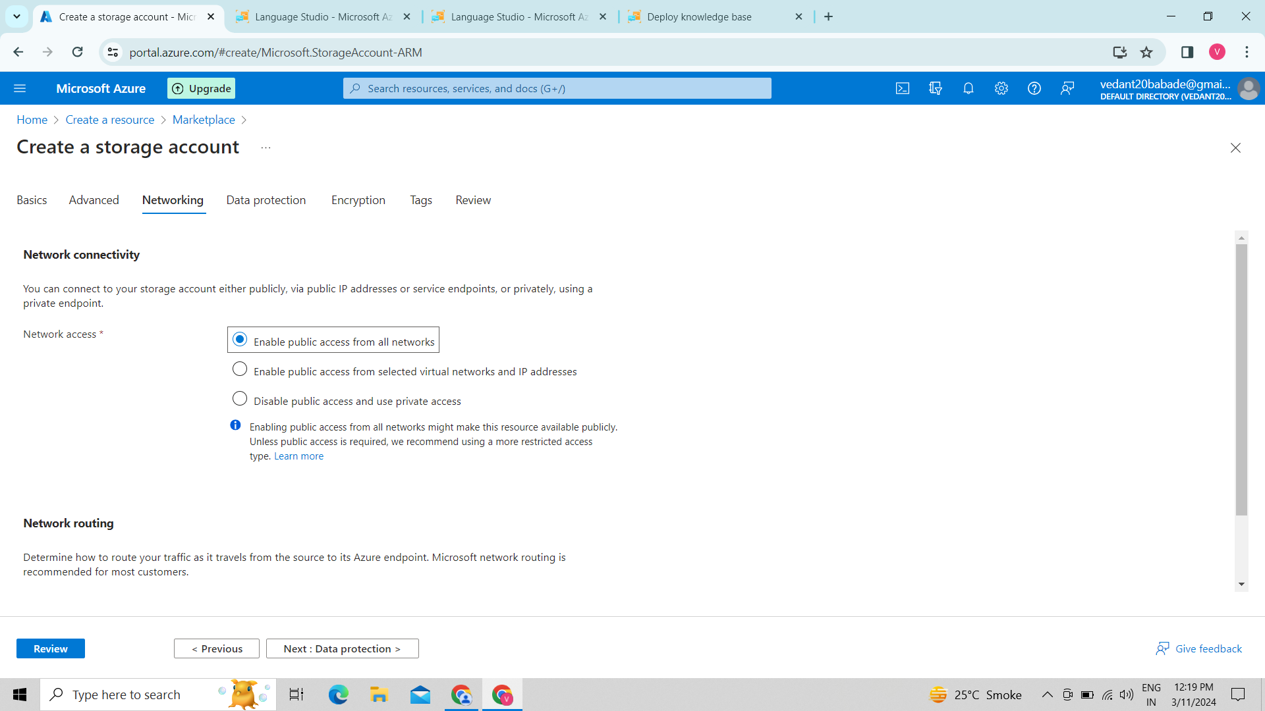

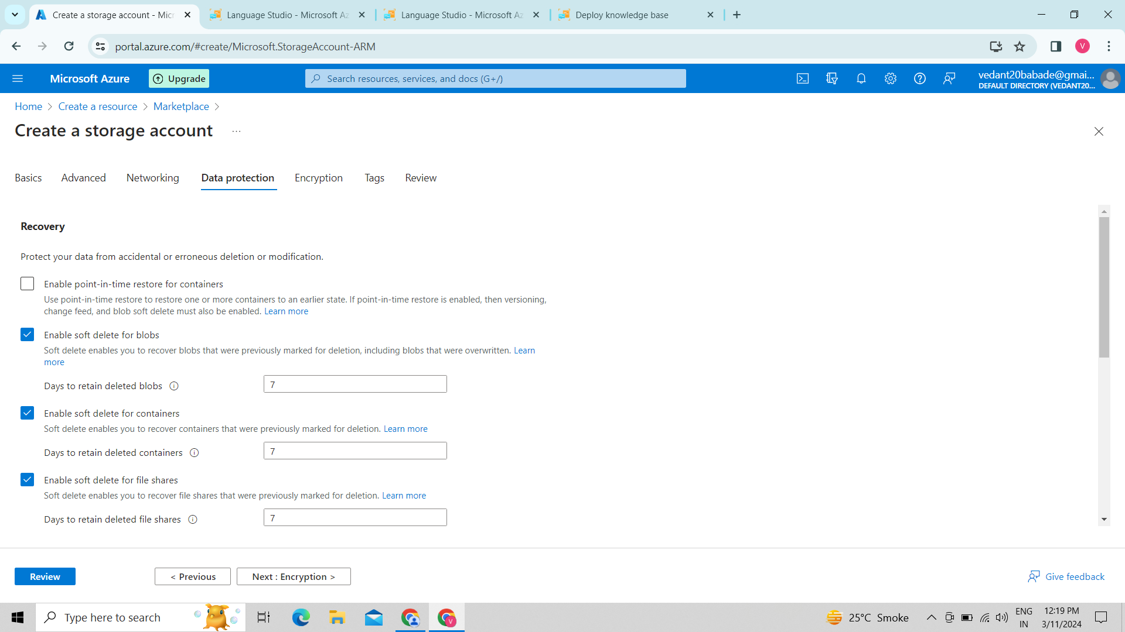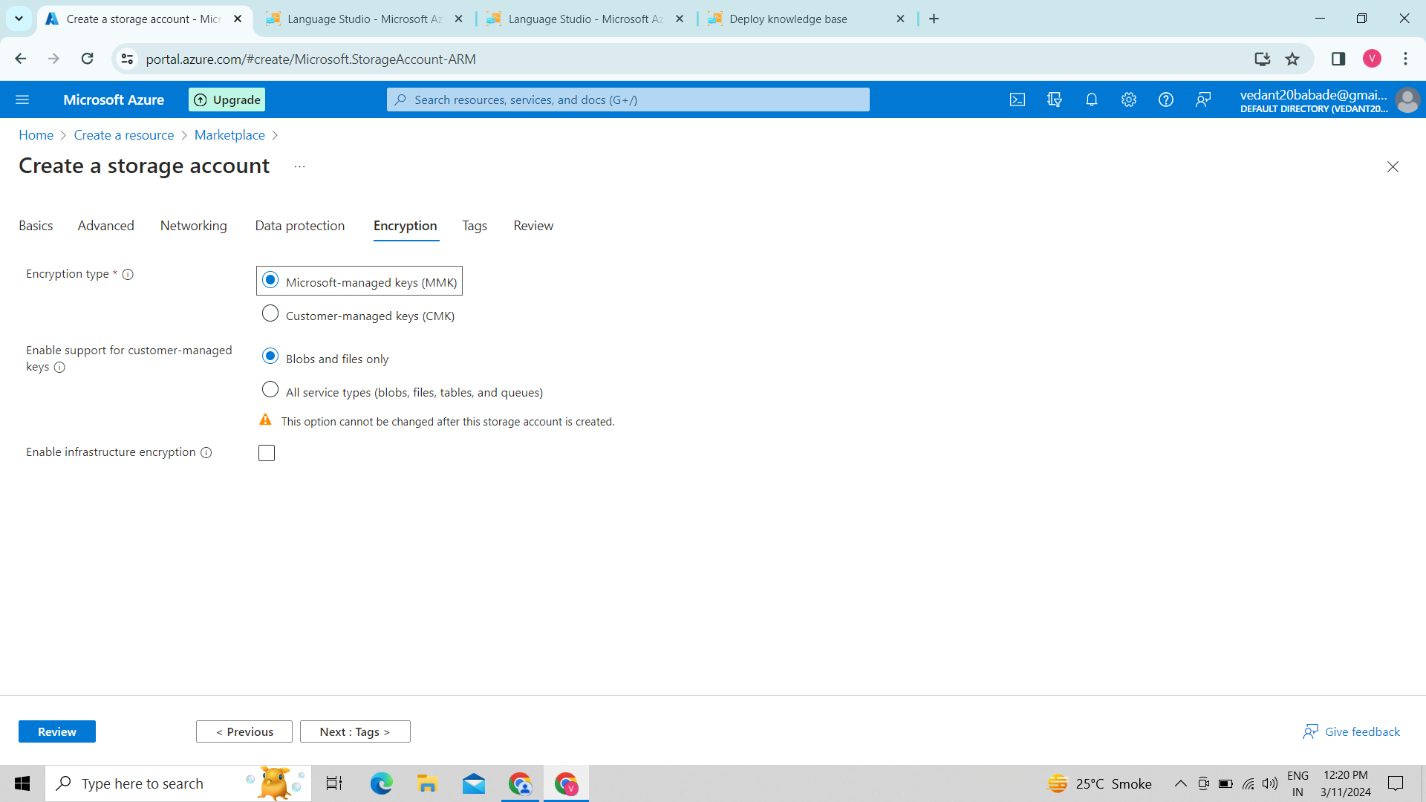

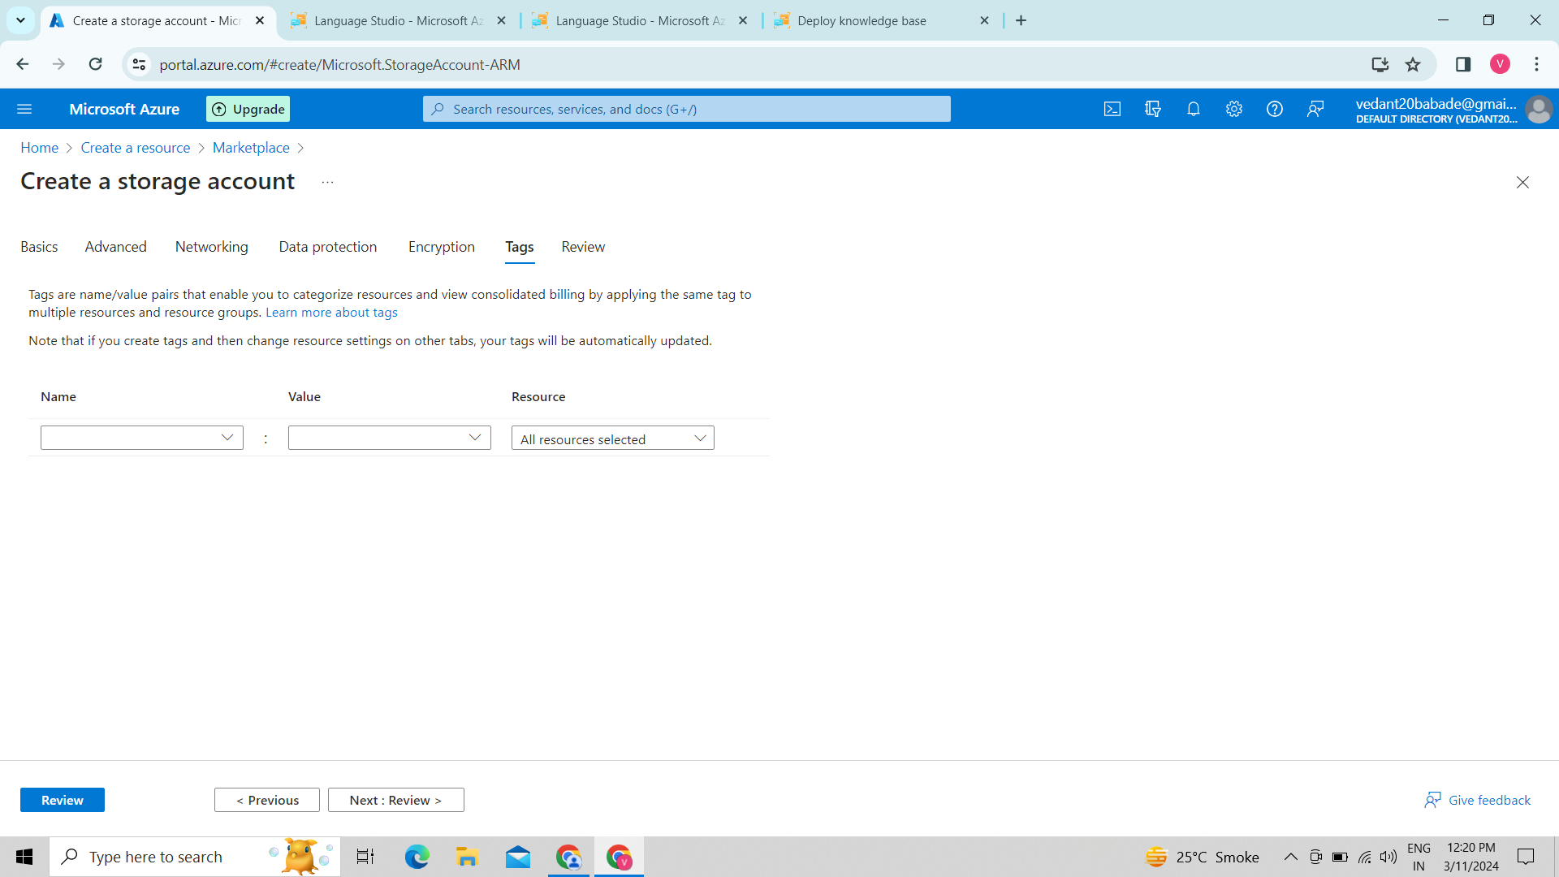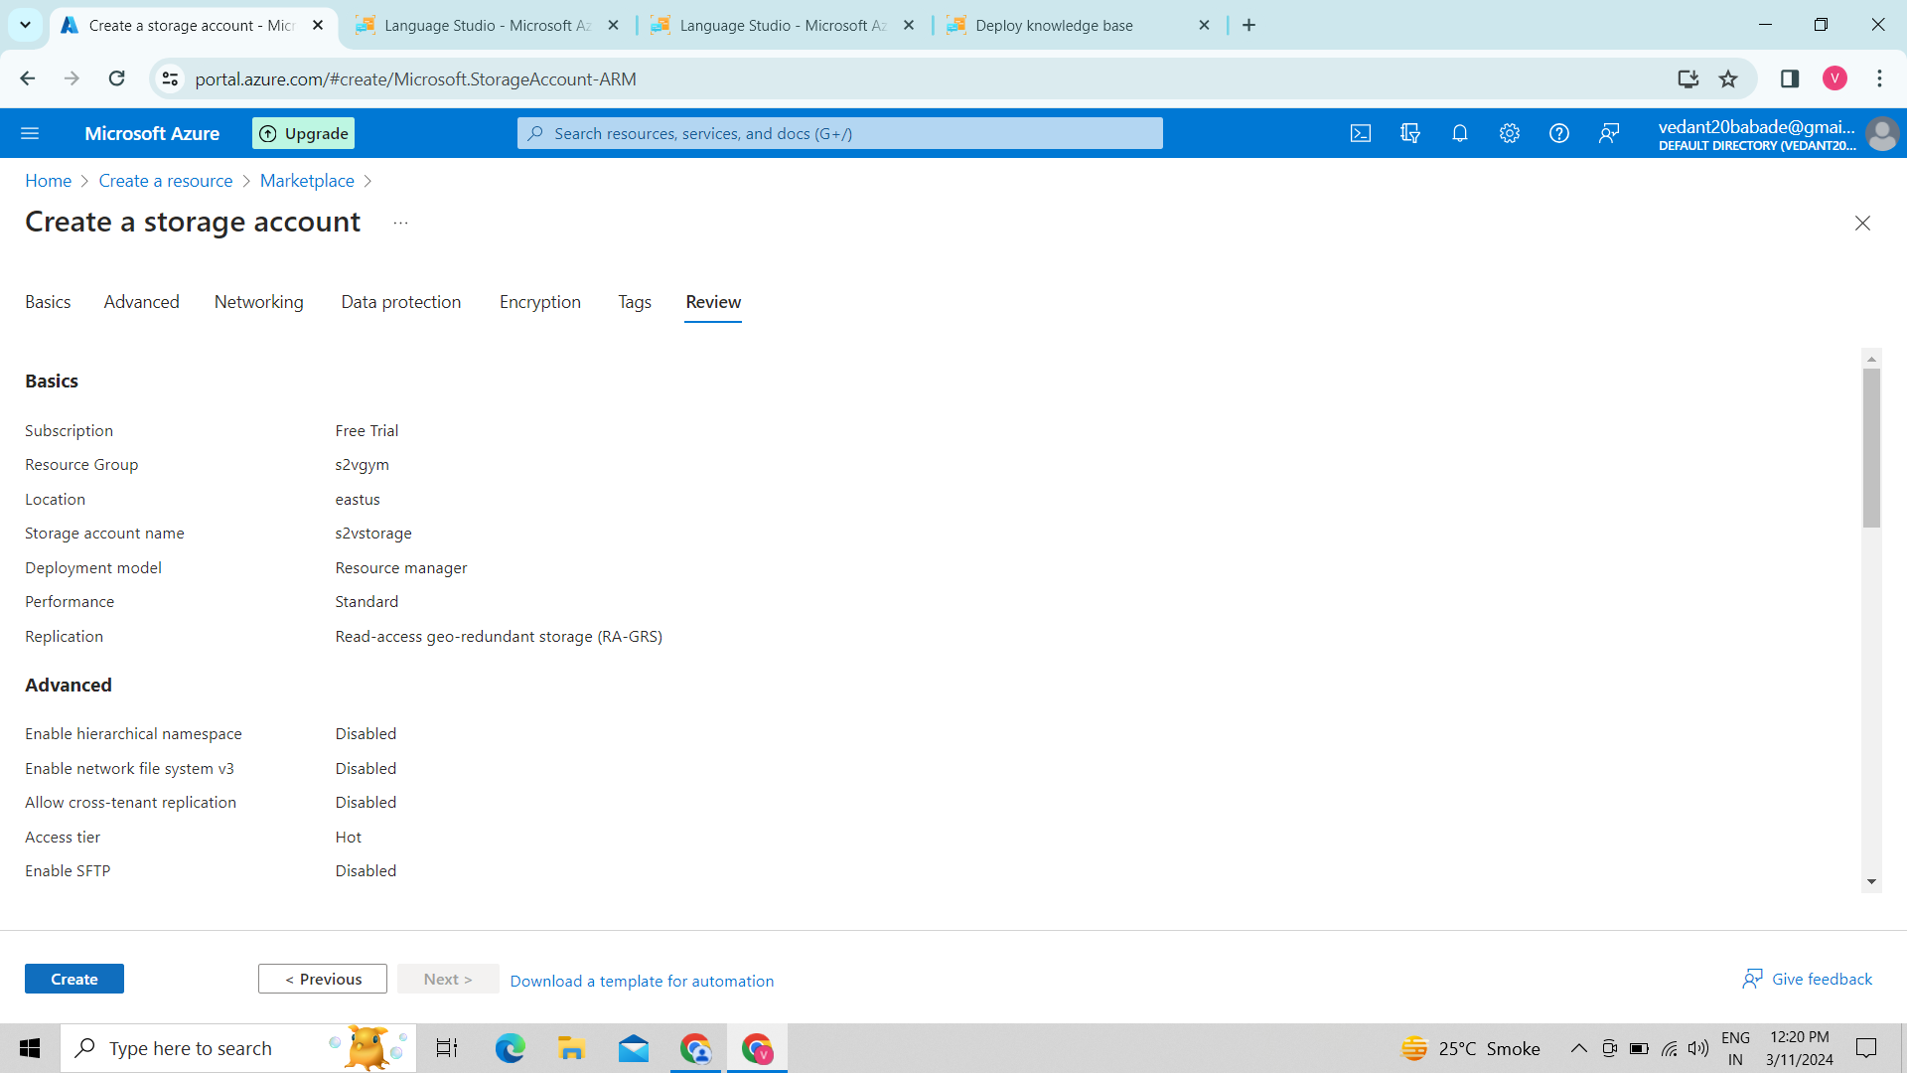

8.The storage is created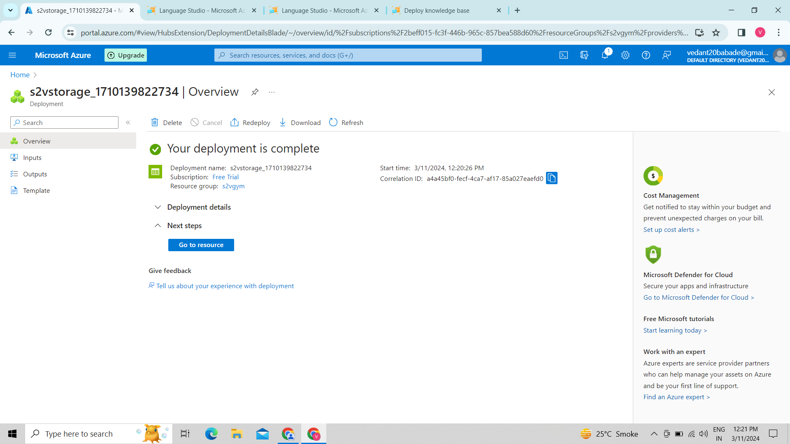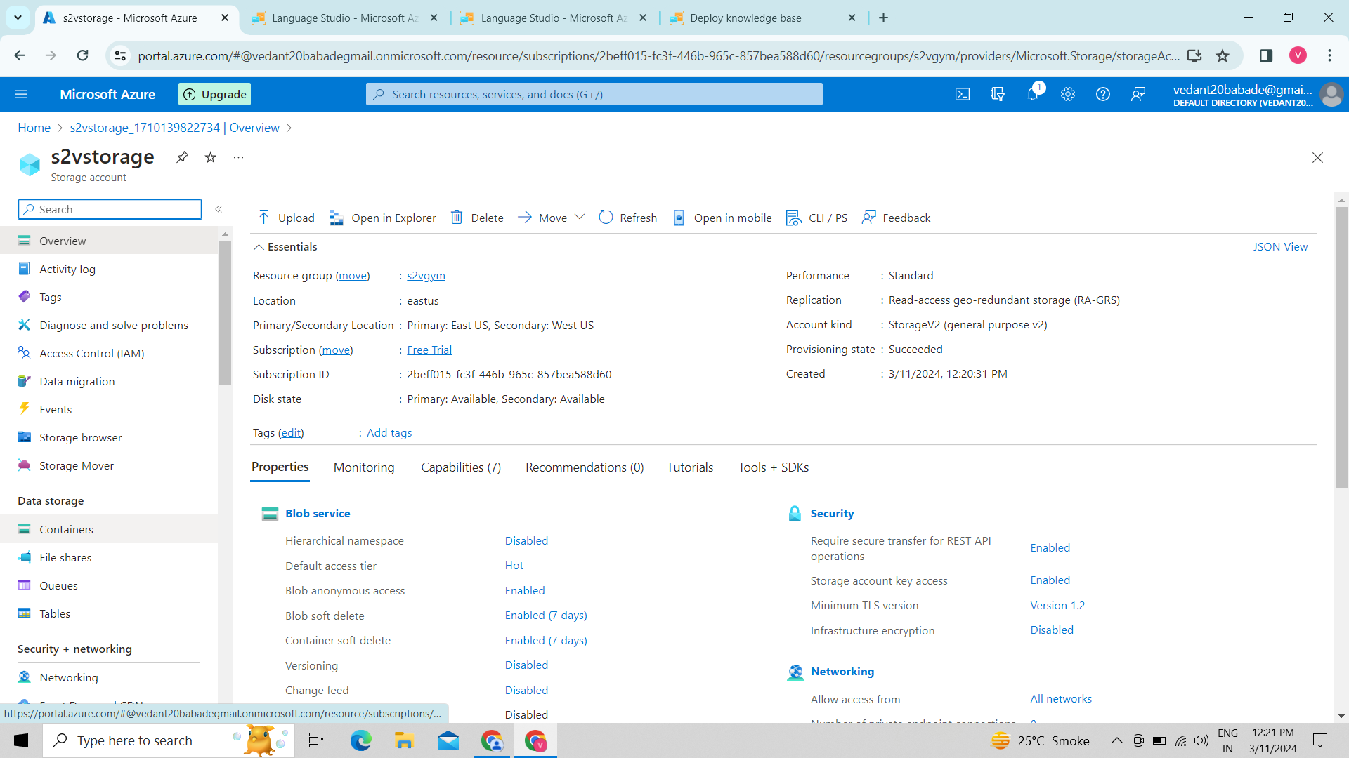

9. Then we created container

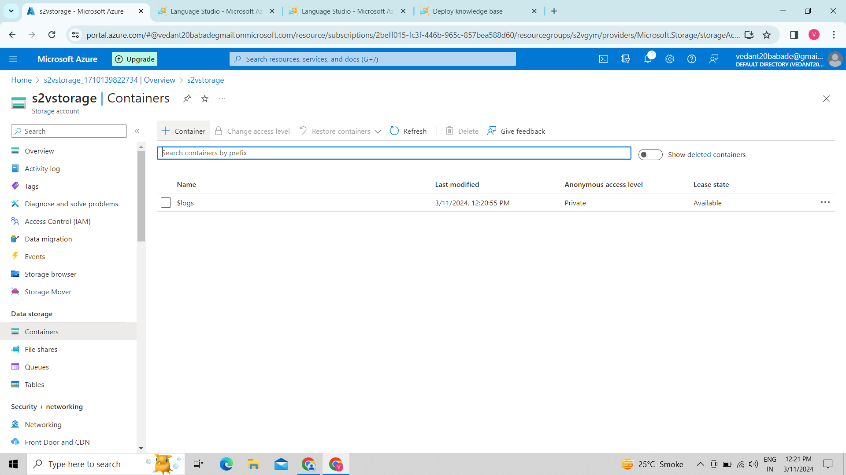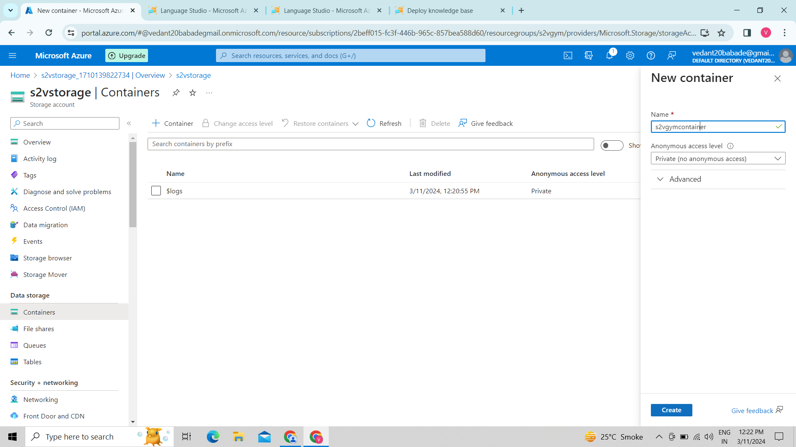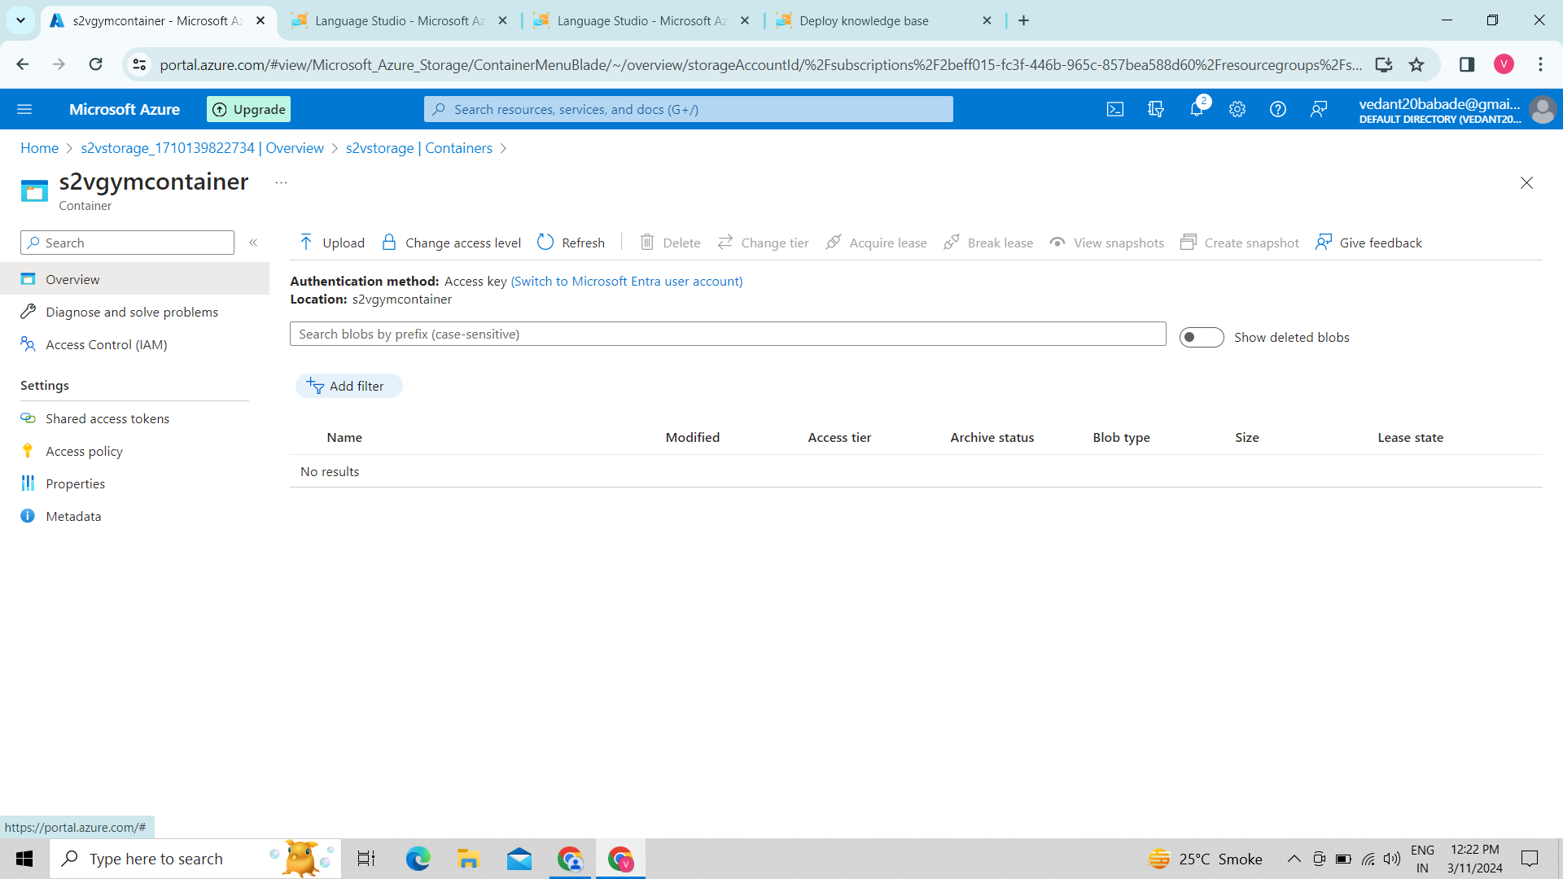

10. we uploaded our excel file in it.

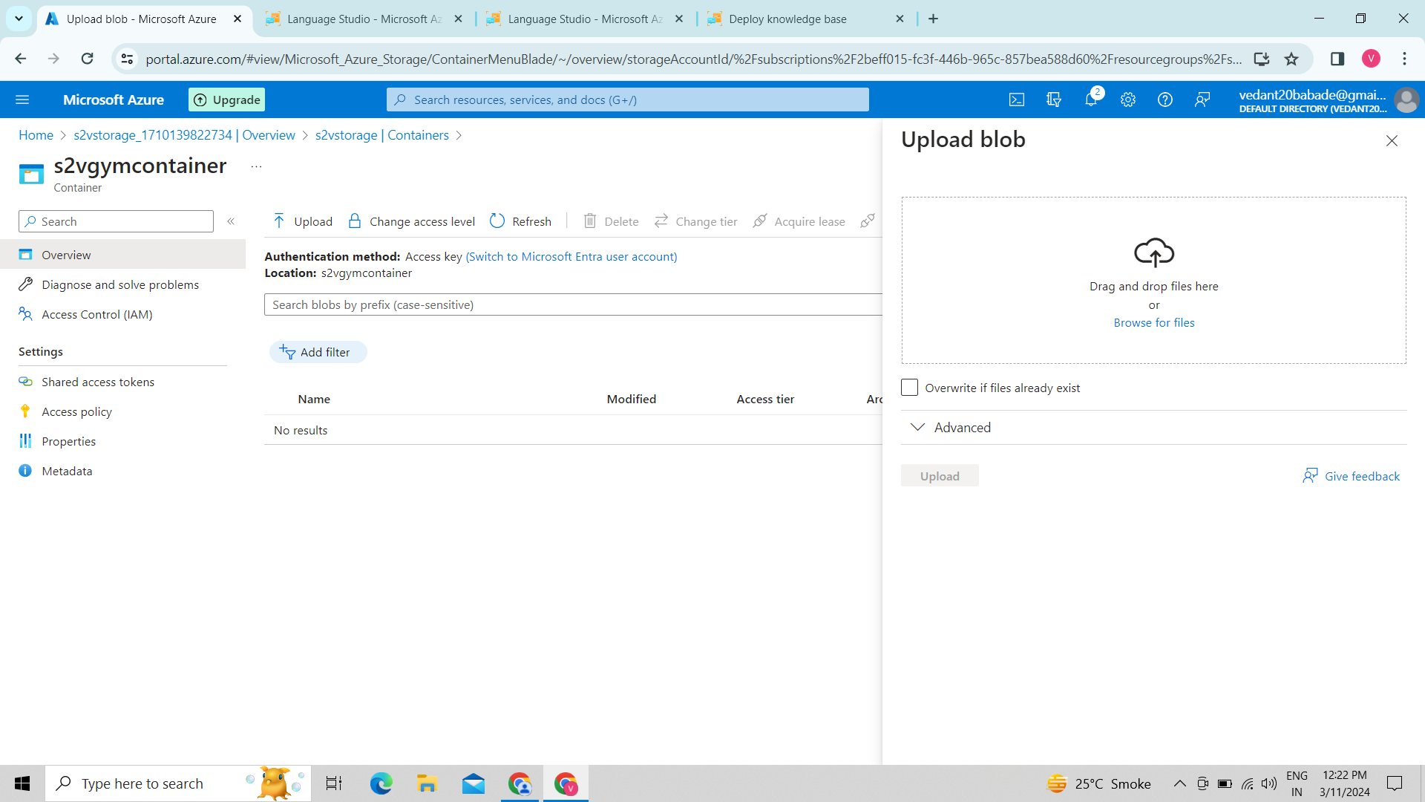

11. we browsed our file .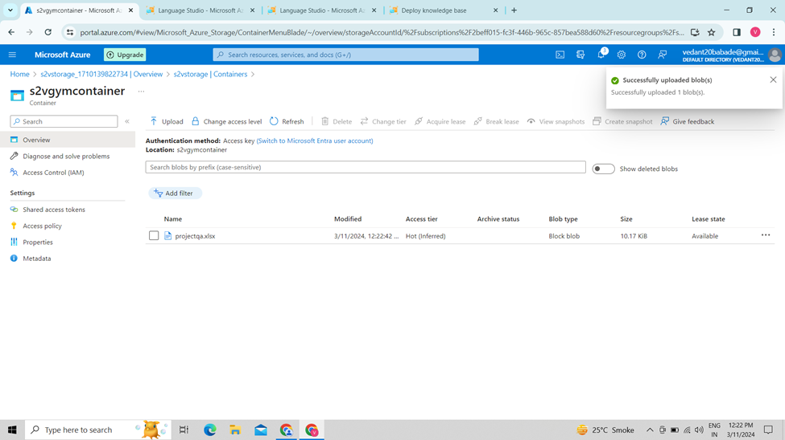

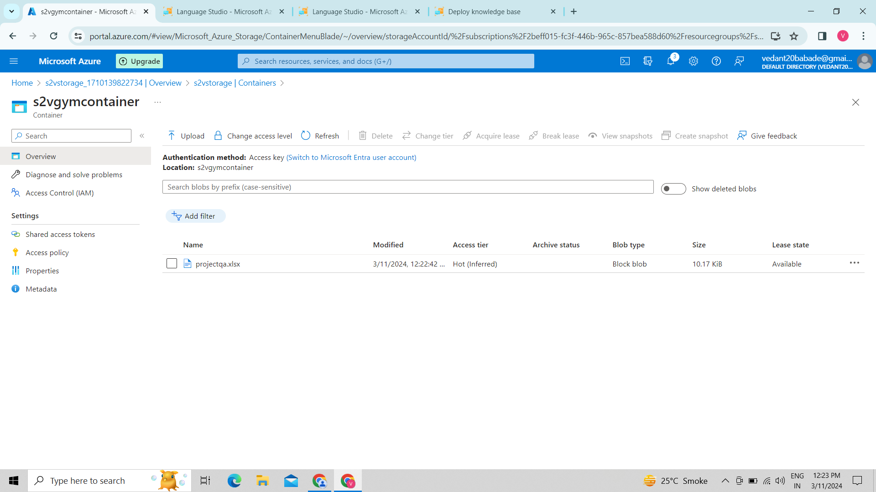

12. we used AL ML services of azure

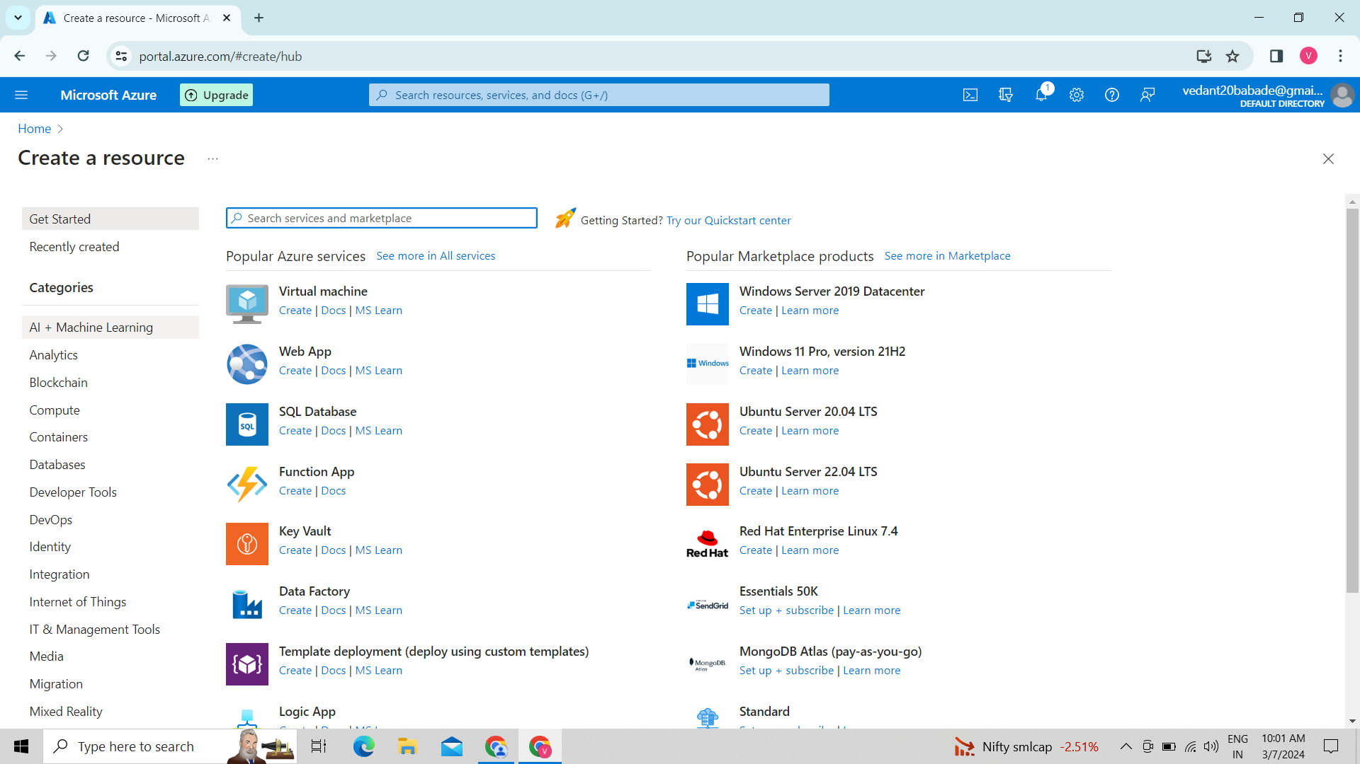

13. we selected language service

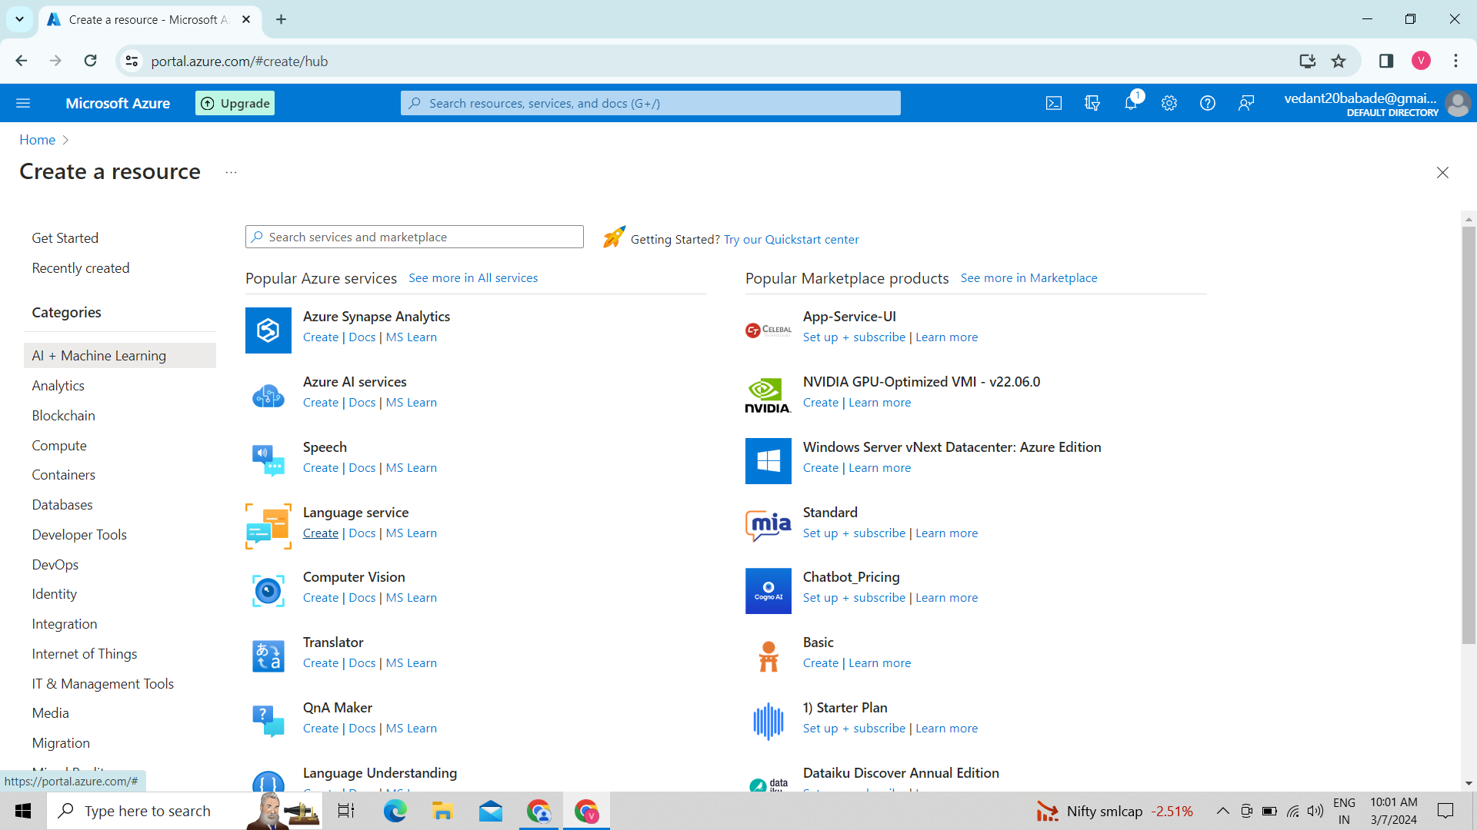

14. we selected custom question answering.

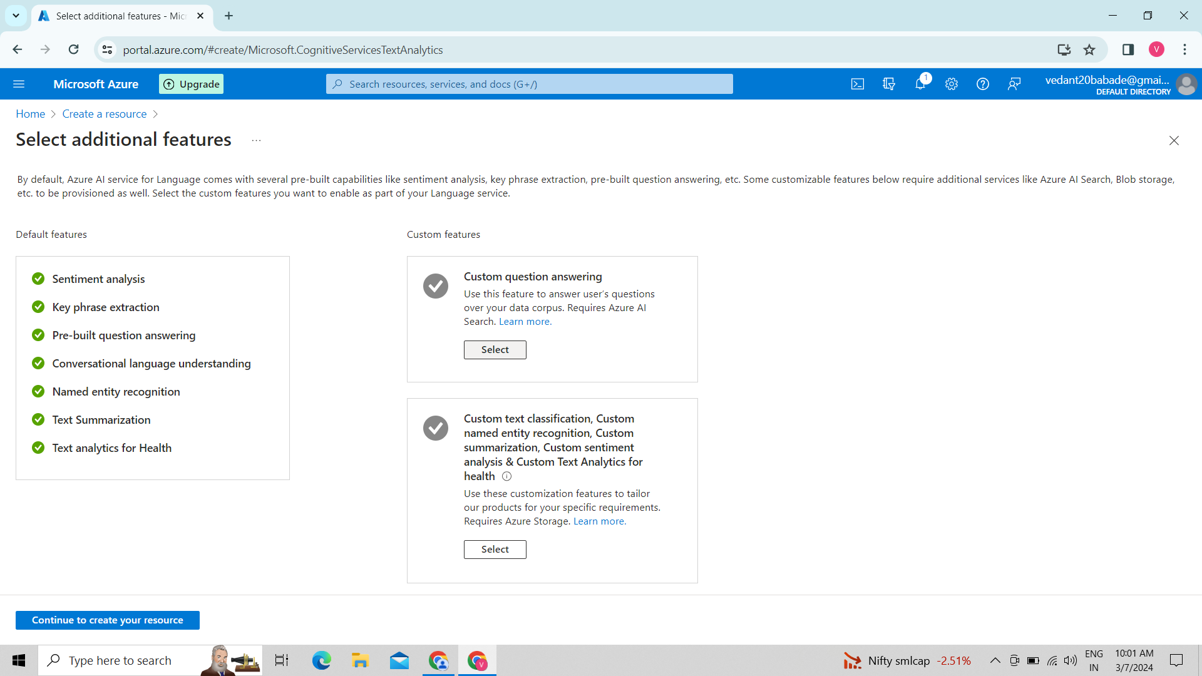

15. created a language service

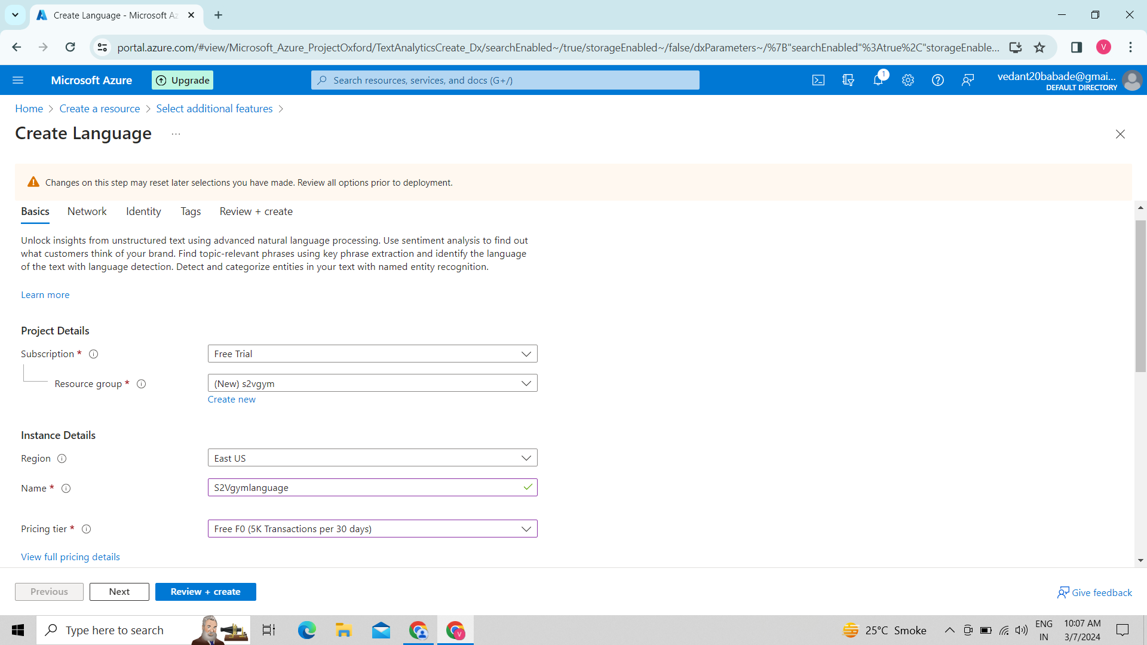

16. we selected pricing tier as free.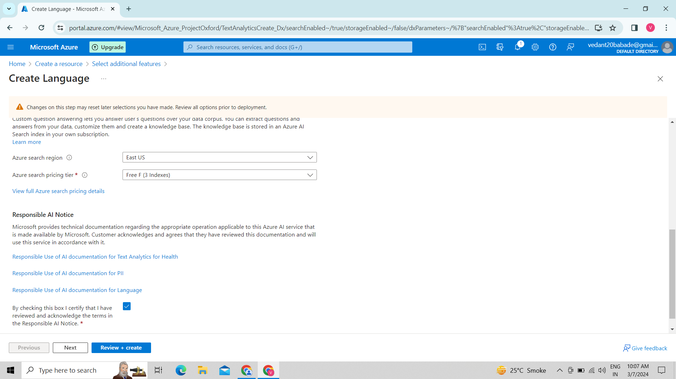

17.The status was on.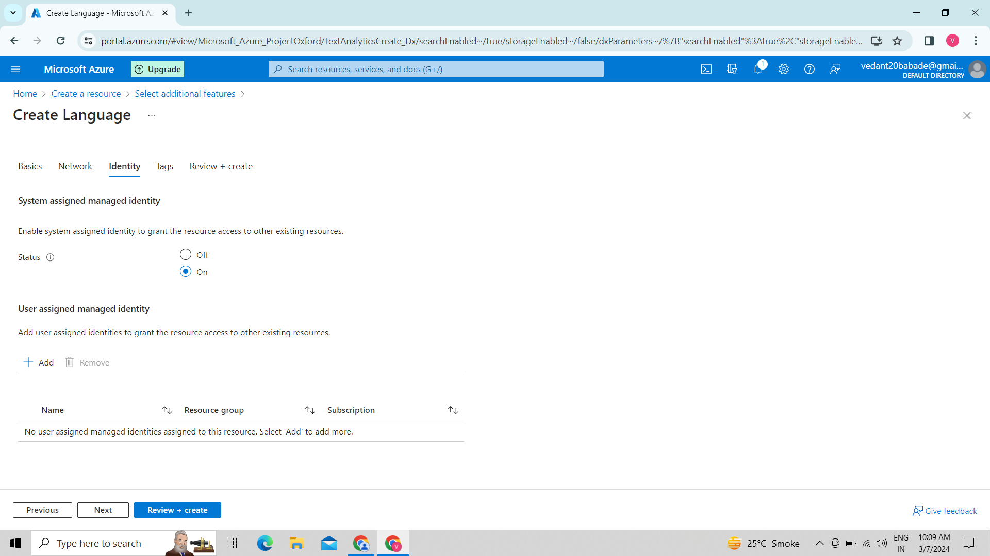18. Finally created.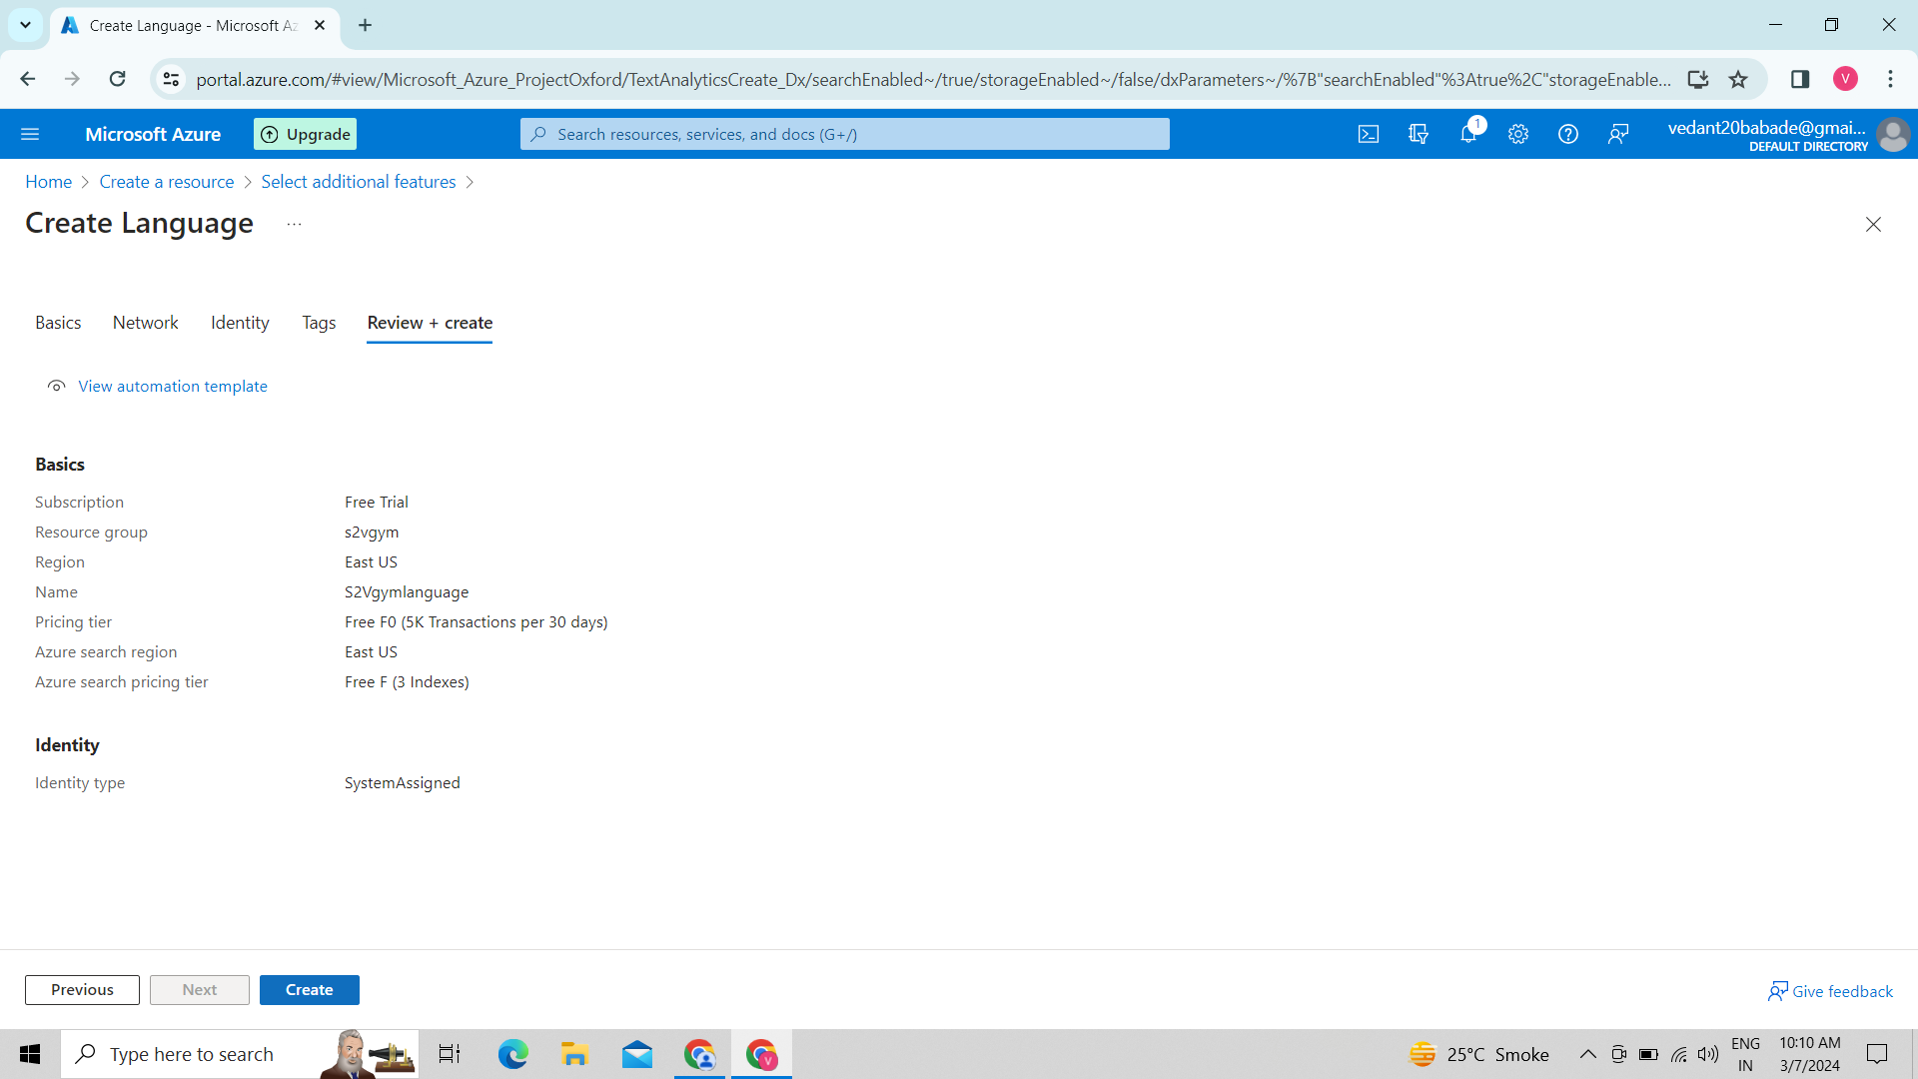

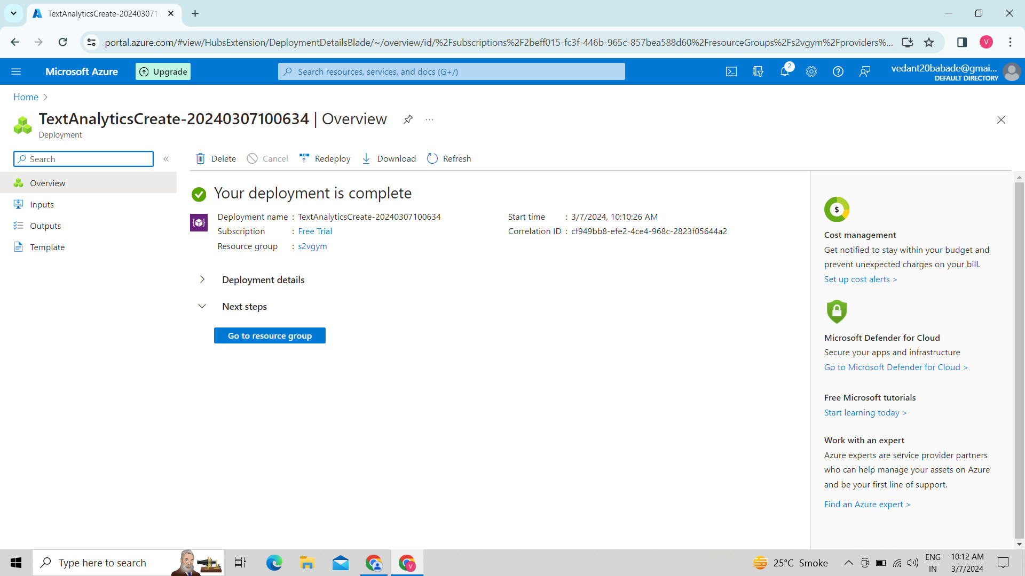

19. This is our language.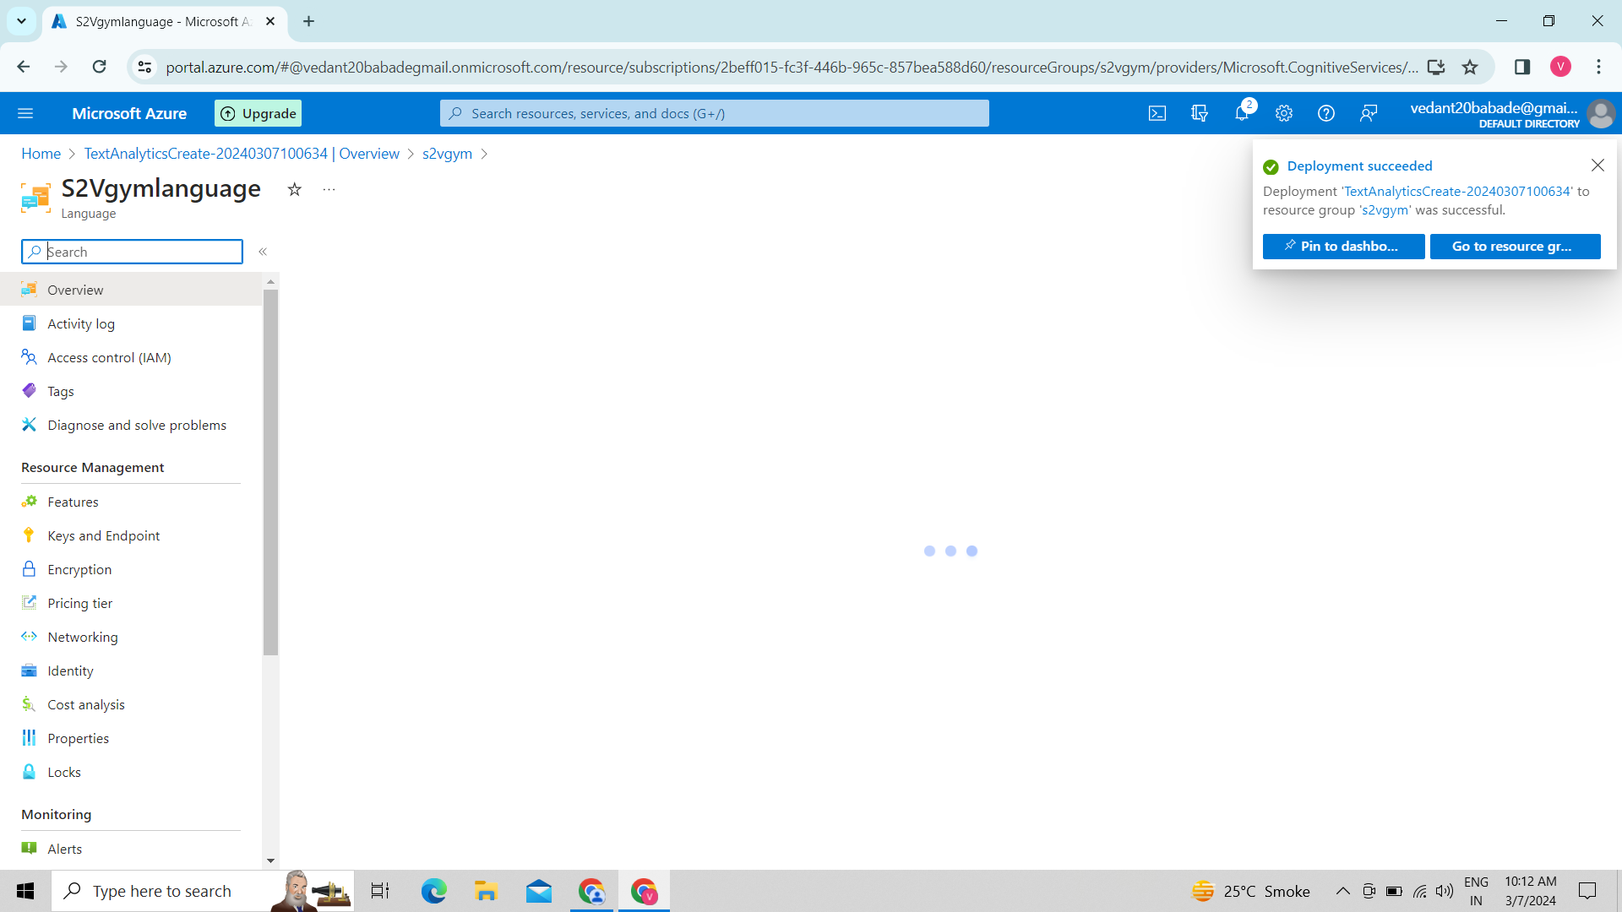

20. Here we created our language studio

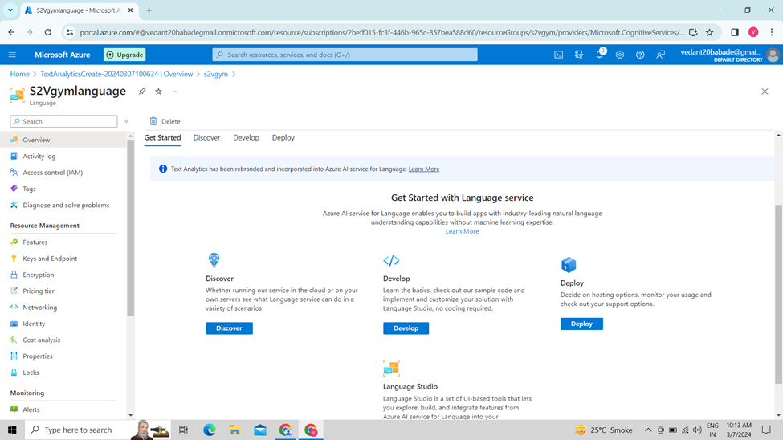

21. we signed in 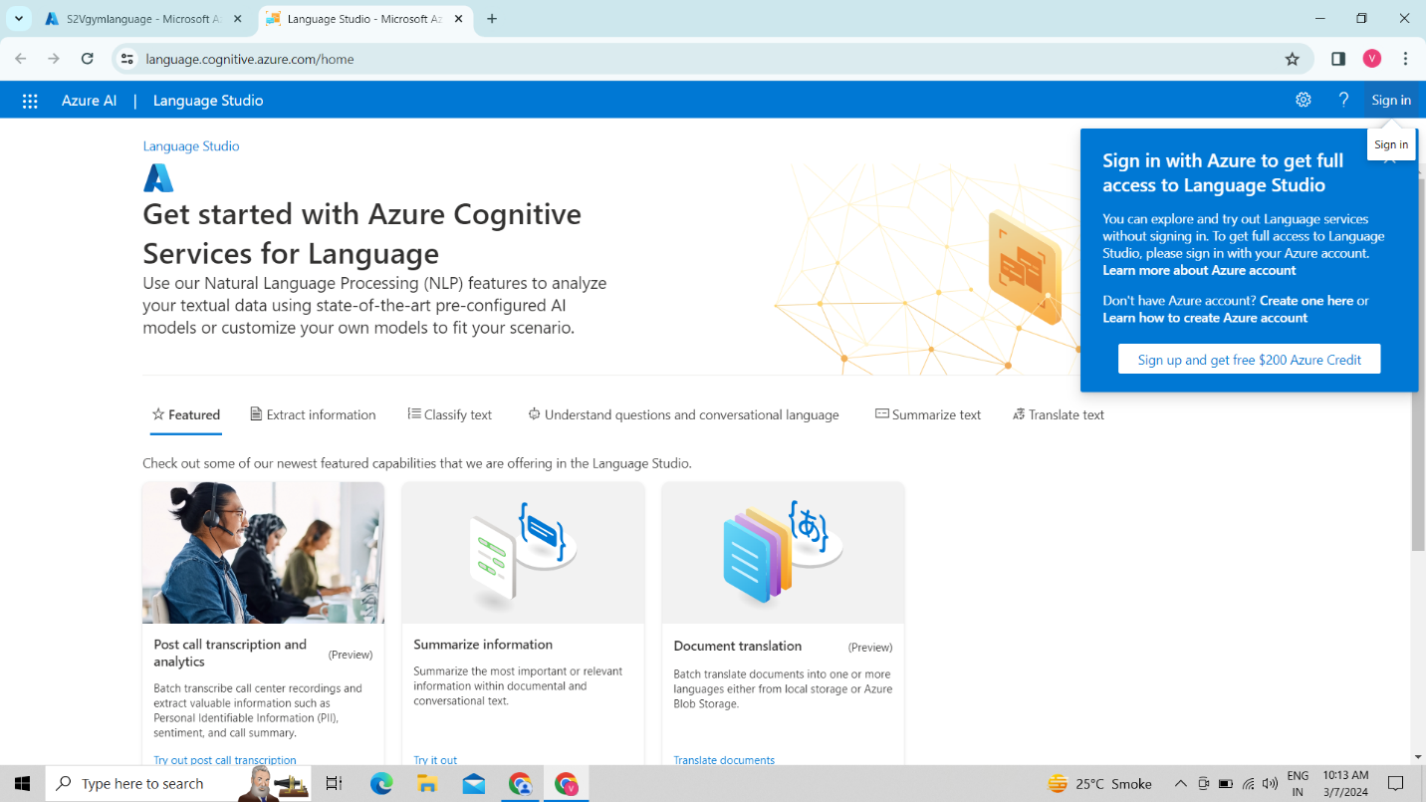

22. we created a new project.

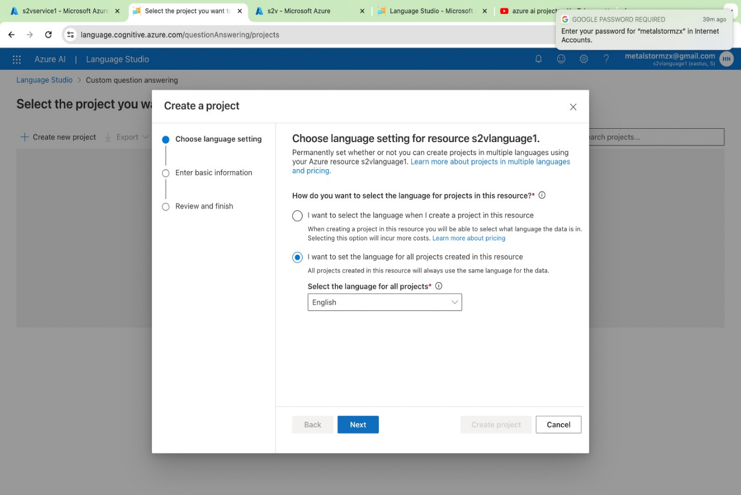

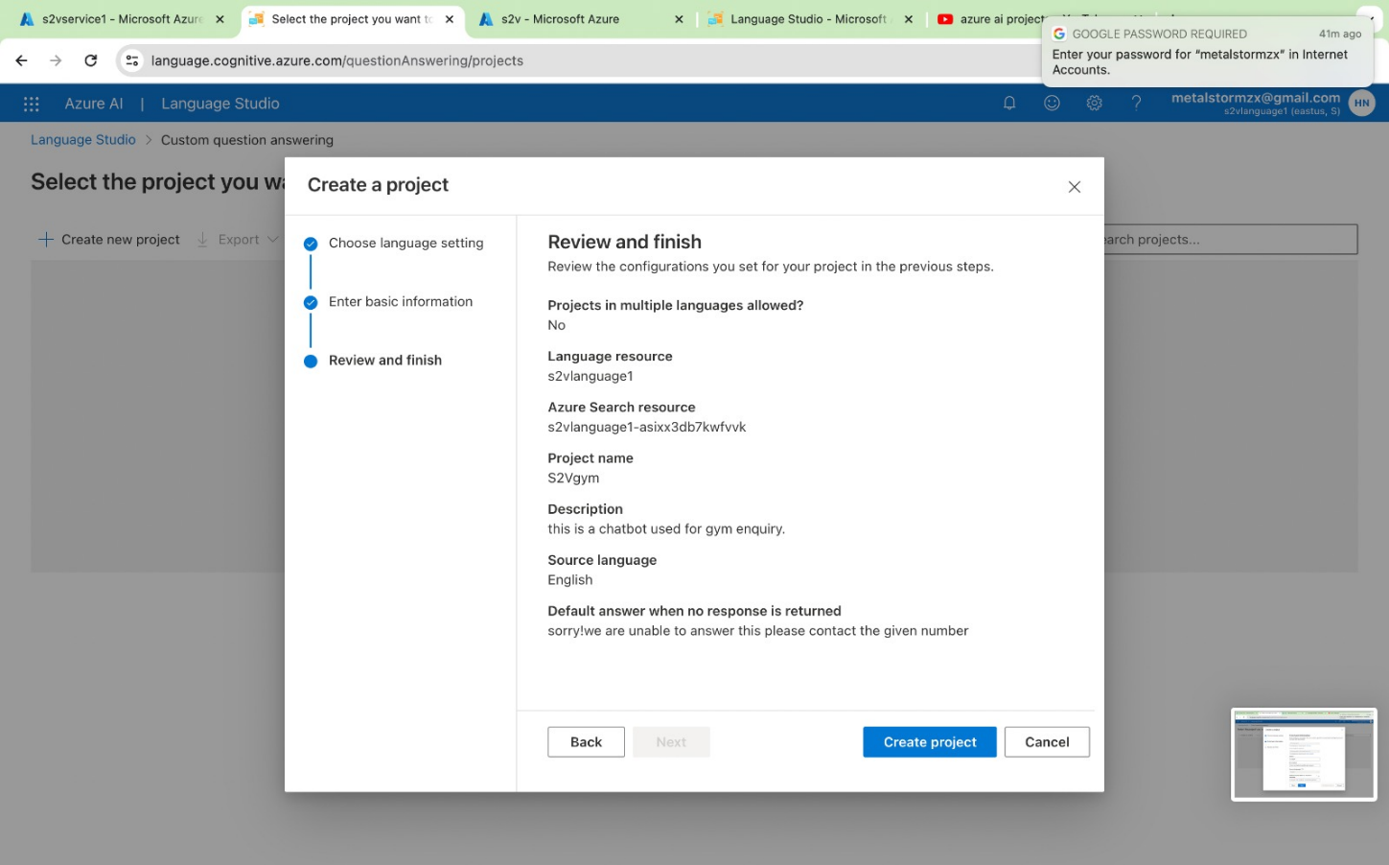

23. We can add file by clicking on manage source

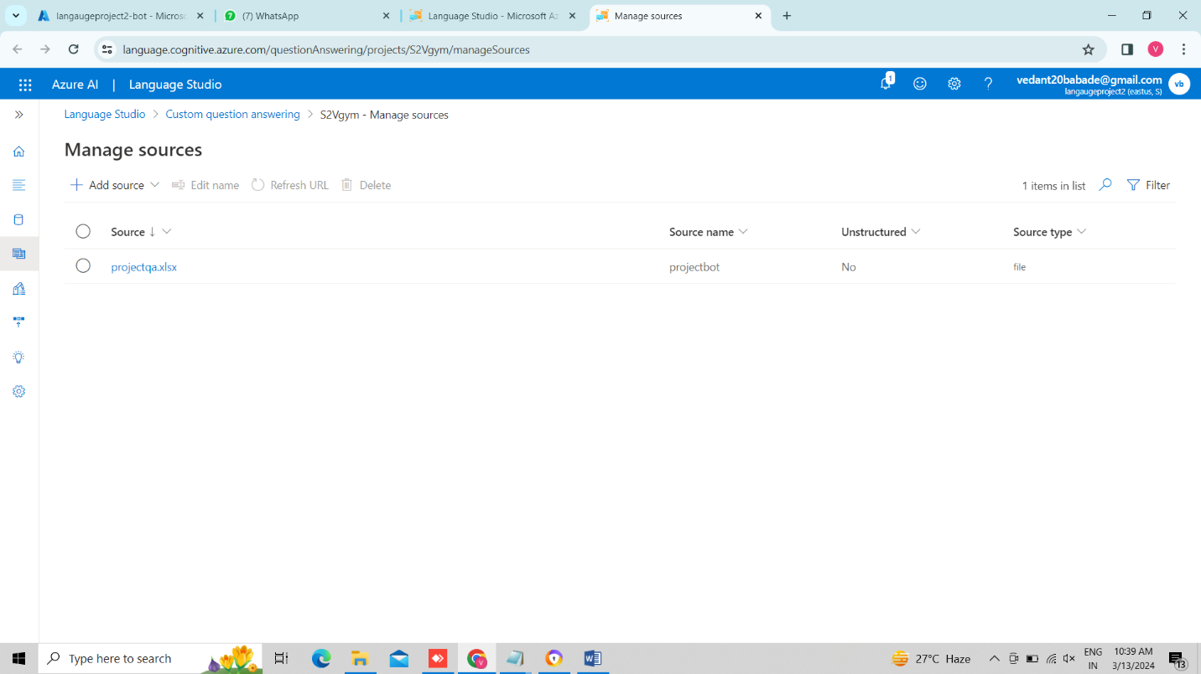

24. We have uploaded our knowledge base of bot.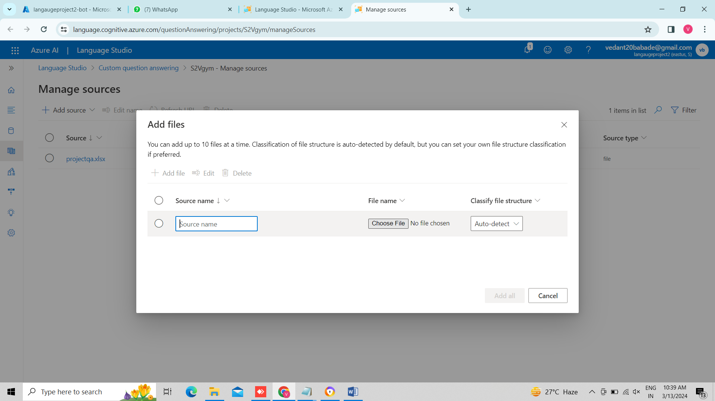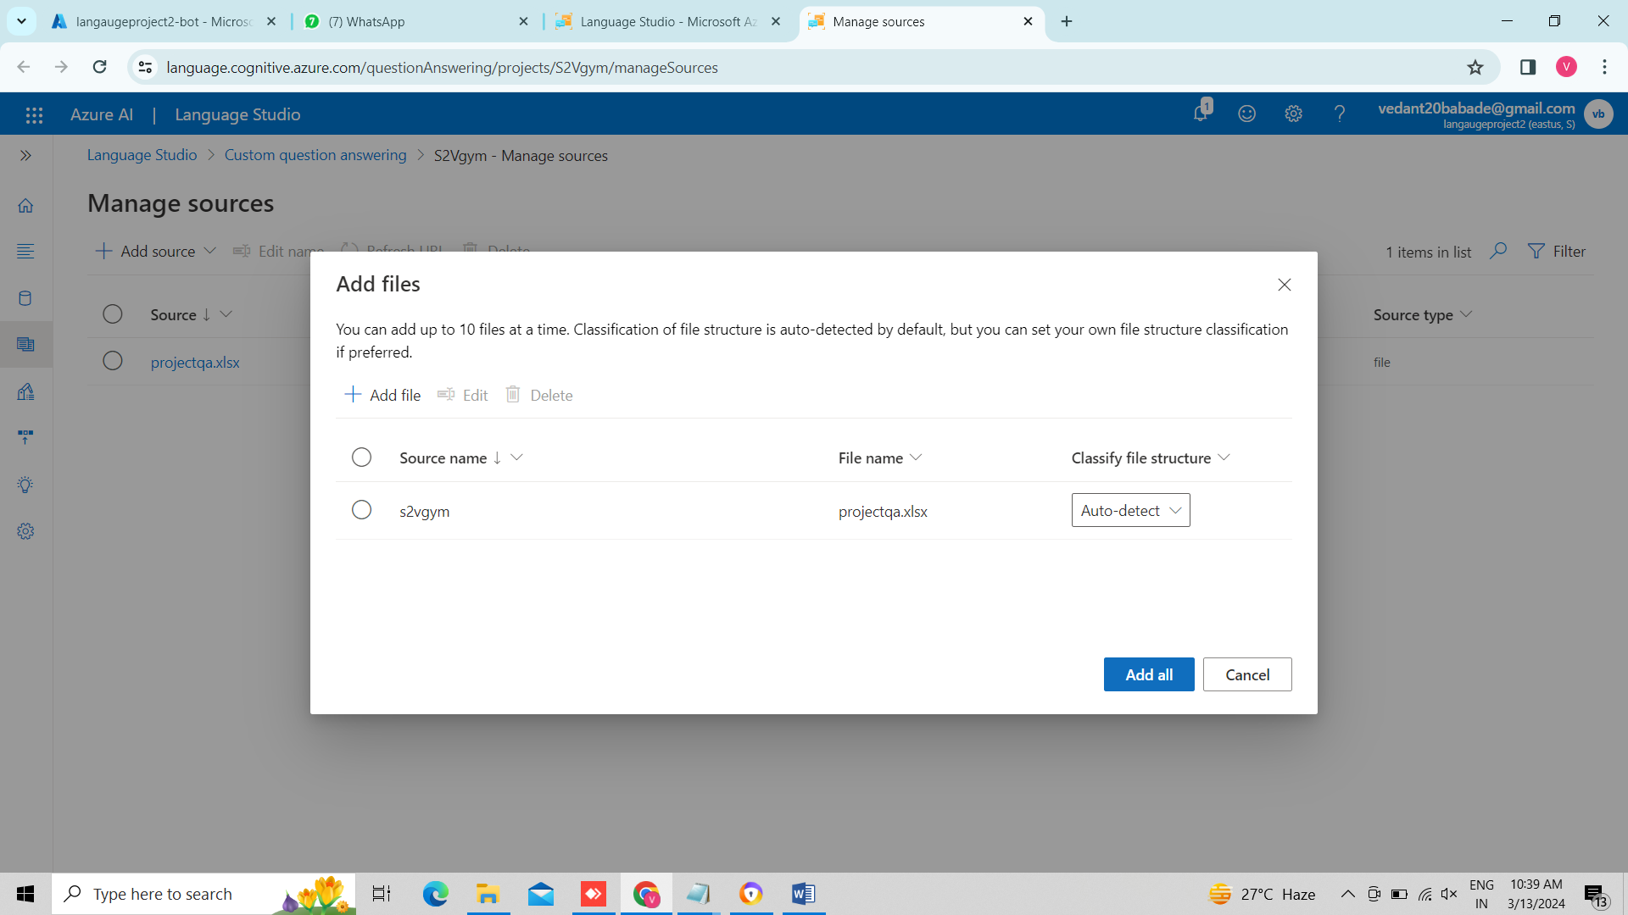

25. Here we edited our database

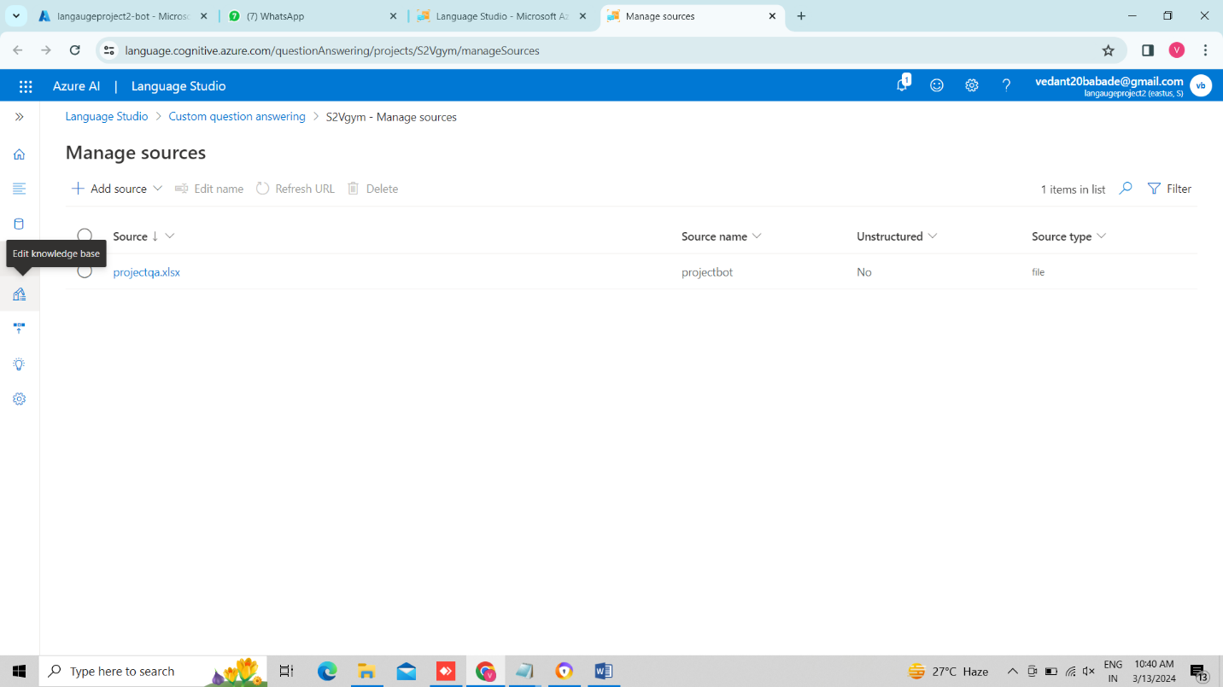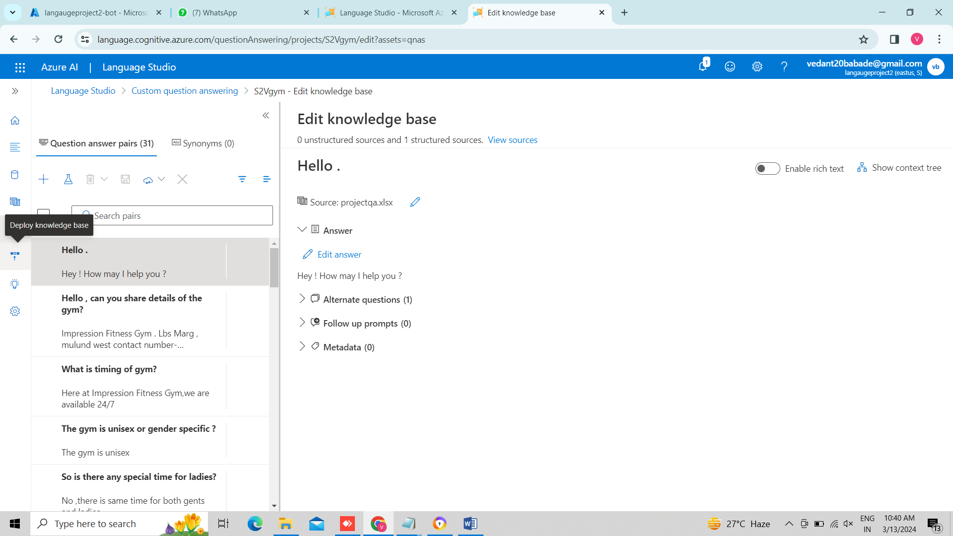

26. Here we deployed our knowledge base

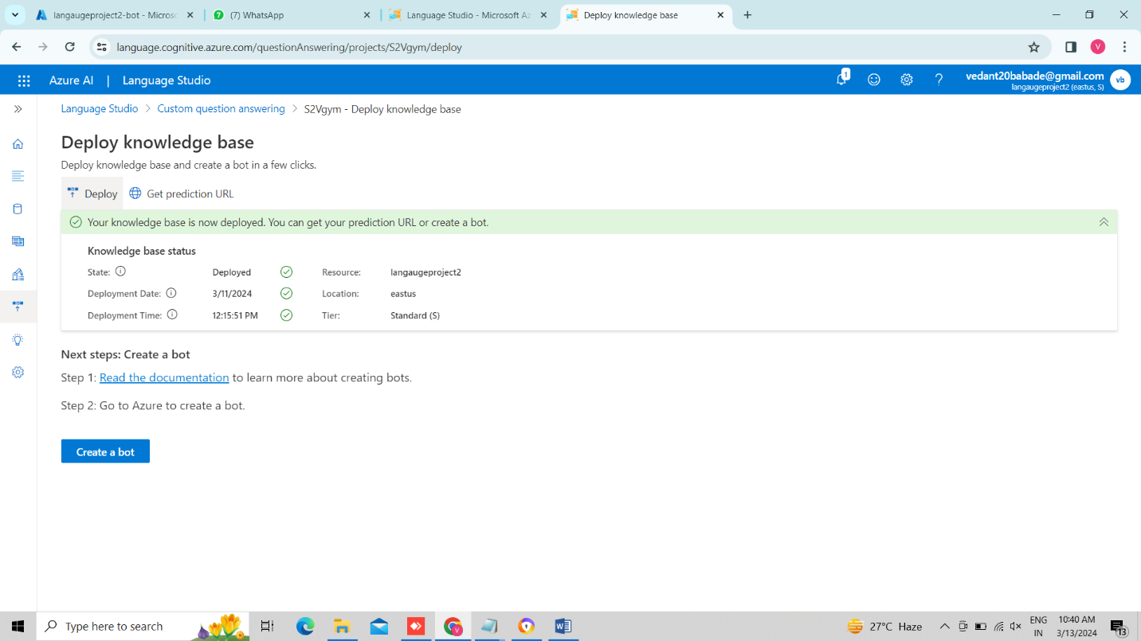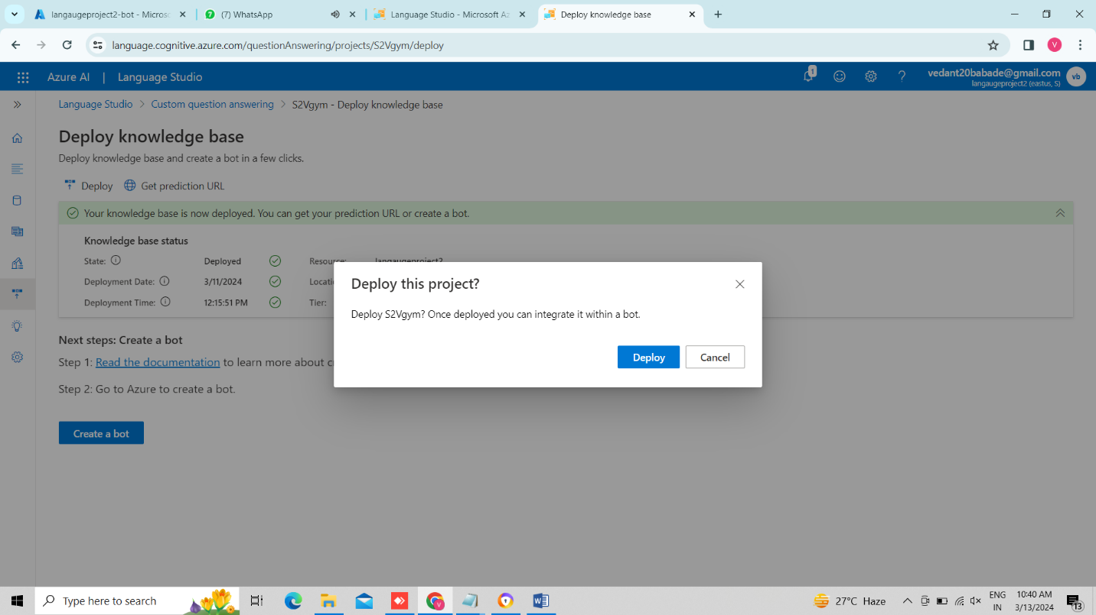

27. now we created our bot.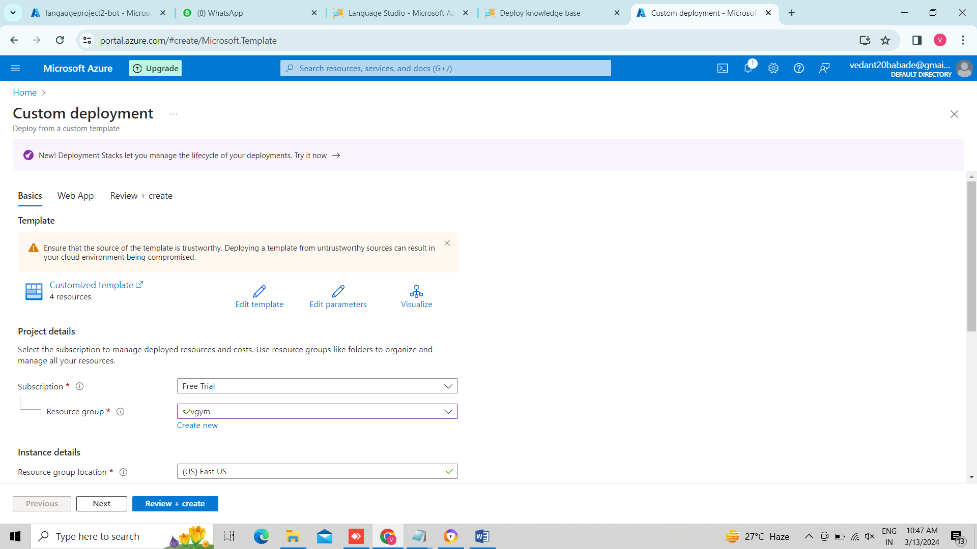

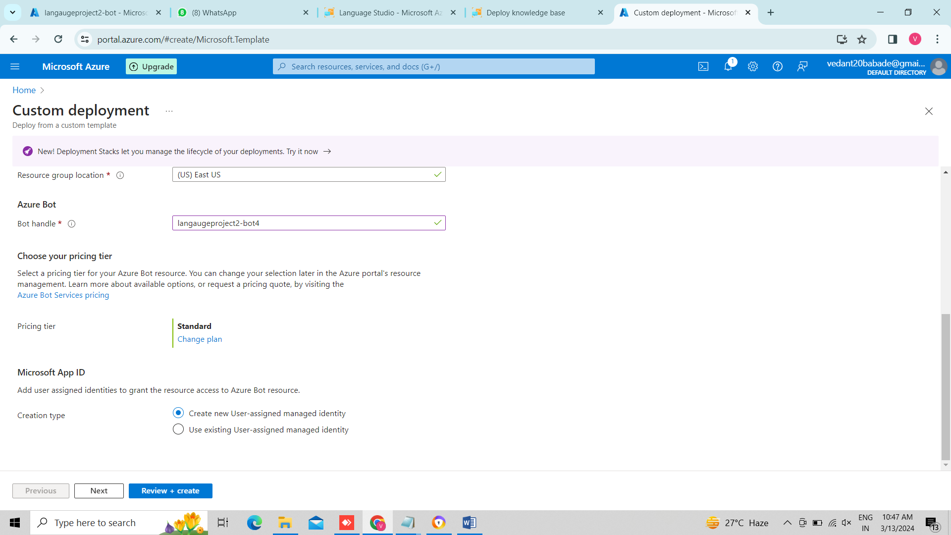

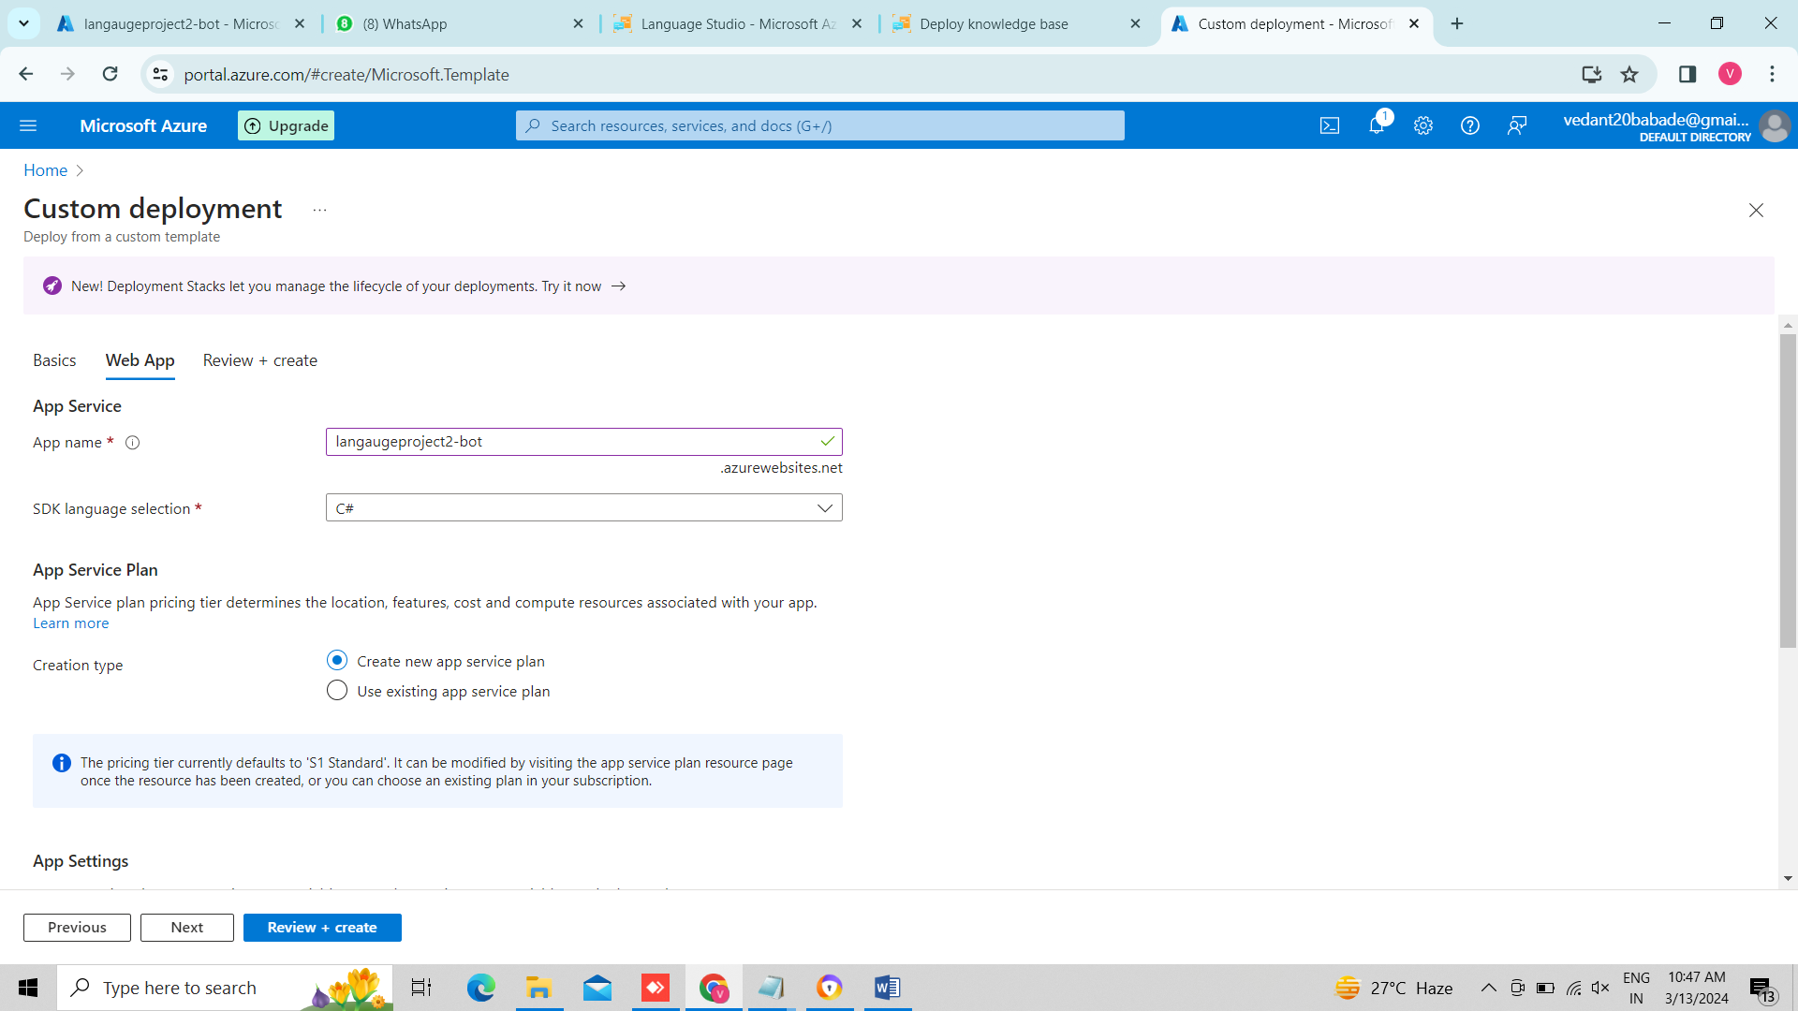

28. we selected 1st key pair from language service.

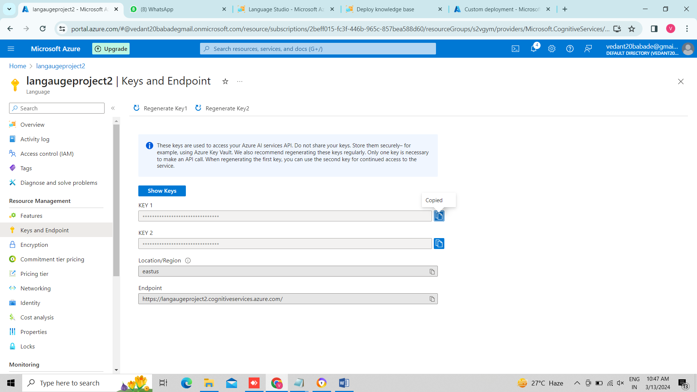

29. so here we created our bot

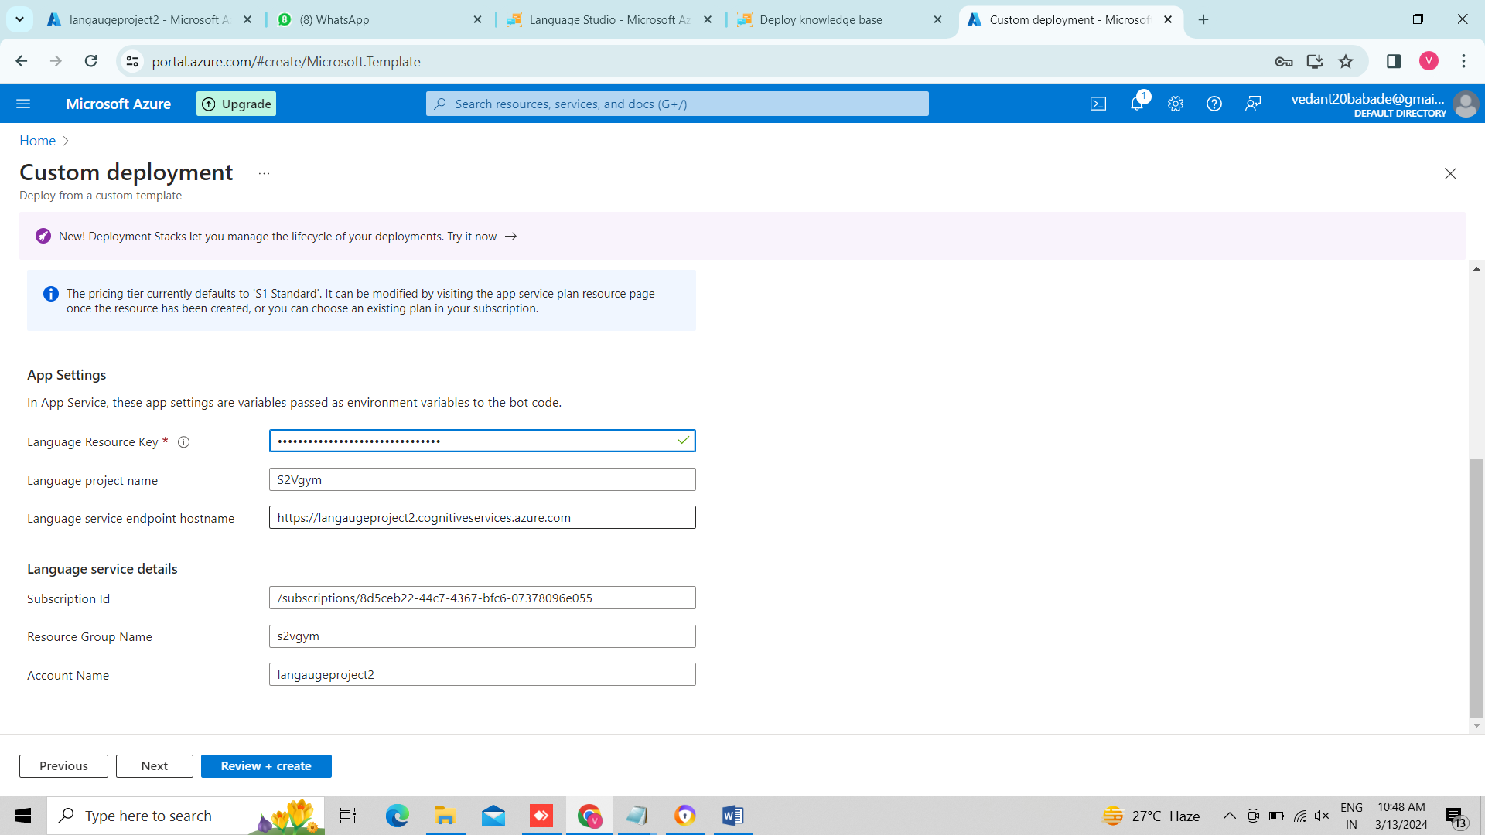

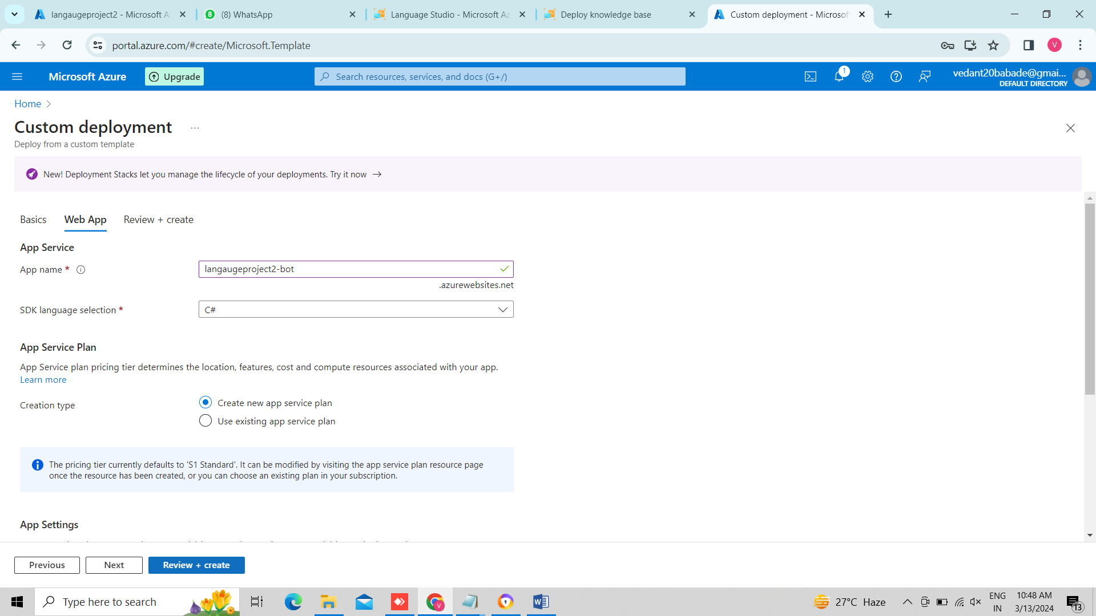

30. so this is our bot profile.

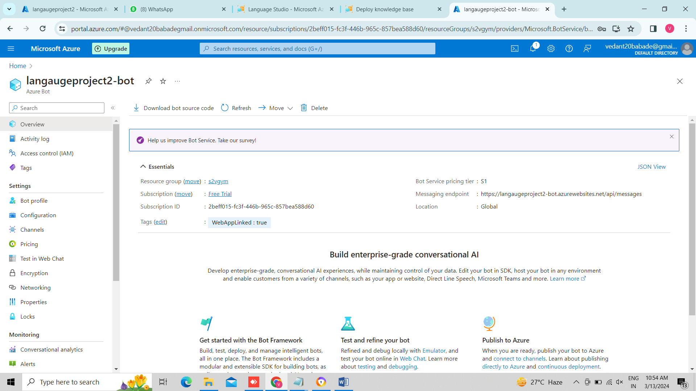

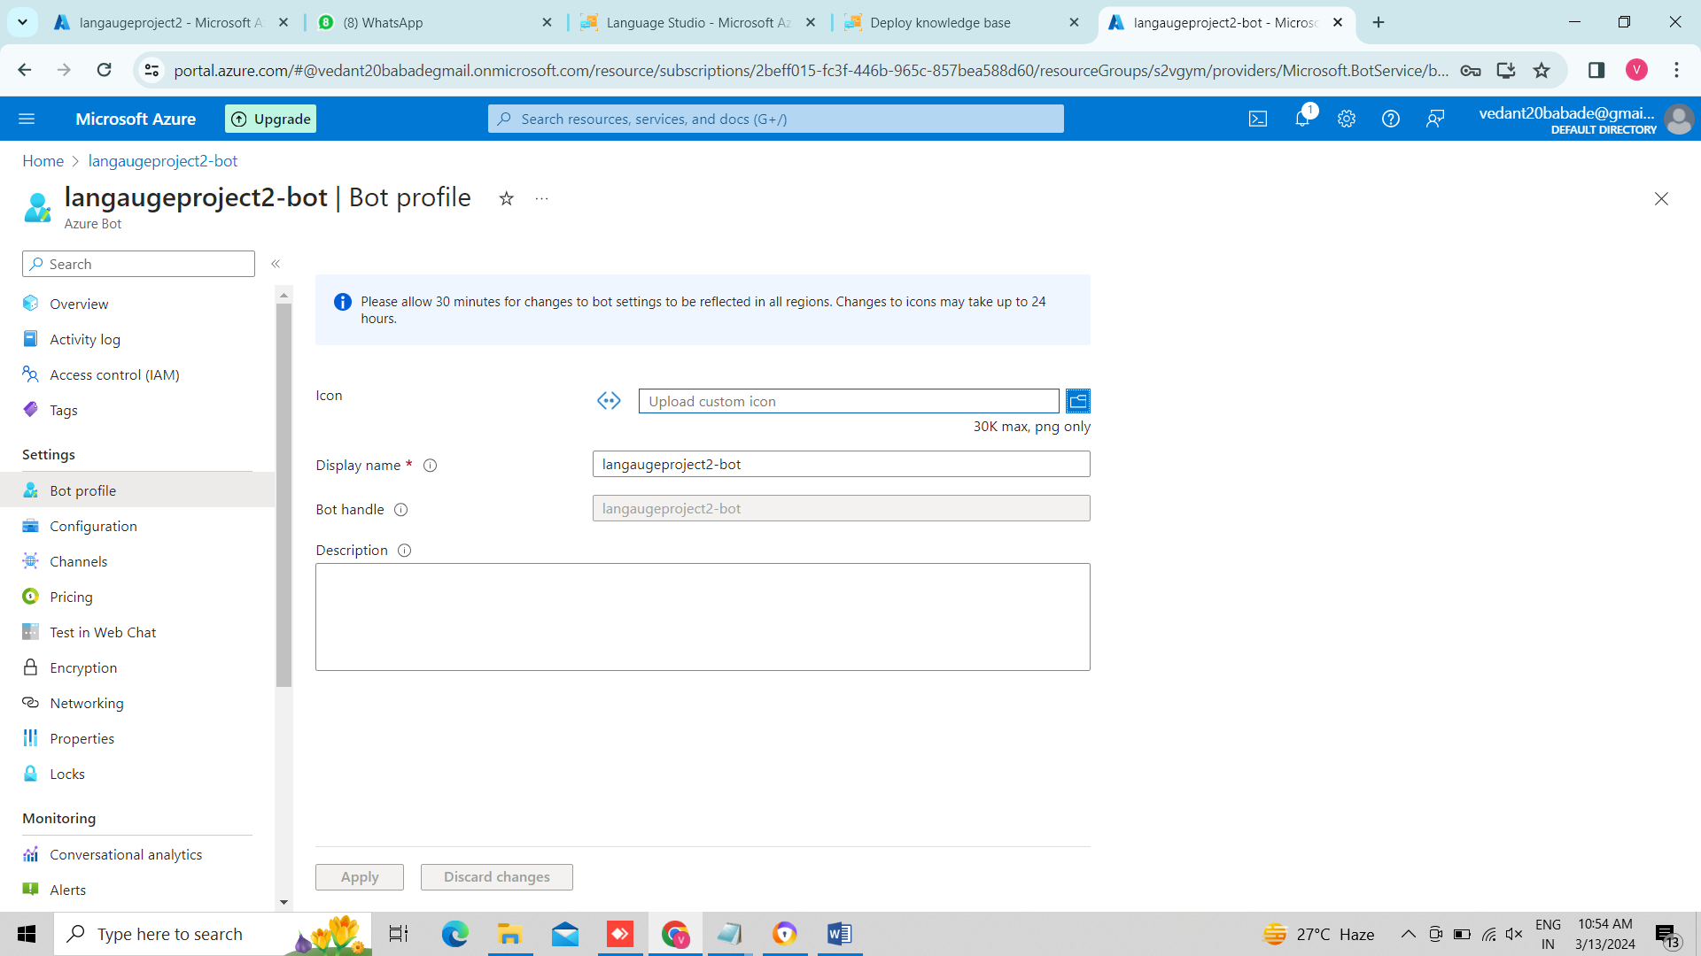

31. we can see our channels, whose status should be healthy to run the bot.

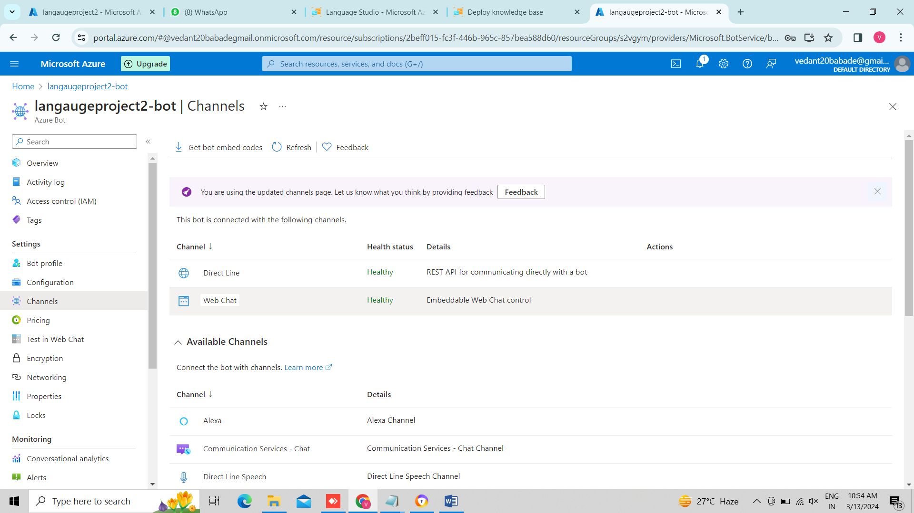

32. We hosted our bot on web browser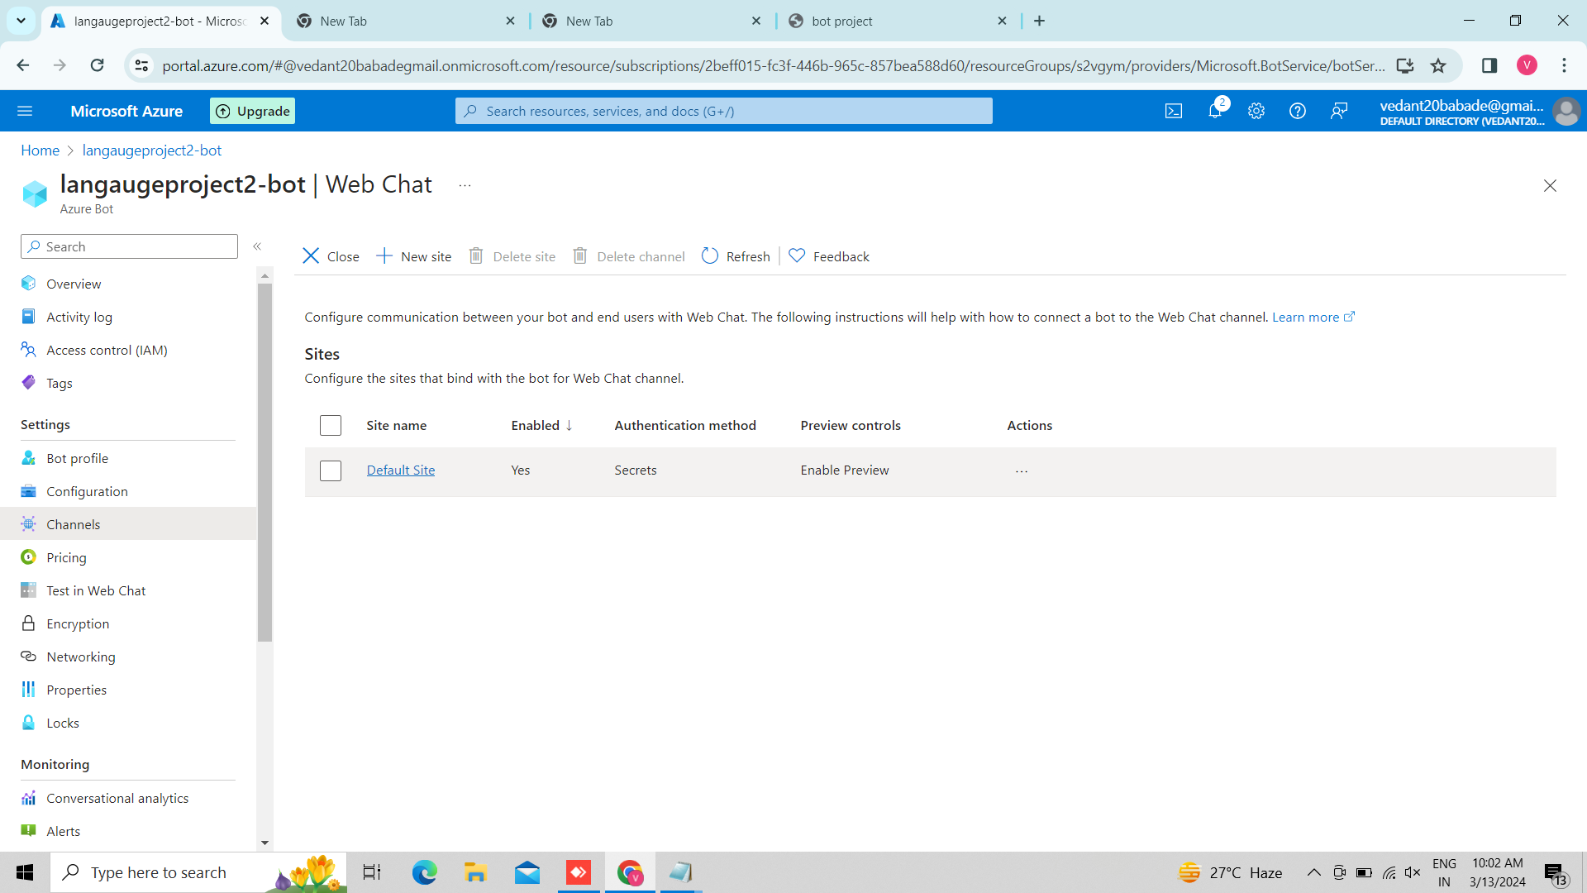

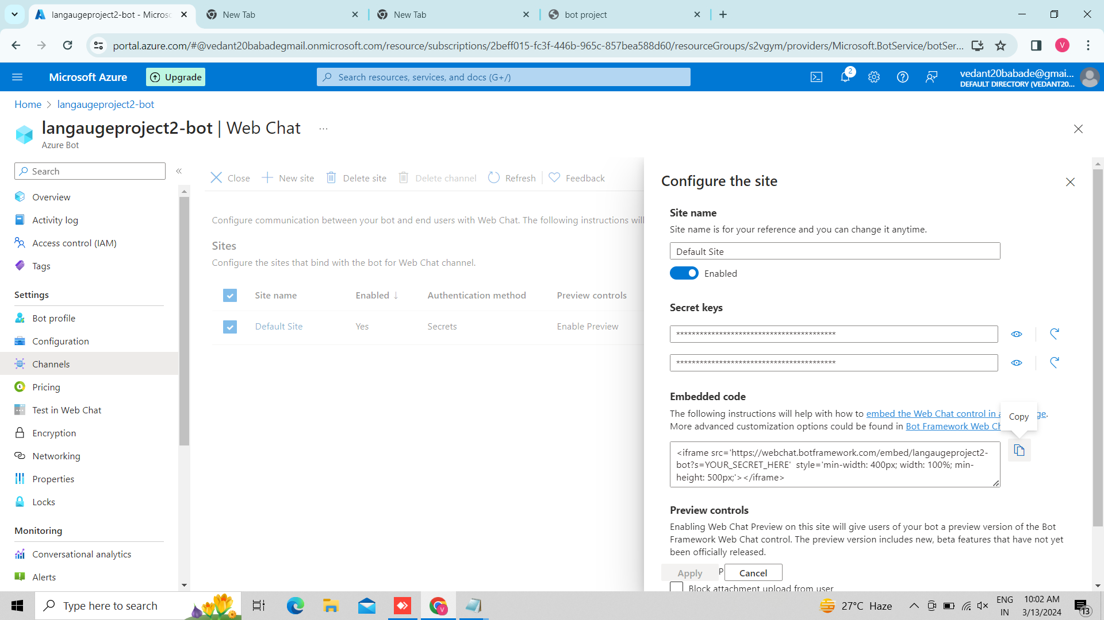

33.we copied and paste secret key in notepad

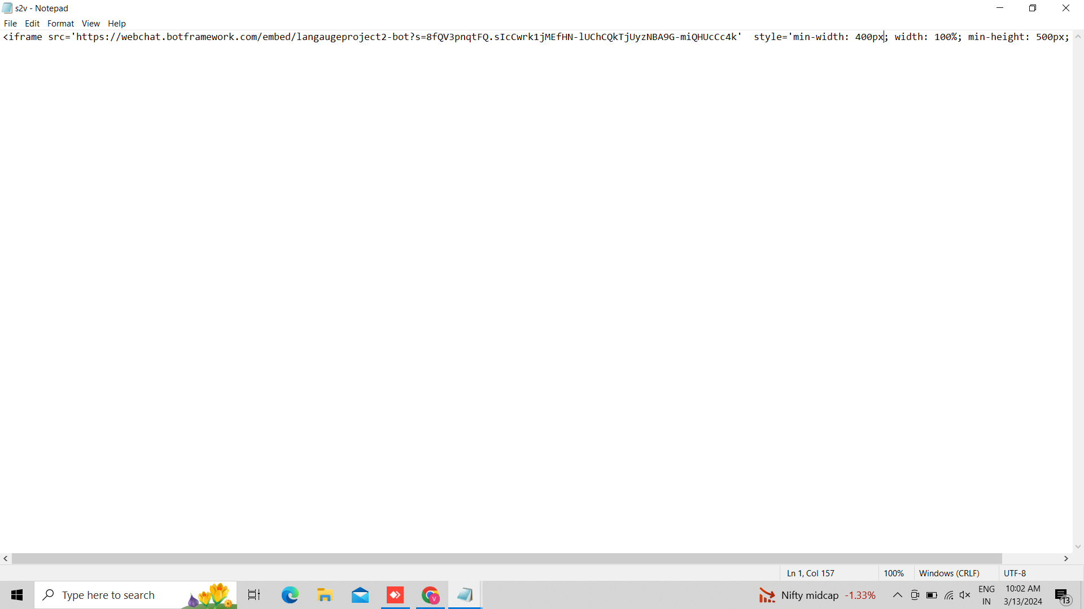

34. This is out HTML file.

35.Create a DNS page:-

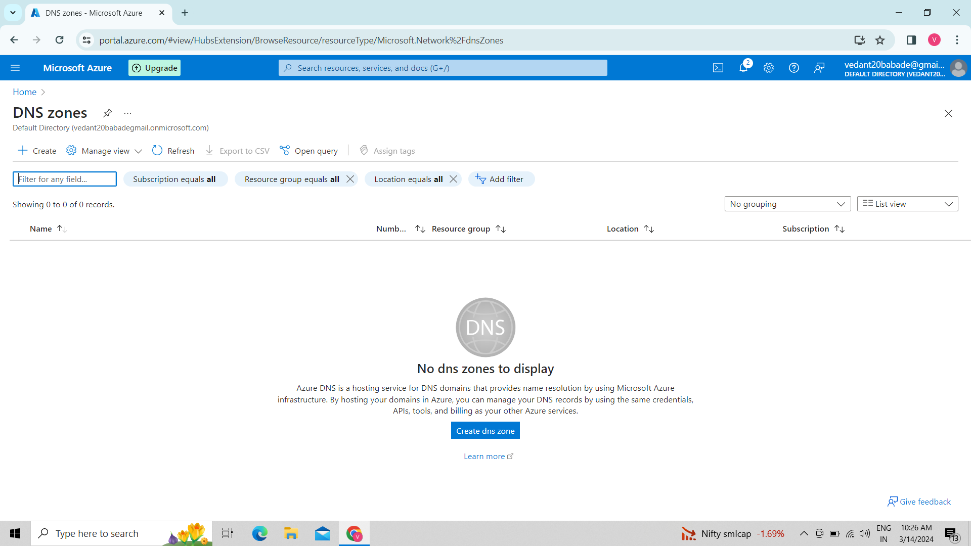

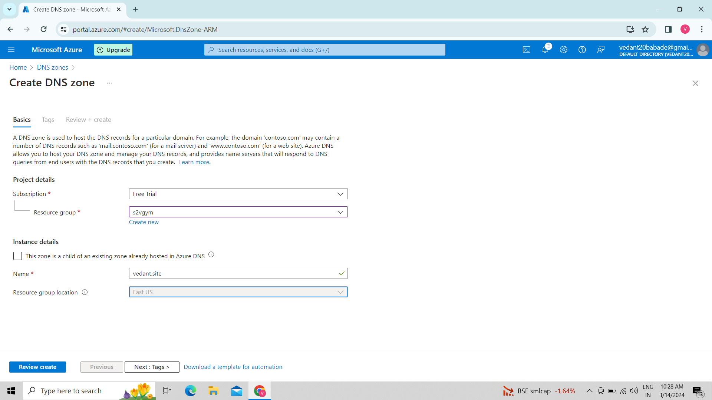

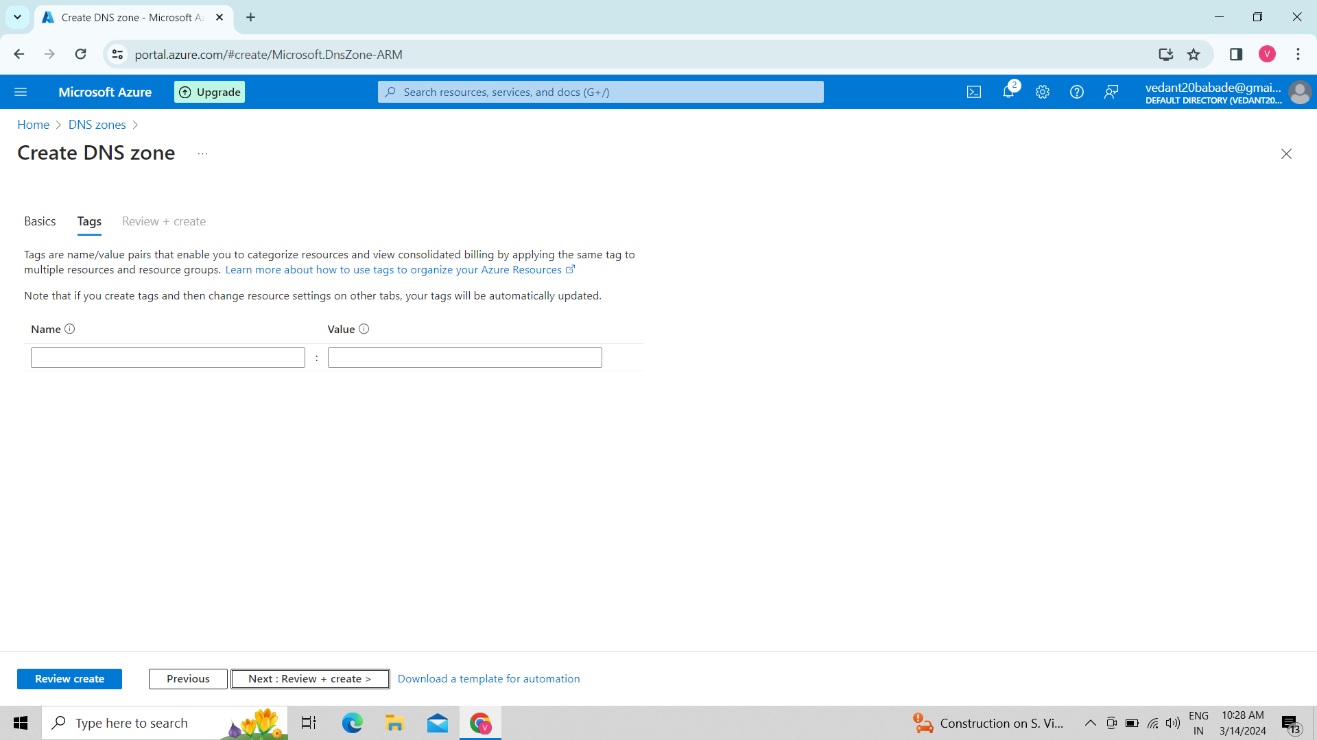

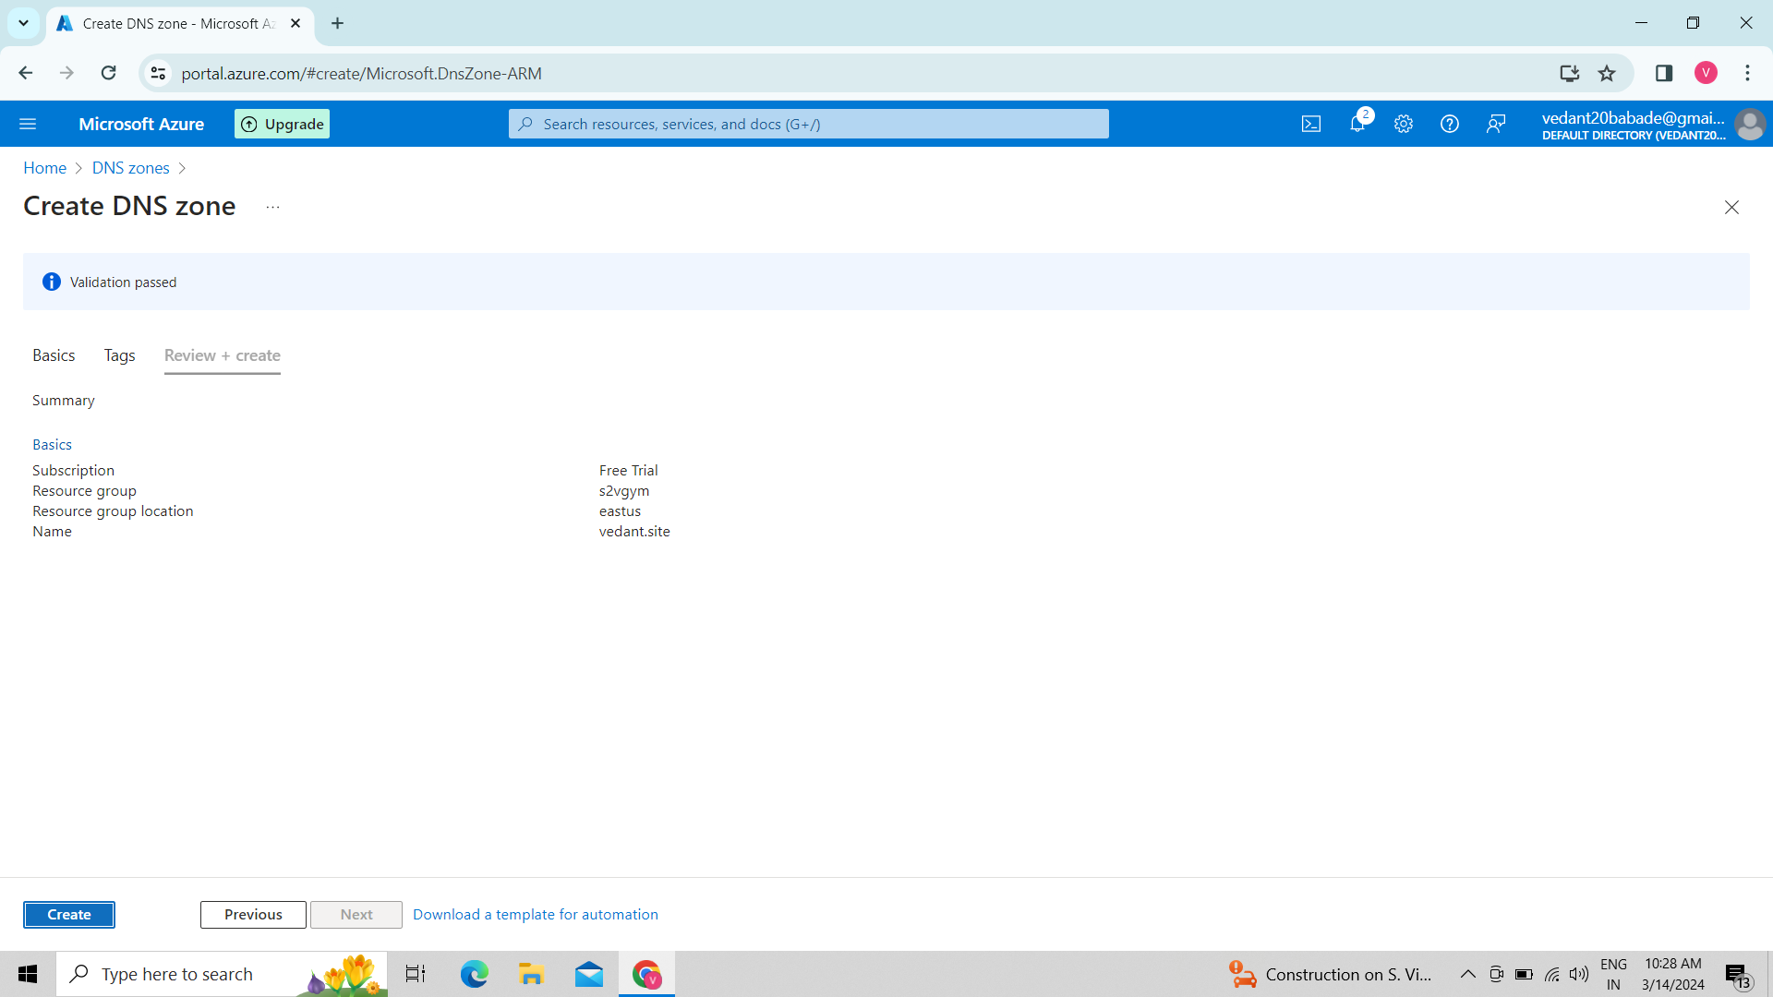

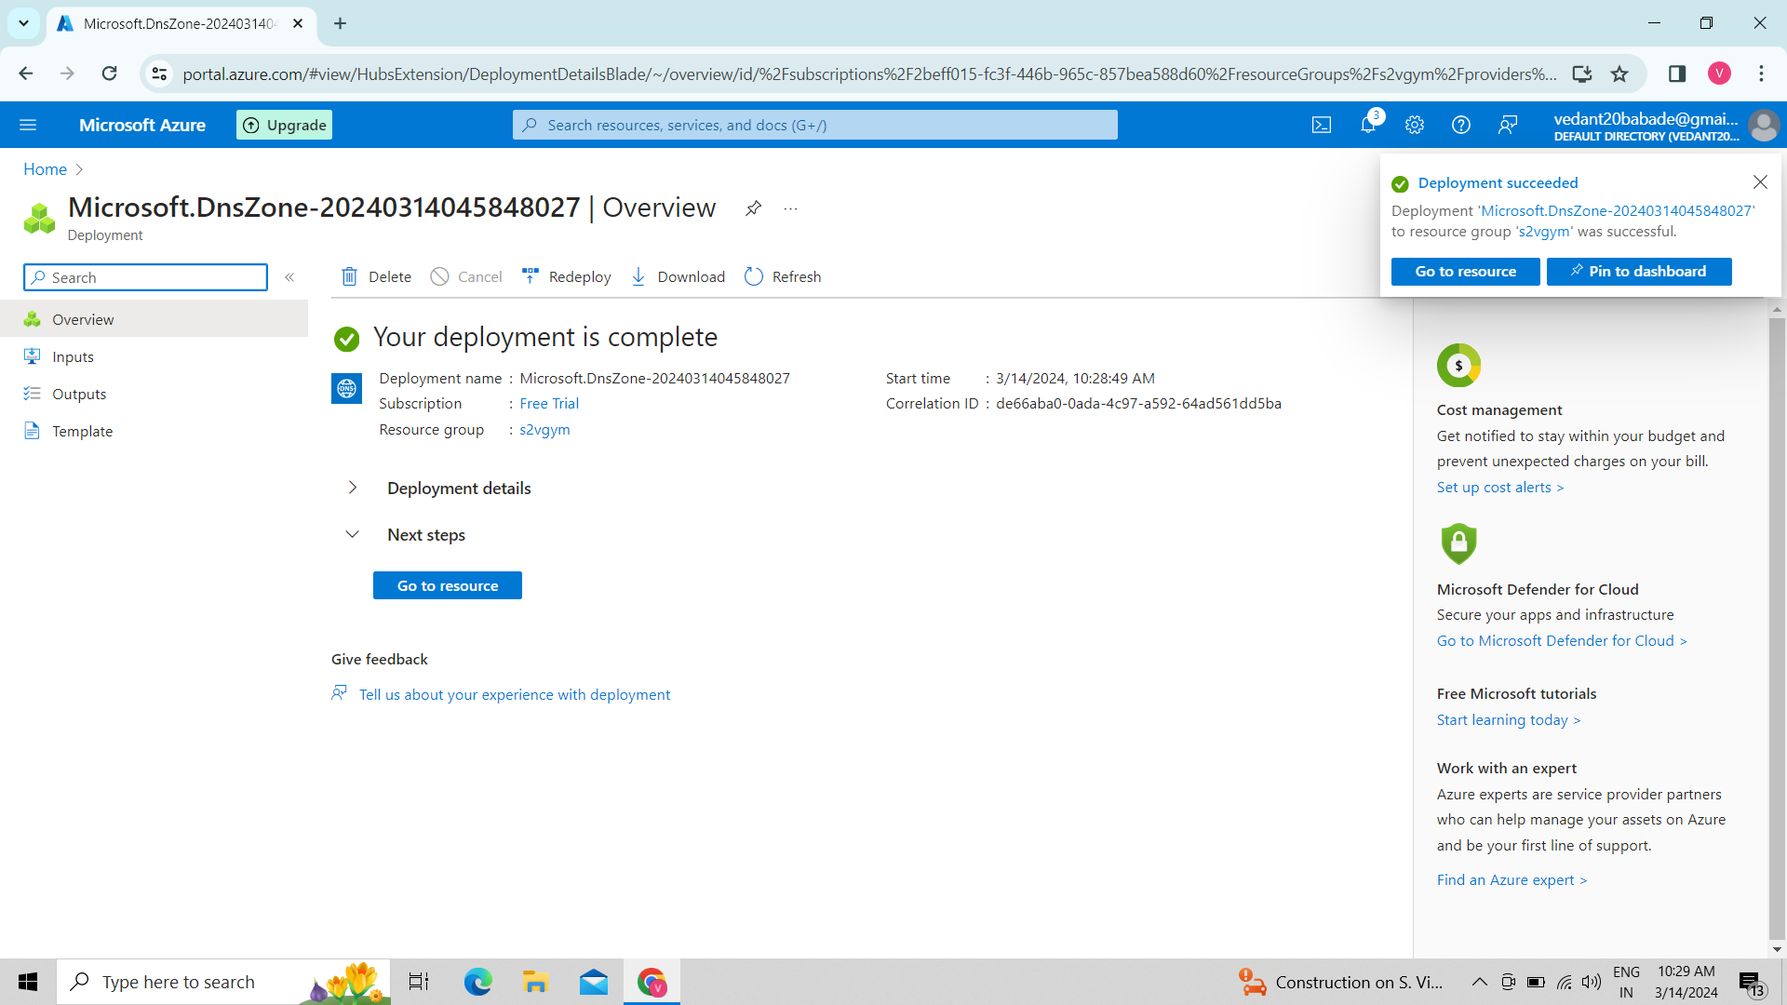

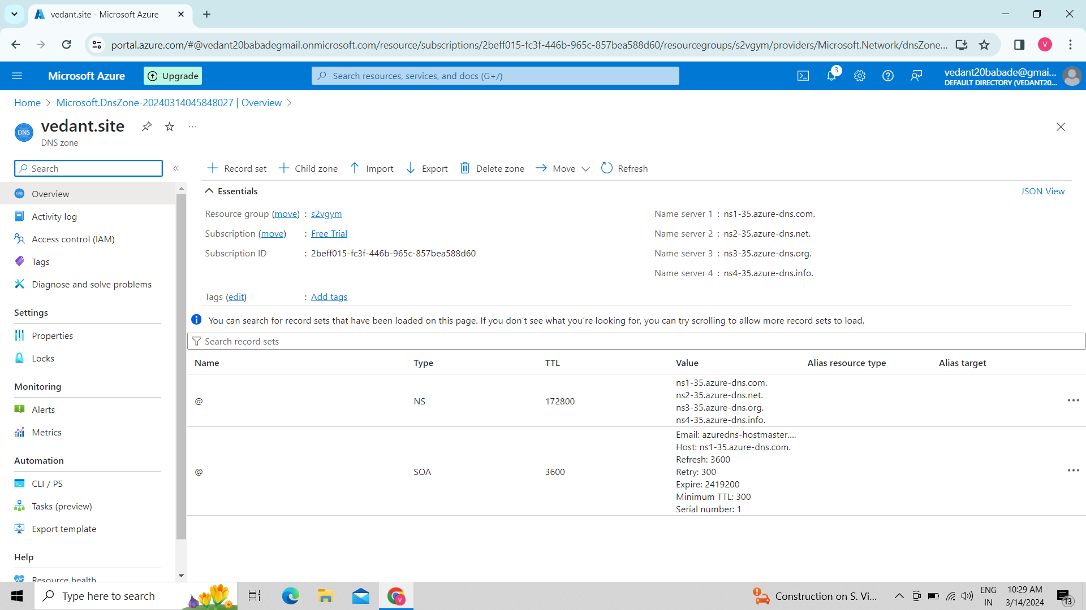

36.Record set:

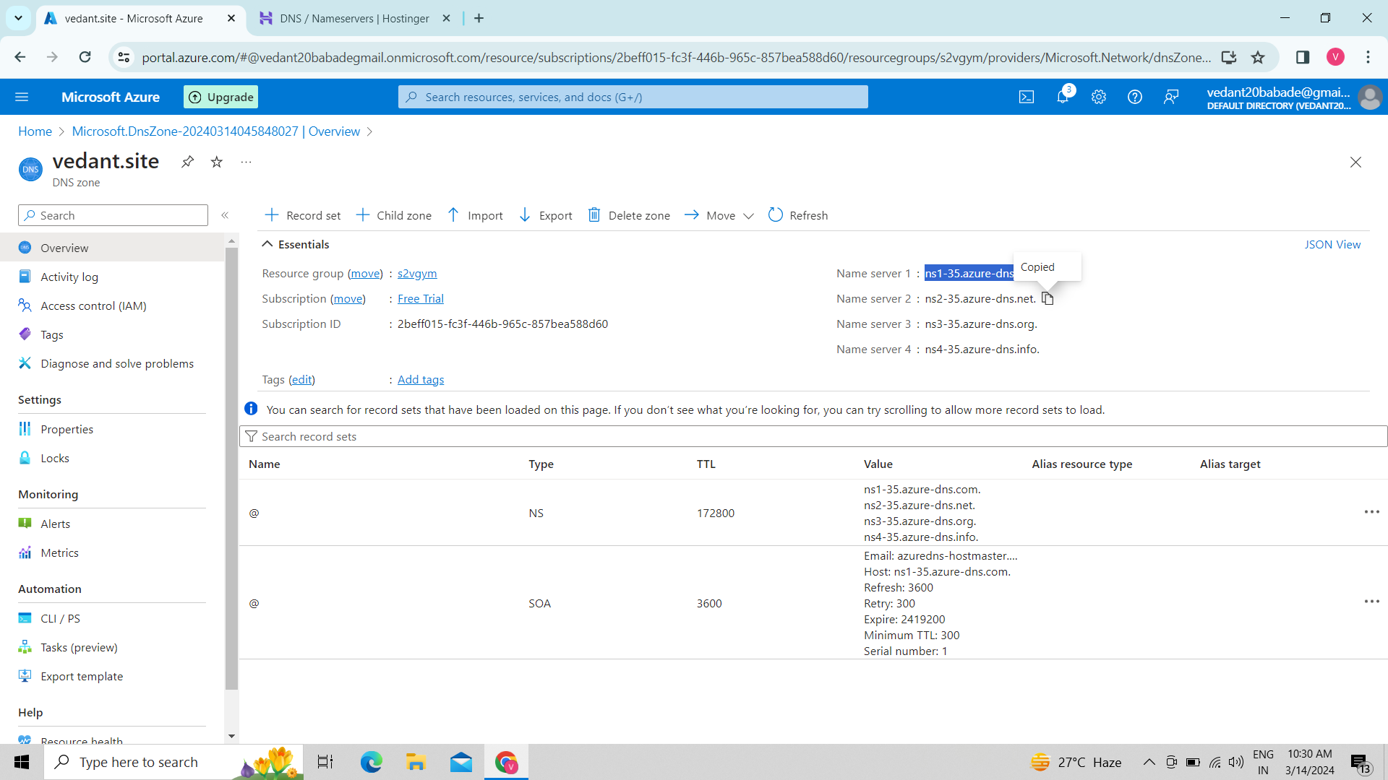

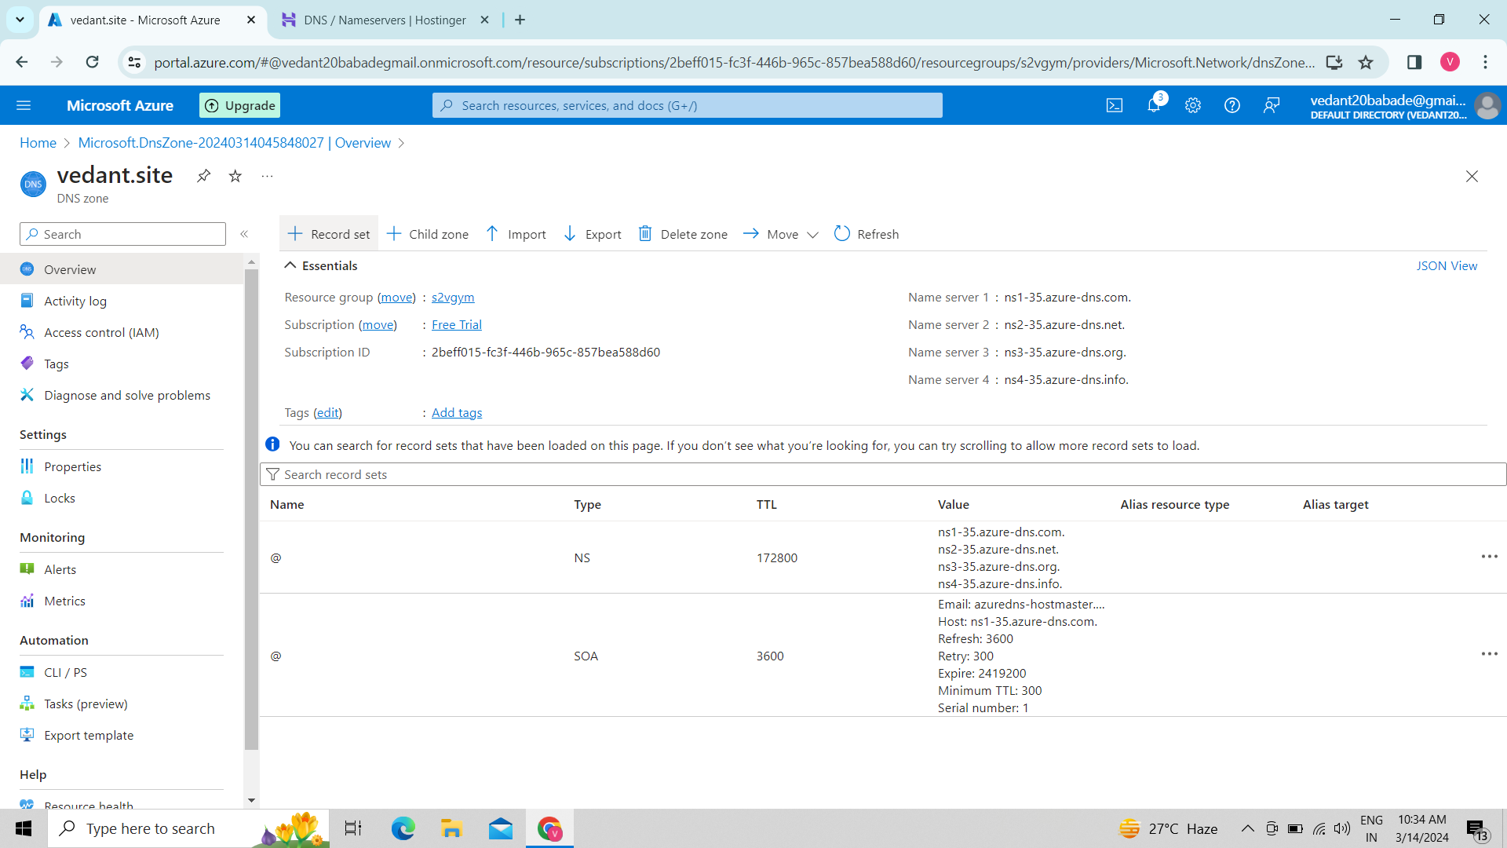

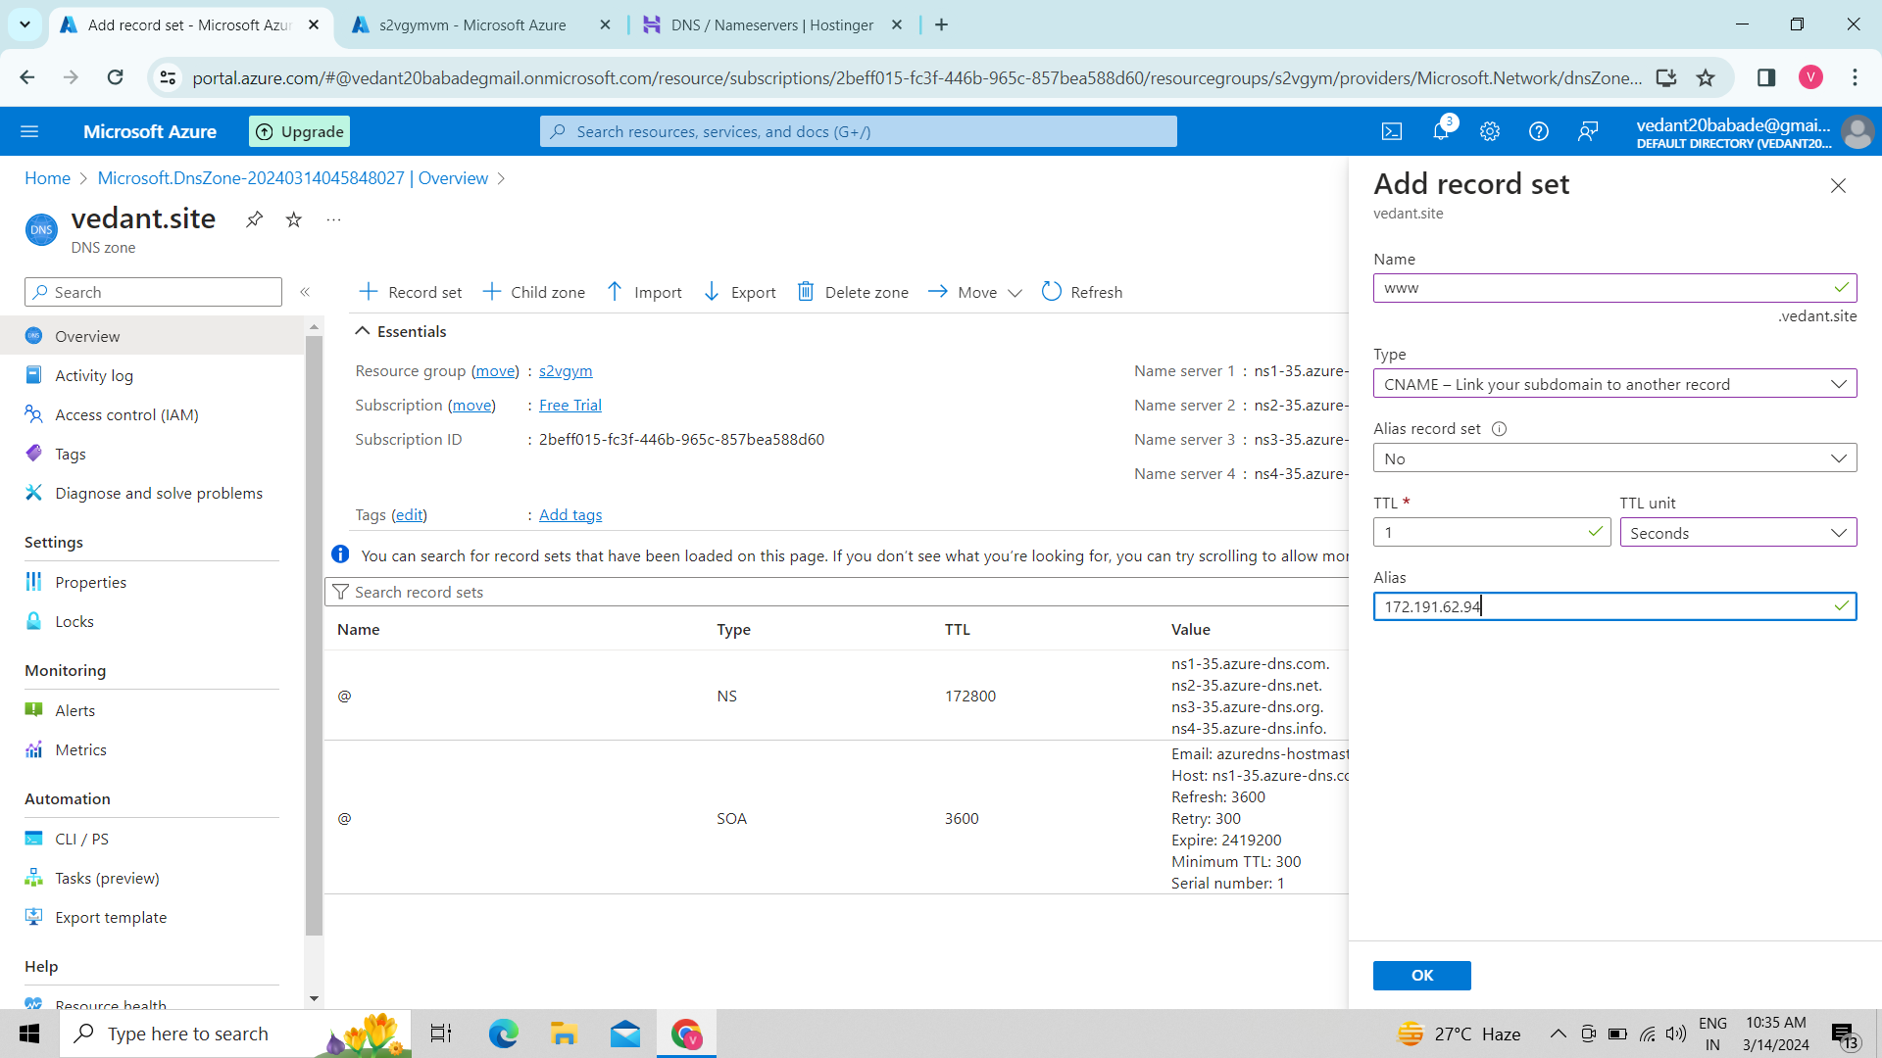

37.Change Domain name server:-

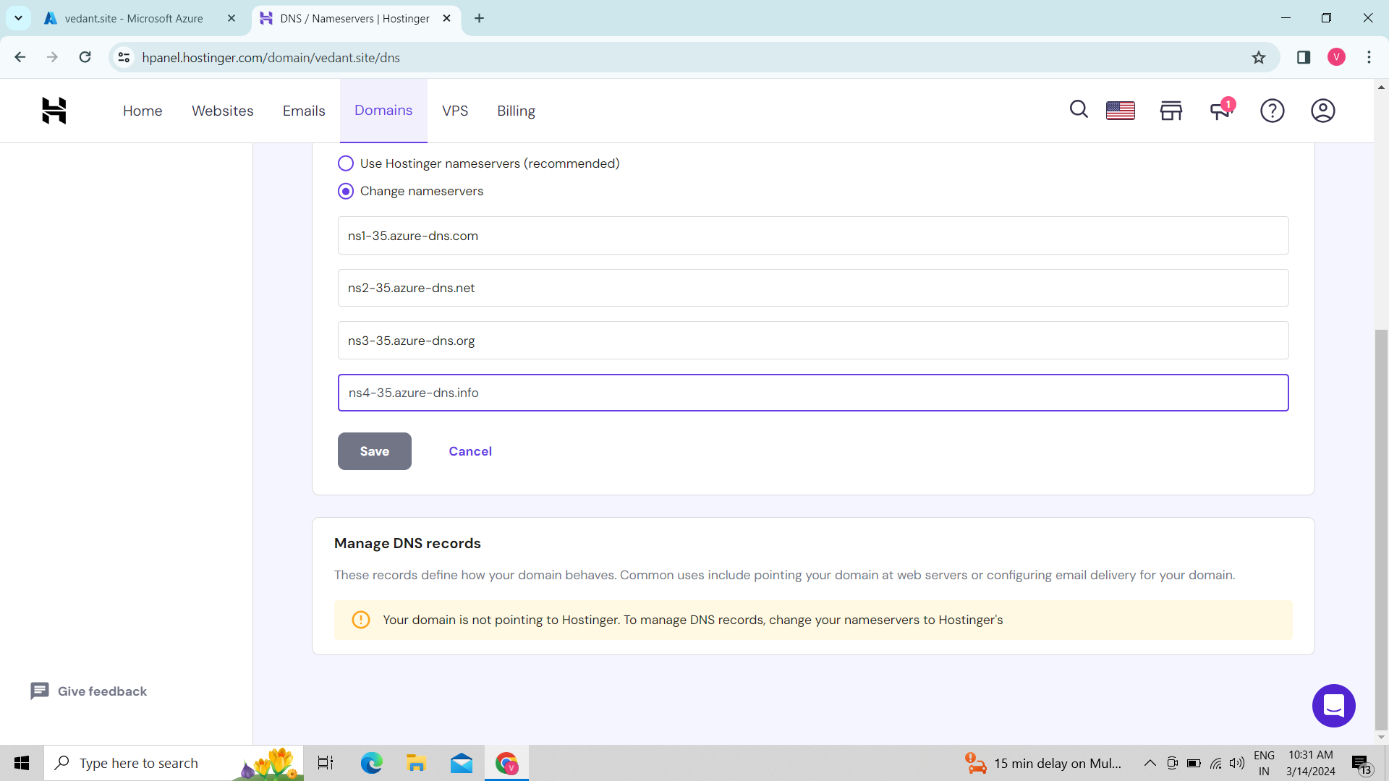

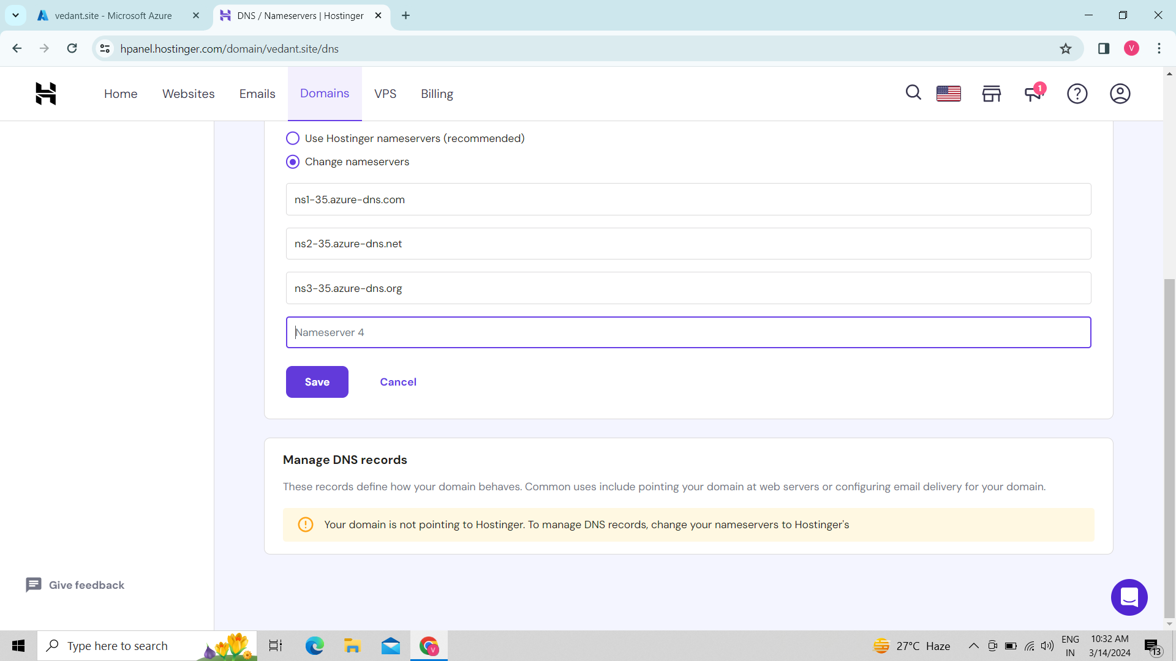

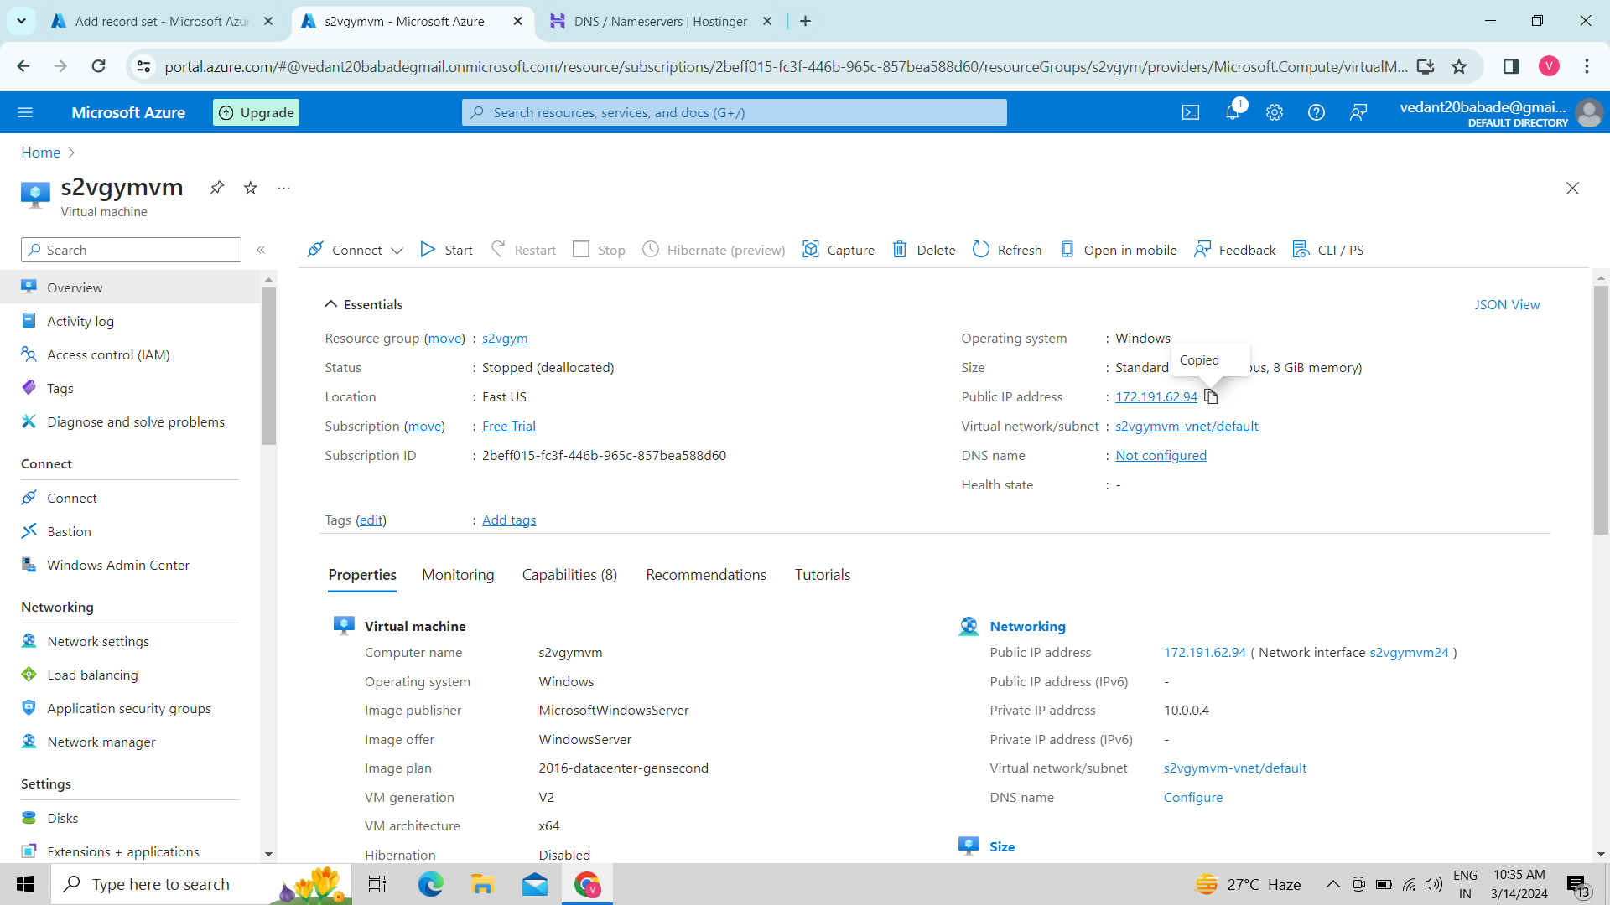

38.Create web app:-

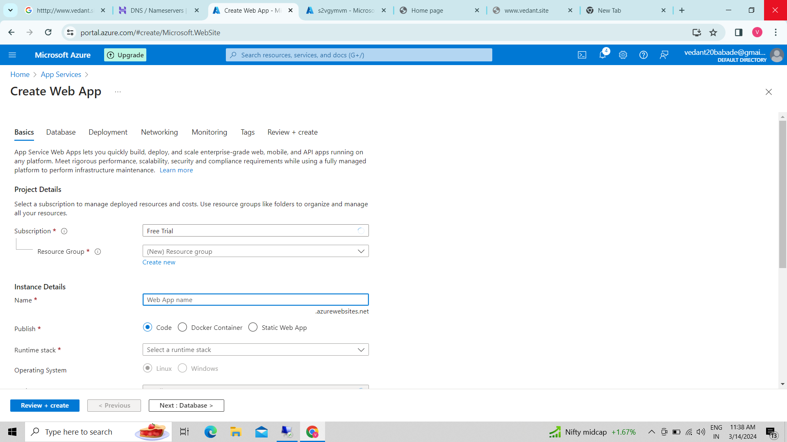

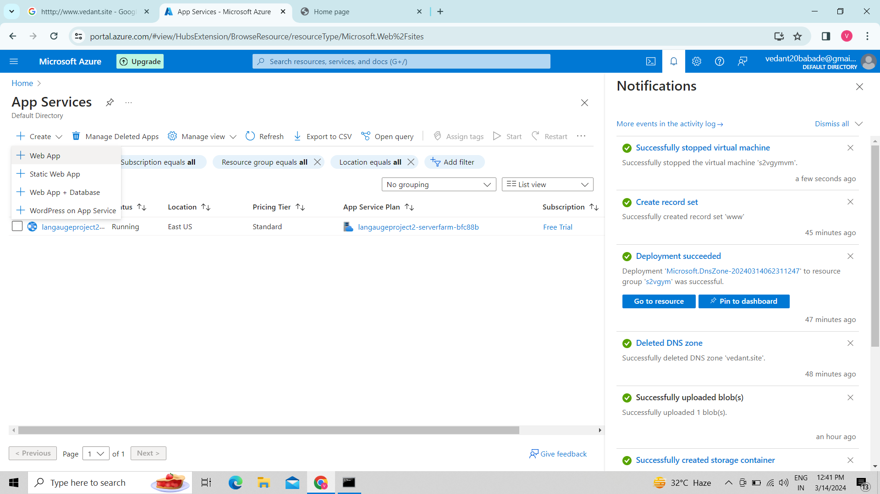

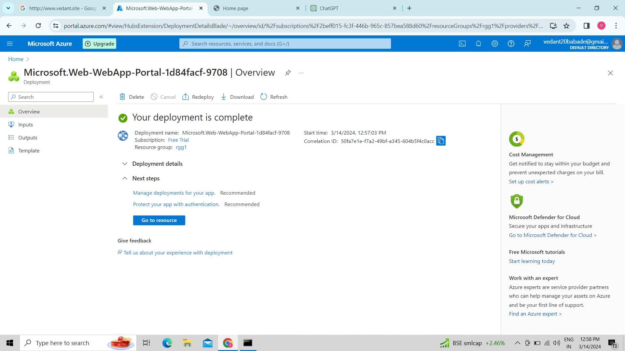

39.Create a custom domain:-

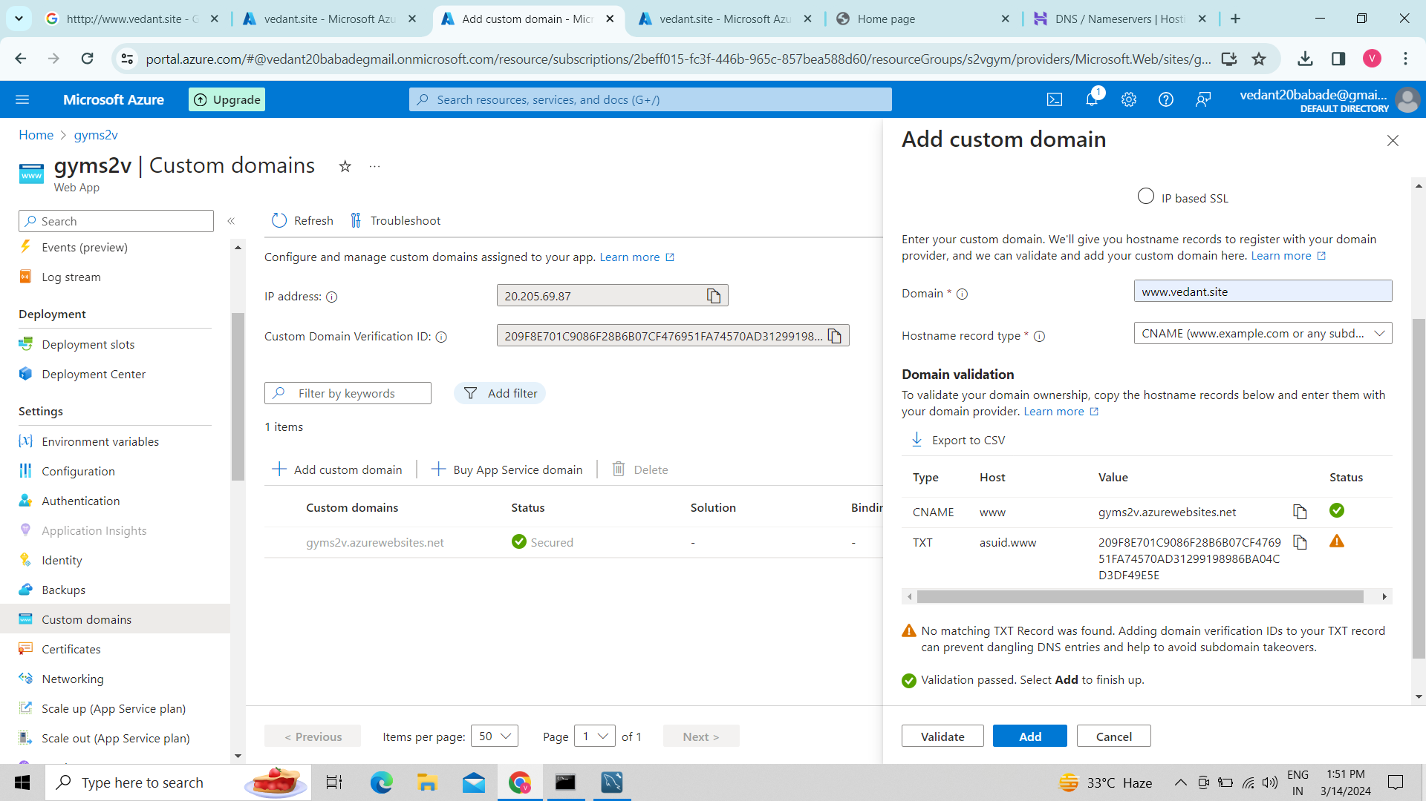

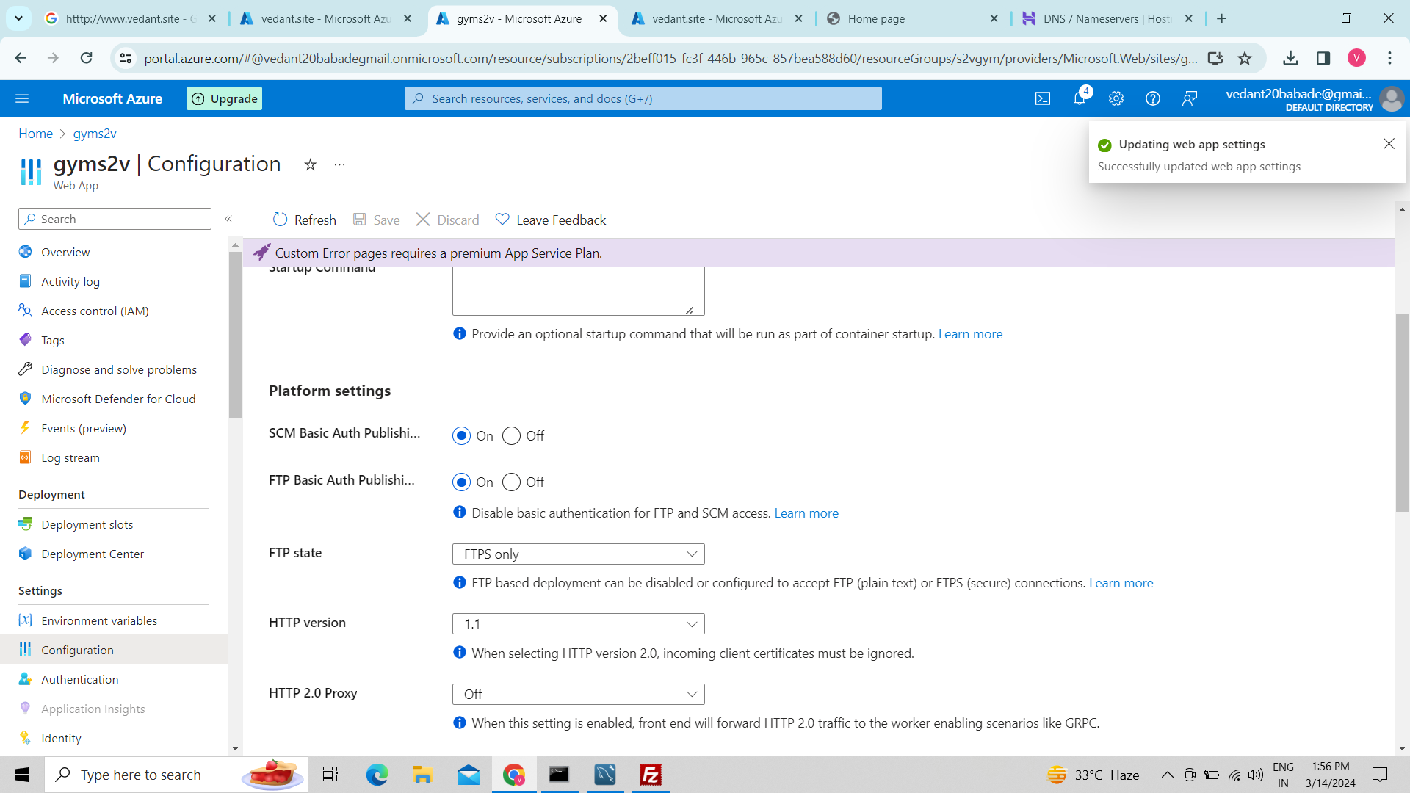

40.File zilla:-

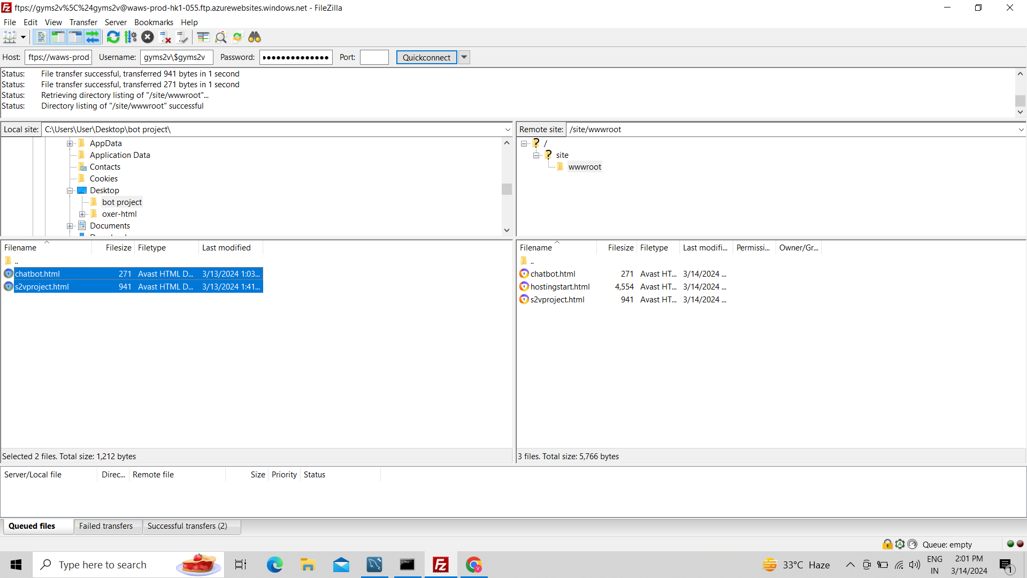

41.Log analytics service:-

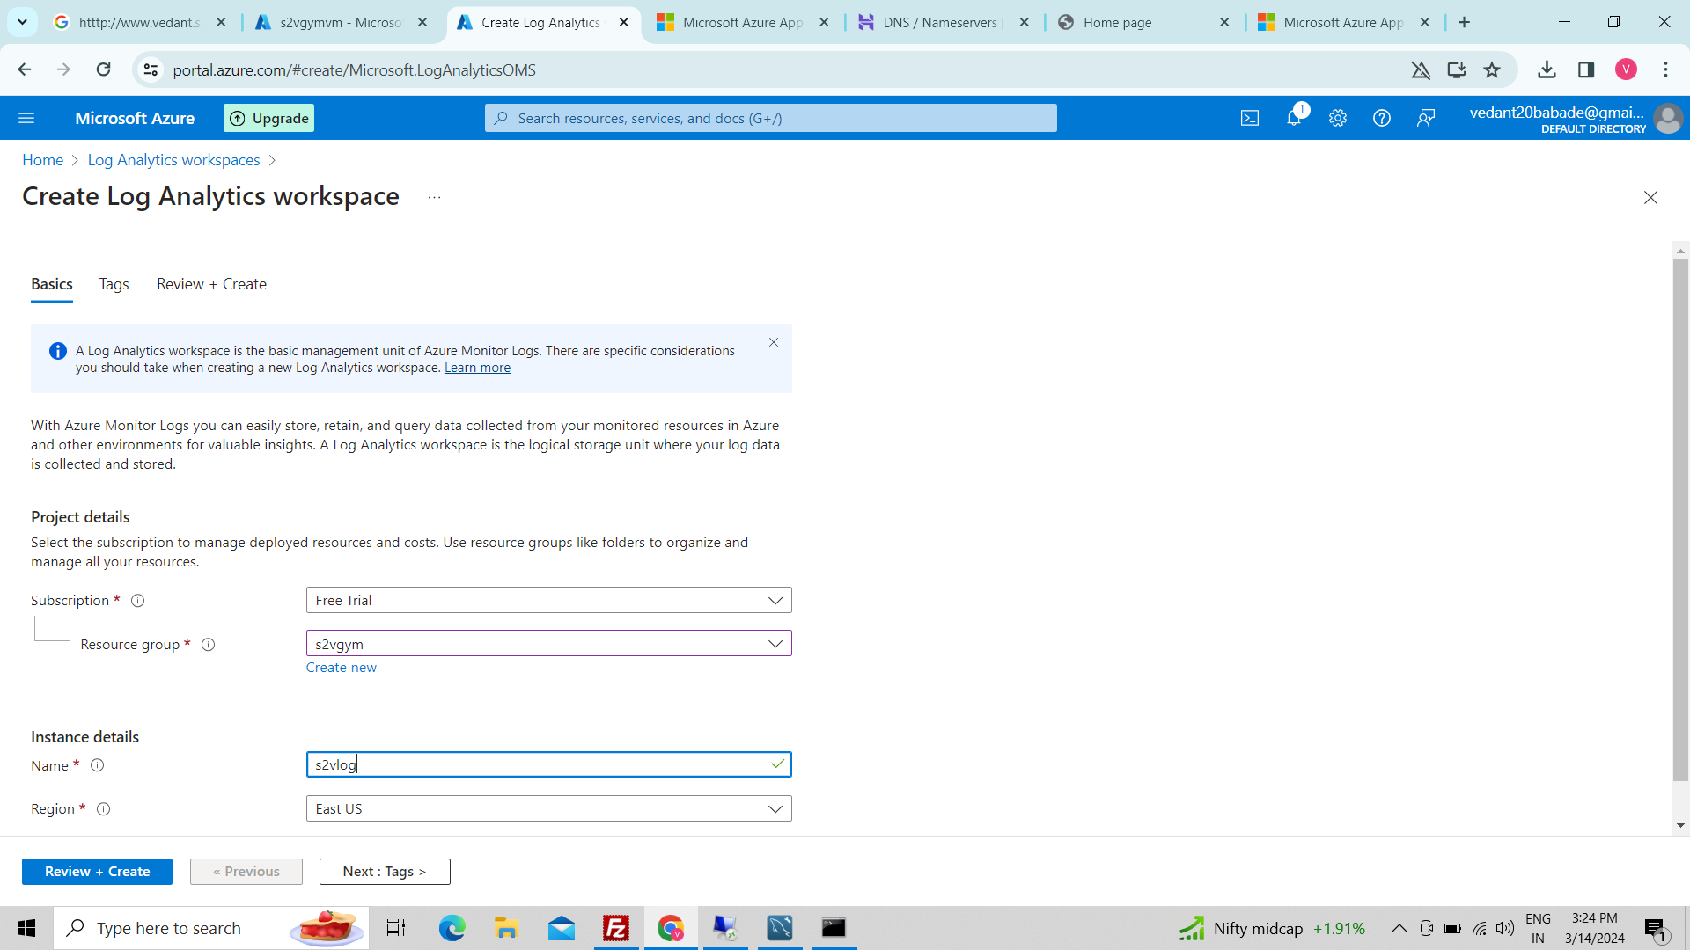

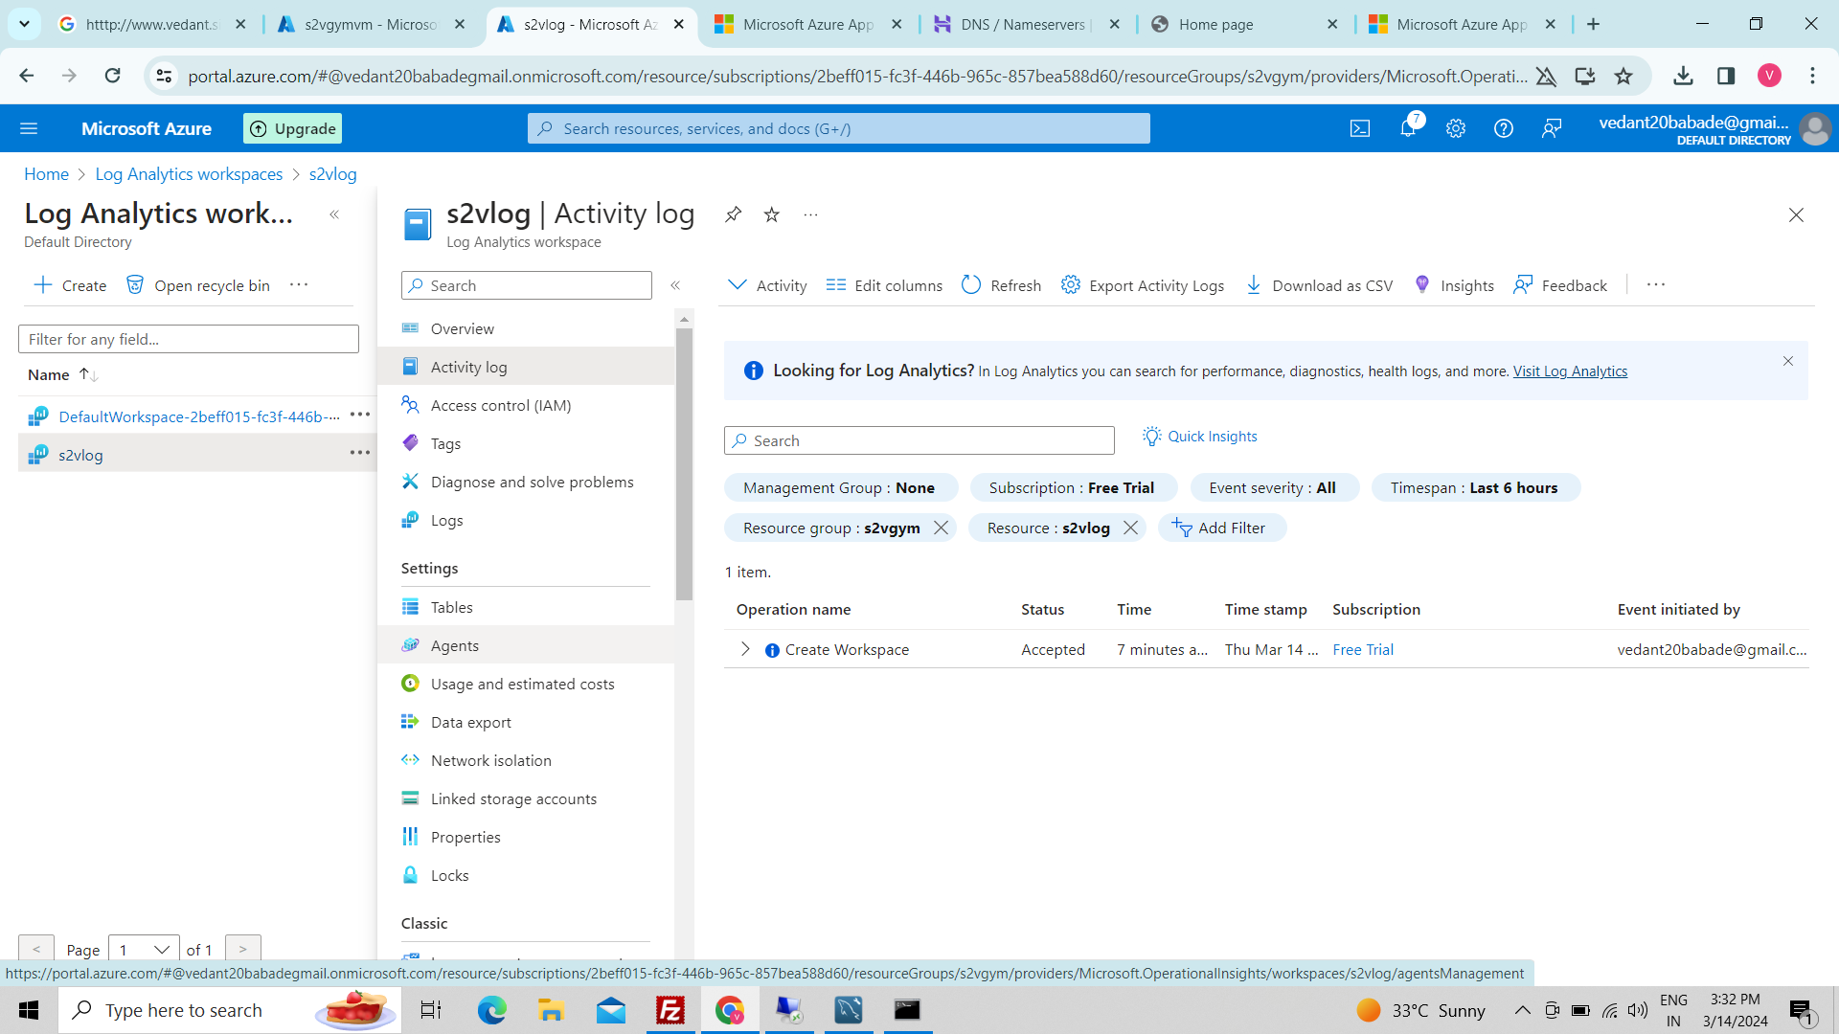

42. Create alert VM:-

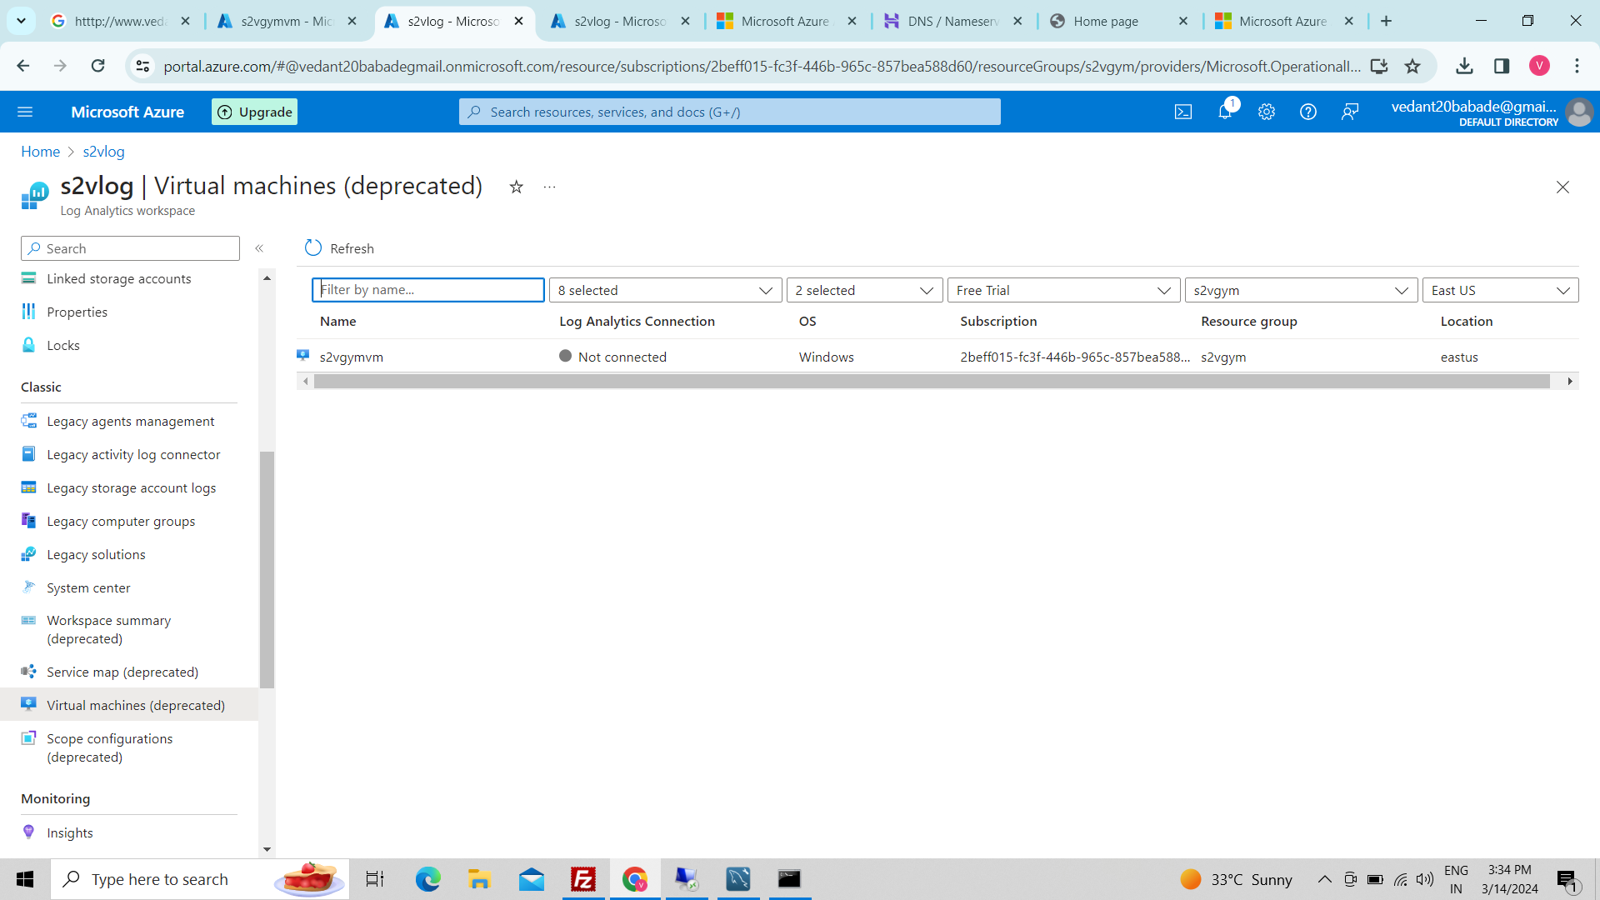

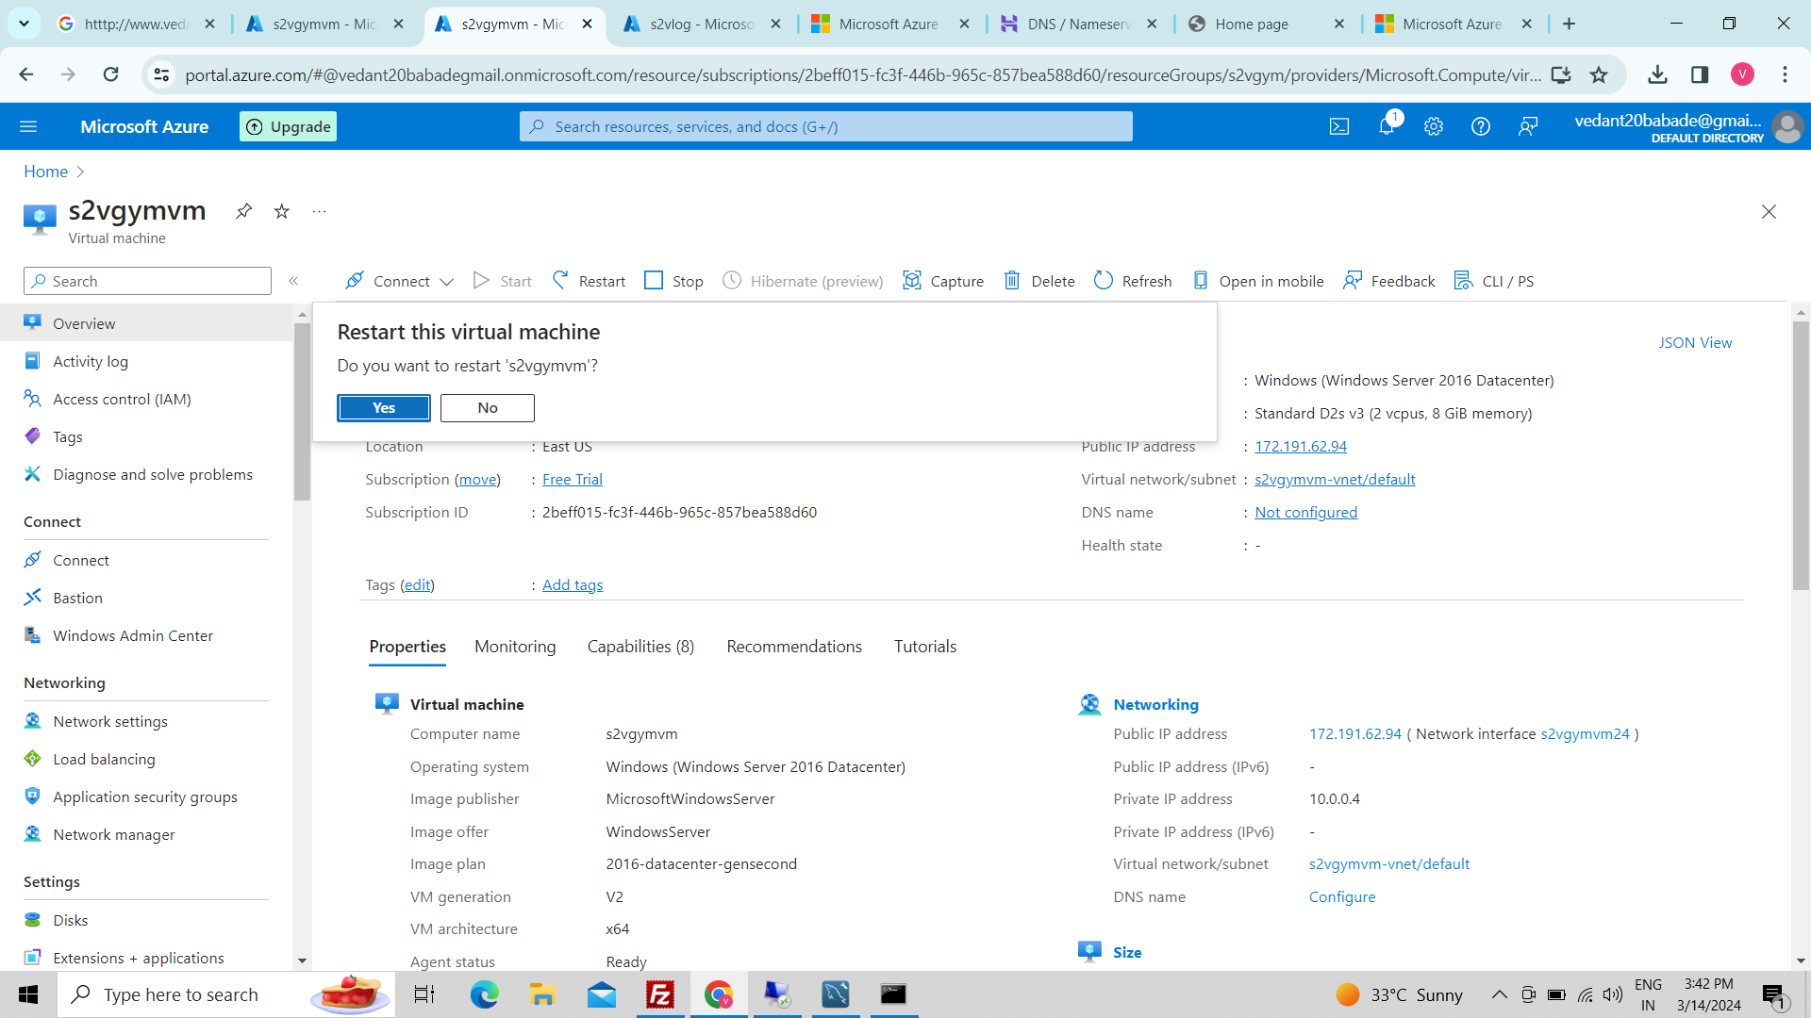

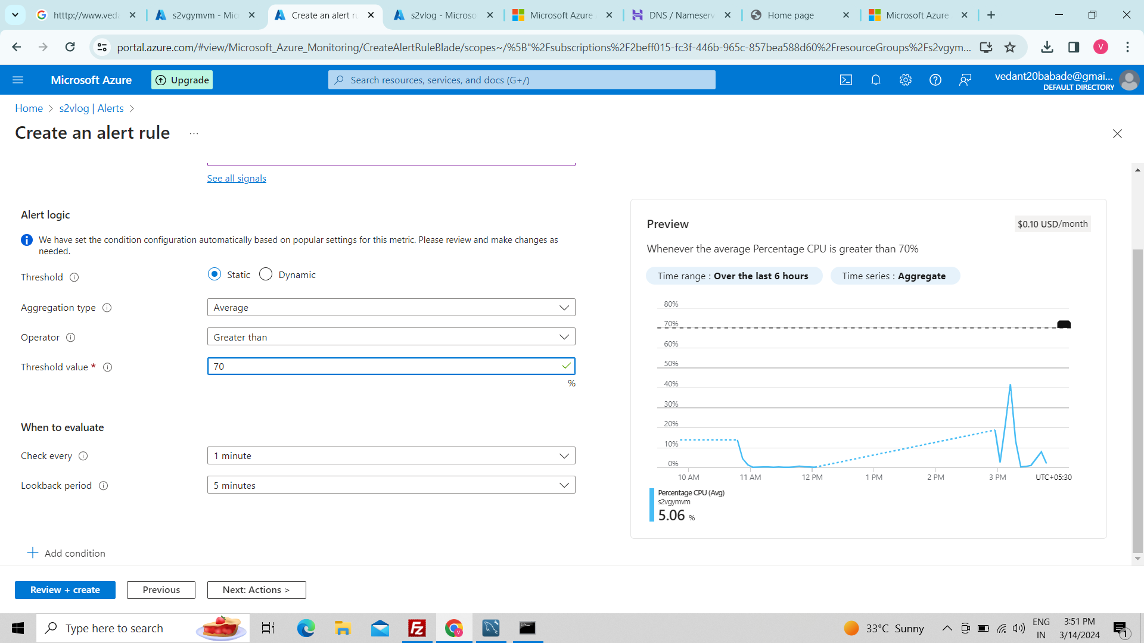

43.create action group:-

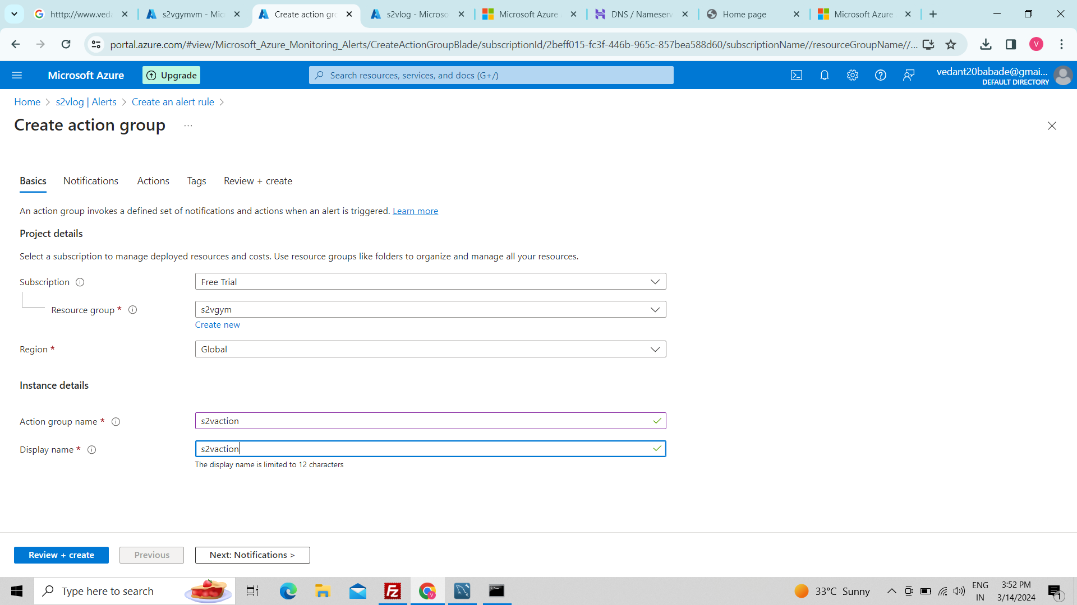

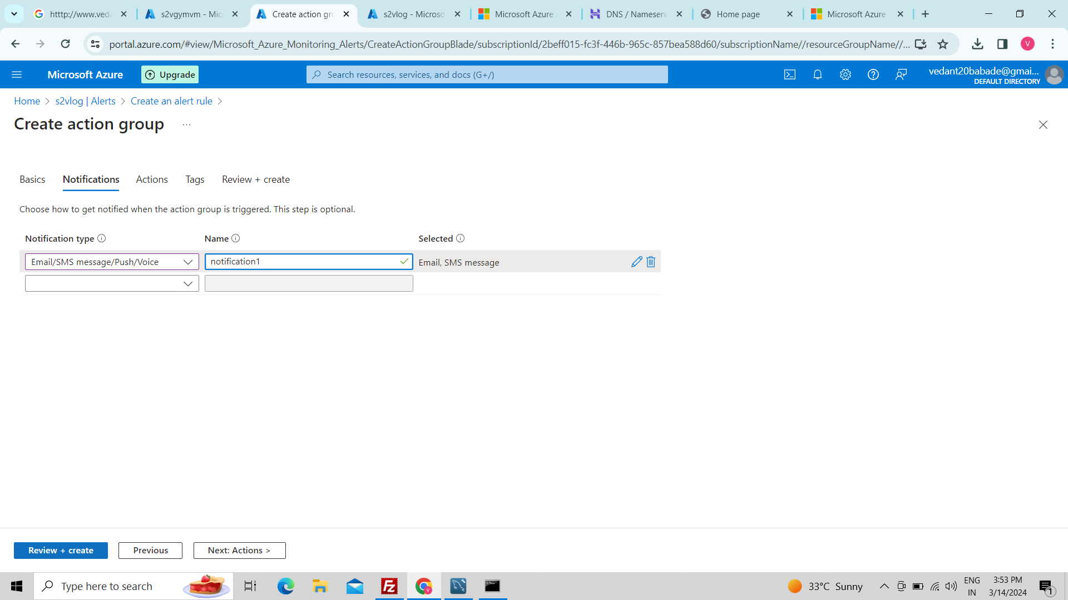

44.Link storage account:-

